**11/04/2022**

**Spring for FullStack Java Program**

* Spring, hibernate and etc… are framework.
* JDBC, Servlet, JSP, EJB, JTA, JAAS and etc… are java technologies.

JSP :: Java Server Page

EJB :: Enterprise Java Bean

JTA :: Java Transaction API

JAAS :: Java Authentication and Authorization Service

* c, c++, java and etc… programming languages.

In Java learning we have

* language learning 🡪 Core Java course
* Technology learning 🡪 Adv.java course
* Framework learning 🡪 Spring, hibernate, web services

**Additional topic u get along with course**

a). 10 + tools :: maven, gradle, GIT, Junit, Mockito, Docker, Jenkins and etc… (DevOps)

b). 10 + common topics:

🡪 resume preparation and interview tips

🡪How to get software job

🡪How to behave in the initial days joining

🡪How to show gap as experience

🡪Understanding IT industry

🡪Tools and process used in real-time projects and etc…

c). 4 to 5 Mini Projects by industry standard Projects by applying coding standard and Design patterns (Best practice)

**What is the difference among programming languages, technologies and frameworks?**

* Programming language are like raw materials (like rice granules, wheat granules)
* Technologies are like semi-finished products (like rice powder, wheat powder(ata))
* Frameworks are like fully-finished products (like Maggie noodles, baba noodles)

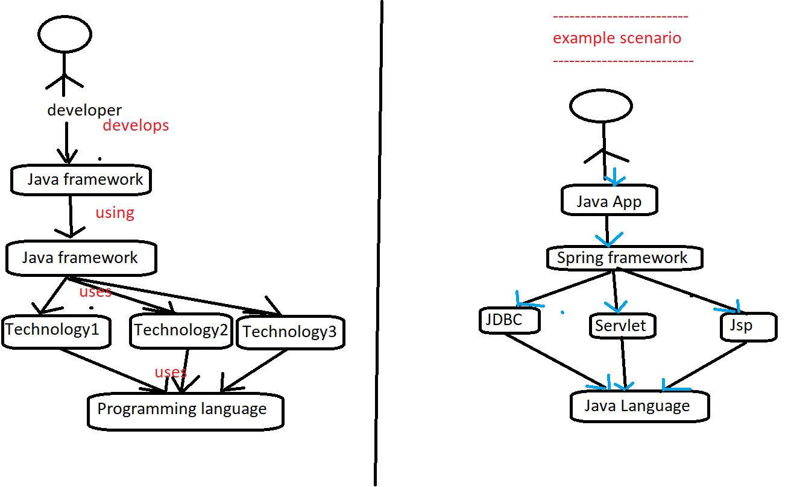

**Programming languages**

* It is installable software as raw material of programming providing basic features for developing software applications.
* It is provides compilers or interpreters to check the syntaxes (rules) and semantics (structure) of programming.
* It is base for creating technologies, framework, Operating systems, tools, DB s/w and etc… directly or indirectly.

Eg :: c, c++, java, c#, ada, small talk and etc…

* JVM based languages are

java , scala , kotlin , groovy and etc…

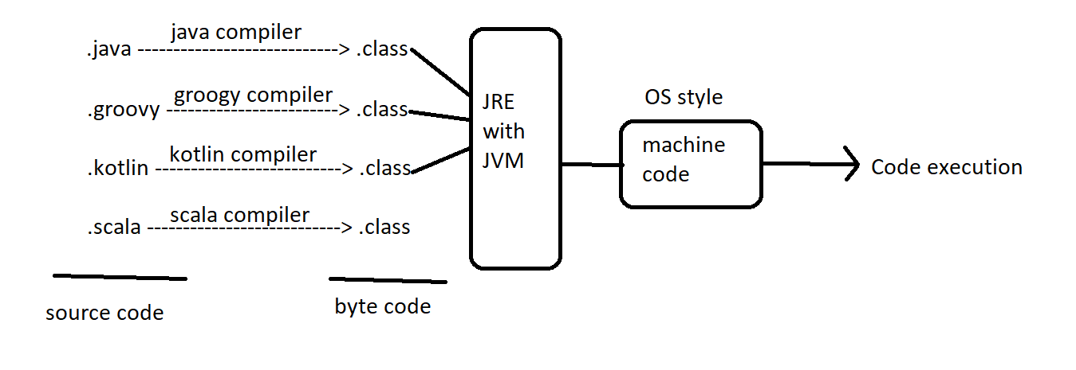

* Java and its technologies are very useful in following areas of applications development

a). standalone Apps(single computer Apps) (eg :: calc app,…)

b). web applications (websites) (eg: nareshit.com, flipcart.com,…)

c). Distributed Apps (service logics can be access remotly) (eg: payTM, GPay, Phone Pe,…)

d). Mobile Apps (android apps) (phone book, music player, …)

e). Data Science Apps (analyzing data … giving predictions)

🡺python and its technologies are very useful in following areas of applications development

a). Data science

b). IOT (Internet Of Things)

**12/04/2022**

**Software Technologies**

* Software technology is a software specification providing set of rules and guidelines in form of application to create implementation software using one or another programming language.

**API :: Application Programming interface**

* API In “C” language comes as .h files having set of functions
* API In “C++” language comes as .h files having set of functions and classes
* API In “Java” language comes as package having set of classes , Interfaces , enums and annotations.(These are also internally classes)

Example of Java apis

jdbc api -> java.sql and its sub pkgs

servlet api -> javax.servlet and sub pkgs

collection api -> java.util and its sub pkgs

lang api - > java.lang and its sub pkgs

and etc…

* Software technology is not installable .. but software technology based implementation software is installable or arrangable.. Working with this implementation software is nothing but working with software technology.

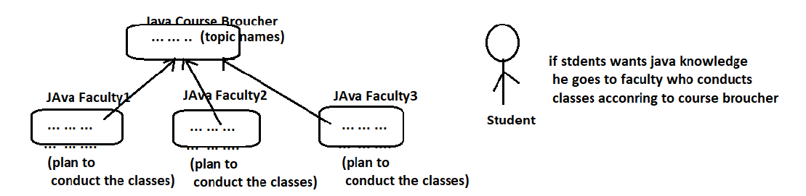

Example:- JDBC is Java technology providing set of rules and guidelines in the form of jdbc api to create JDBC driver s/w.

JDBC technology is not installable …. But jdbc Technology based JDBC driver s/w is installable or arrangable … So working with JDBC driver s/w is nothing but working with JDBC technology.

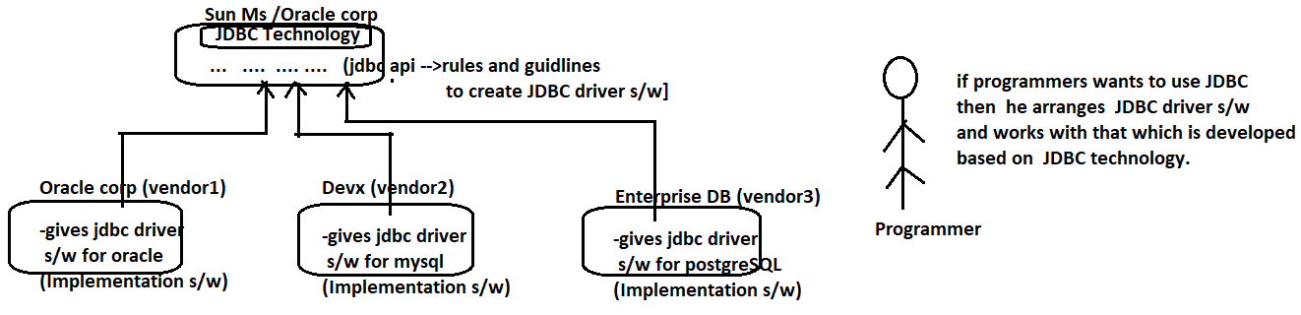

* Developers / programmers do not work with technologies directly… they arrange technology based implementation software’s to work with technologies.
* Technology gives rules and guidelines in the form of apis… In these apis will be given in the form interfaces and guidelines will be given in form of classes… (abstract class represents both rules and guidelines)

**UpTo Java7**

Java interface :: Rules (because all the methods interface must be implemented in impl class)

Java concreate class :: Guide lines (super class methods overloading and usage in sub class is optional)

Java abstract classes :: both rules and guidelines (because abstract class can contain both abstract methods(rules) and concreate methods (guidelines))

**Form Java8**

Java interfaces & abstract class :: represent both rules and guidelines.

(note : java8 interface can have method definitions as default, static methods) along with method declarations)

Java concreate classes :: represent only guidelines.

* To work servlet technology we need arrange servlet technology impl s/w that is servlet container.
* To work with jsp technology we need to arrange jsp technology impl s/w that is jsp container.
* To work with EJB technology we need to arrange EJB technology impl s/w that is EJB container.
* To work with JMS technology we need to arrange JMS technology impl s/w that is MOM(Message Oriented Middleware)

EJB :: Enterprise Java Bean

JMS :: Java Messaging Service

JSP :: Java Server Pages

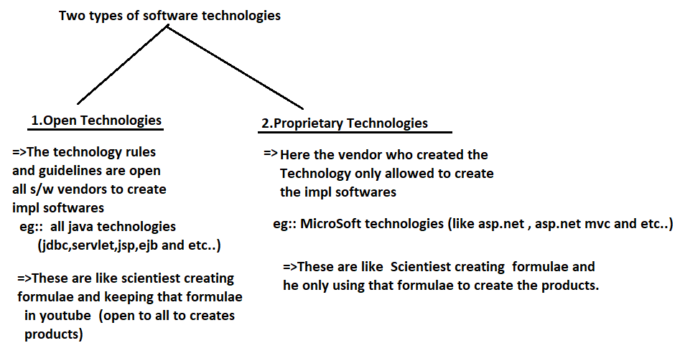

* **Why sun Ms/Oracle corp is releasing their technologies as Technologies?**

Ans:- Sun Ms/Oracle corp wants to create competition among the vendors who creates the technology based implementation software … So the quality implementation software can be given software developers at affordable prices.

* **If s/w vendor company is giving their software as free and open source softwares then how does it survive financially?**

Ans:- These companies change money for services they offer and for bi-products they create

=>By offering certification exams

=> By offering Corporate trainings

=> By publishing books

=> By releasing commercial Bi-products like IDEs, plugins and etc…

=> By helping software companies who strucked in the middle of the development and etc.

**13/04/2022**

**Framework:-**

House :: physical construction

Home :: physical construction + people inside it

**Def1 ::** Framework is a installable software that is build on top of one or more technologies having ability to generate the common logics of the application development dynamically to make the developers to write only application specific logics.

**Def2 ::** Framework is a installable software that is build on top of one or more technologies providing abstraction on technologies to simplify the application development process.

**Abstraction :-** Hiding the unnecessary details .. and showing only the necessary things.

Eg :: spring , spring boot , hibernate , web services , JSF , ADF and etc…

JSF :: Java Server Faces

ADF :: Application Development Framework

* Every Framework internally uses one or more technologies to generate common logics of application development … but does not make programmers to bother about that… This is nothing but Frameworks providing abstraction on technologies.

**Plain JDBC App (Technology App)**

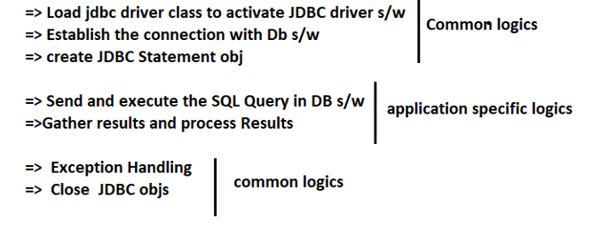

Common logics :: Repeatable logics in multiple Apps of same type/ category

Application Specific logics :: These logics will change app to app

* While working with Technologies , the programmer needs to take care of both common logics and application specific logics i.e. burden on the programmer will be increased.
* Common logics is called boiler plate code .. The code repeats in multiple parts of the app wither with no changes is called boilerplate code ..

Boilerplate code = common logics

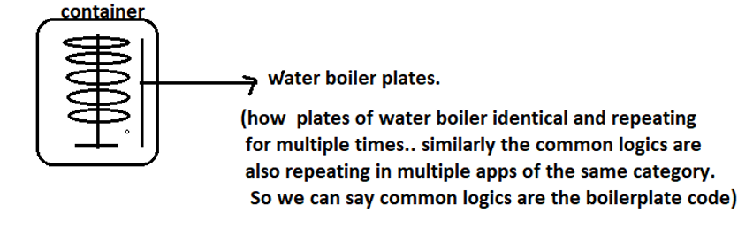

Spring JDBC App(framework App) [Spring JDBC internally uses plain jdbc technology]

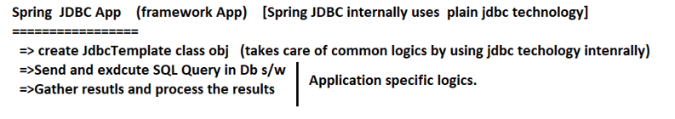

**Note ::** Here Programmer needs to develop only application specifics logics .. not the common logics .. i.e. boilerplate code problem is gone.

**Conclusion ::** Use technologies (adv.java content) to develop java based small projects (10 to 20 db tables)

Use frameworks (spring , spring boot, hibernate,…) to develop java based medium scale projects(20 to 40 bd tables) and large scale projects (>=40 db tables)

**Small scale Projects ::** Calculator App, Desktop Game, Promotional websites

**Medium scale Projects ::** University website, college websites, company websites.

**Large scale Projects ::** e-commerce Apps (flipkart , amazon, IRCTC, mantra ,…), Banking App, UPI Payment Apps and etc…

**Benefits with frameworks**

1. Avoids boilerplate code/ Common logics development Spring boot = spring++
2. Provides abstraction on Java ,JEE Technologies
3. Improves the Productivity (More work in less time with great accuracy)
4. Framework apis are modeled after realtime scenarios , so in projects we can develop tasks directly by using those apis.
5. Frameworks are industry’s defacto standard to develop medium scale and large scale projects.

**15/04/2022**

* In every programming environment.. frameworks popular to develop complex projects
* php frameworks are drupal , WordPress and etc…
* java frameworks are spring , hibernate, webservices and etc…
* python frameworks are Django and etc…
* java script toolkits/ frameworks are angular, reactjs, jquery and etc.

**Different types of java frameworks**

1. ORM frameworks
2. MVC frameworks
3. JEE frameworks/ Application frameworks
4. WebServices framework/ Distributed Frameworks
5. BigData Frameworks

**(a)ORM frameworks(Object Relational Mapping frameworks)**

* These frameworks provide abstraction(i.e internally uses JDBC technology) on JDBC technology and allows us to develop objects based(o-r mapping :: object relational mapping) DB s/w independent Persistence logic (performance insert, update, delete operation on DB s/w) with out SQL Queries.

Here each object of java class represents each record of db table… So using objects we can perform all insert , update, delete operation on the records.

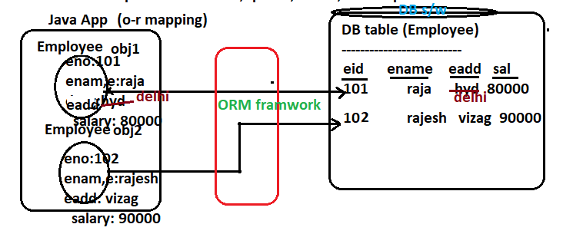

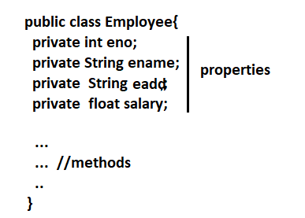

Eg:: Hibernate ------------------------------🡪 from SoftTree (RedHat) (1)

Toplink ----------------------------------🡪 from oracle corp

iBatis ------------------------------------🡪 from apache (3)

OJB(Object Java Beans) ------------🡪 from apache

Eclipse Link ---------------------------🡪 from Eclipse (2)

and etc…

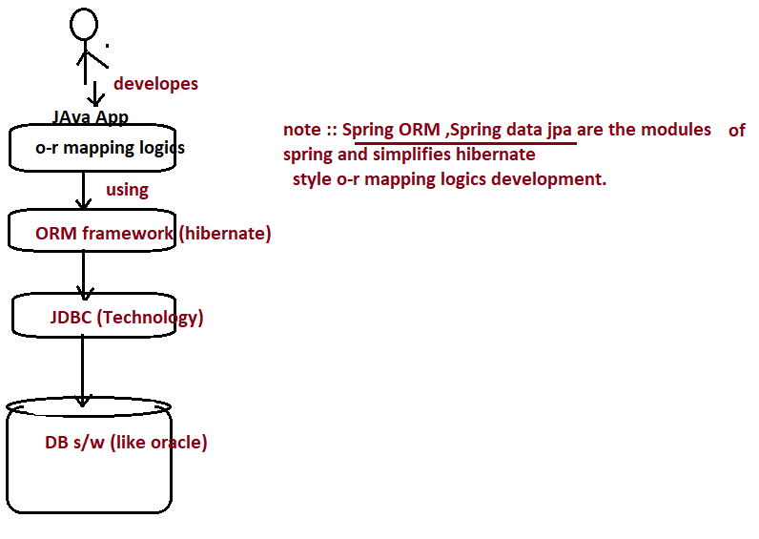

**(b) MVC frameworks :-**

**MVC ::**Model view Controller is architecture to develop web applications as layered applications i.e. different logic will be placed in different comps (classes /files) that are in communication.

M -> Model Layer 🡪 represents data (b.logics + persistence logics) 🡪 like Accountant officer

V-> View 🡪 represents presentation logics. 🡪 like superviser.

Note:- keeping all logics in single class or single file is non-layered application development (bad practice)… Like staying in bachelor room.

Note:- keeping different logics in different classes or files is layered application development (good pratice)… Like staying in 3BHK/4BHK Flat.

* MVC frameworks provides abstraction on servlet, jsp technologies and simplifies MVC architecture based web application development as layered application development.

Struts -----------------------------------🡪 from apache

JSF (Java Server Faces) ------------🡪 from Sun Ms/ Oracel corp (2)

Spring MVC (part of spring Framework as module) ----🡪 from interface21/ pivotal (1)

ADF (Application Development framework) -------------🡪 from oracle corp

Webwork -----------------------------------------🡪 from open symphony

And etc…

Example of web applications(web sites)

Eg :: nareshit.com, flipkart.com, amazon.in and etc…

**(e)WebServices frameworks / Distributed Frameworks**

=> The Application that allows to access b.logics either locally or remotely through method calls from different types client apps is called Distributed Application.

Eg :: paytm , google pay, phone pay, pay pall , BSE StockComp , Weather Report comp , SBI Bank App and etc…

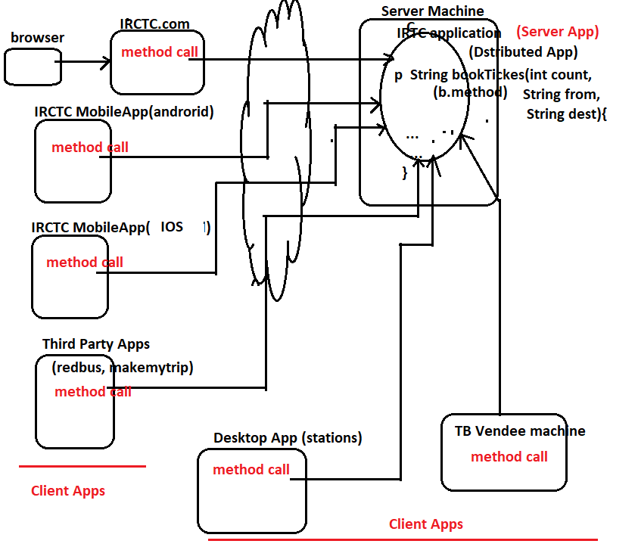

Java Technology to develop Distributed apps are RMI (out dated) , EJB(out dated), CORBA (out dated) becoz they both Client App and sever App must be there in Java.

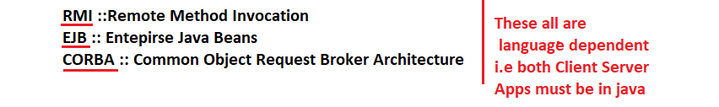

* To solve this problem we have got webservices which say Client and server Apps of distributed environment … can be there in two different languages.
* To develop WebServices Apps in java (only server or only client or both) we have following frameworks.

JaX-RS (Jersy)

Spring Rest (1)

Metro

RestEasy

And etc…

Enterprise app = web application + distributed App

(Flipkart with debit/ credit card payment or upi payment is called enterprise App)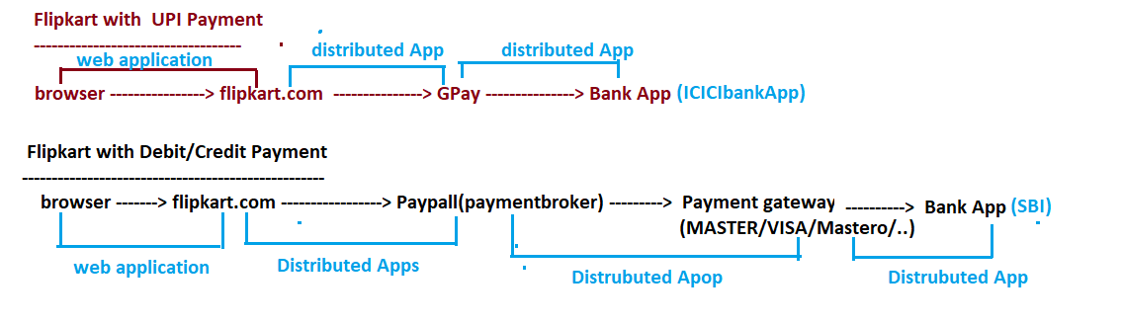

18/04/2022

**What is difference b/w web application and distributed app?**

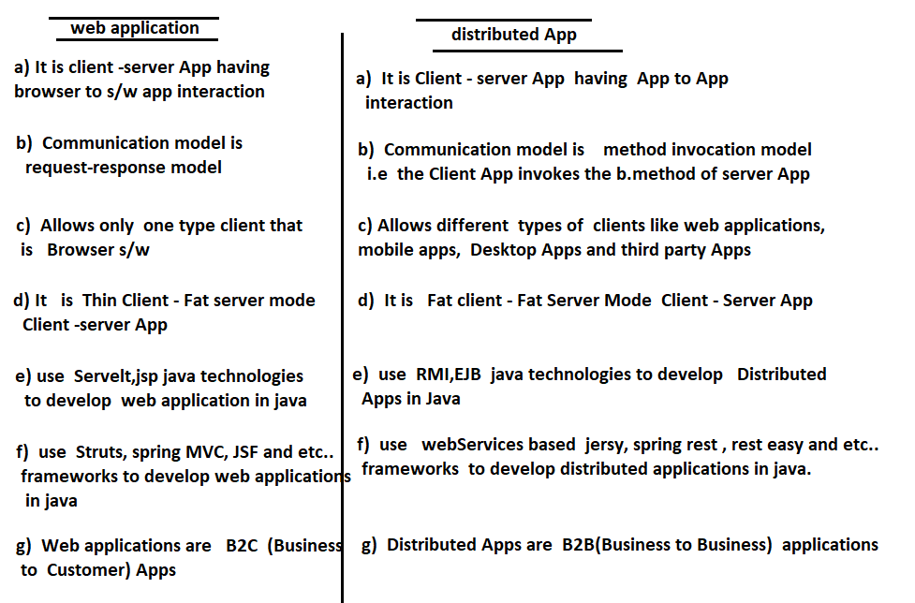

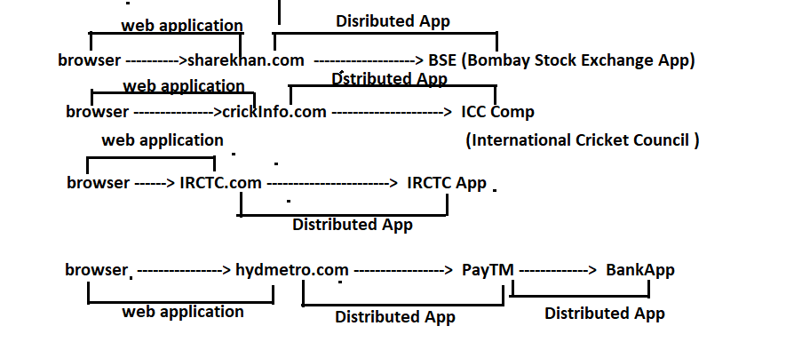

JEE Frameworks / Application Frameworks:-

* This framework provides abstraction on multiple Java , JEE Technologies (jdbc, servlet , jsp , and etc…) and on other small java frameworks (like hibernate , iBatis and etc …) to simplify all kinds of logics and applications development.

Ex :: spring ----------------------------🡪 from interface21 (pivotal team)

Spring boot --------------------🡪 from interface21 (pivotal team)

Spring boot = spring++

* Spring provides abstraction on multiple Java, JEE technologies where as spring boot provides abstraction on spring framework itself.
* Using spring , spring boot , we can develop standalone apps , web applications, distributed Apps enterprise apps and etc…
* Using spring , spring boot we can develop presentation logics , b.logics, persistence logics and other logics.
* If spring , spring boot frameworks are used effectively there is no need to working with ORM , MVC , WebServices frameworks separately.
* Since spring , spring boot frameworks vey big .. they are related to market as modules So that we can use our choice modules in the Project development.
* Spring 5.3.19/ spring boot 2.6.6 (latest version) is having 20+ modules .. The modules are-

=> spring core/ spring boot core

=> spring jdbc / spring boot jdbc

=> spring orm / spring boot orm

=> spring mvc / spring boot mvc

=> spring security / spring boot security

=> spring AOP / spring boot AOP

=> spring Tx Mg / spring boot Tx Mg

=> spring mail / spring boot mail

=> spring Batch / spring boot Batch

=> spring scheduling / spring boot scheduling

=> spring oauth / spring boot oauth

=> spring cloud / spring boot cloud (Micro Services)

=> spring rest / spring boot rest

=> spring data / spring boot data…

And etc…

Fresher needs to learn :: spring core, spring jdbc, spring mvc, spring security, spring mail, spring TxMgmt modules.

**(e)BigData Fameworks**

=>The data that is beyond storing and processing capacity using regular storage , s/w’s and computer is called as BigData.

Note : youtube, fb, Instagram, popular e-comerce websites and etc… generates this Big Data…

* We need to use special framework software called big data to store and process big data using multiple regular computers connected in a networks.

Eg :: Hadoop -------------🡪 from apache

Spark ----------------🡪 from apache

(100 times faster than hadoop)

Note :: As Java developer need to learn big data framework only while becoming Data Scientist … but remaining frameworks are required to come a fulfilled java developer.

**19/04/2022**

**Two types of java frameworks based on their mode of application development:-**

1. Invasive Java frameworks
2. Non-Invasive Java frameworks

**(a) Invasive Java frameworks:-**

**=>** Here the classes of App / Project development are tightly coupled with Framework apis i.e. each class of Project / App development should implement framework api interface or should extend from framework api class.

=> The classes App / Project development of one framework cannot be moved another framework for execution because they are tightly coupled with certain framework.

**Eg** :: Struts

Working with Invasive frameworks is like joining in the company having bond.

Class in struts Framework (Struts api dependent class)

public class RegisterAction extends org.apache.action.Action{

…..b.methods having b.logic struts framework API class

……..

}

**Non-Invasive Java frameworks :-**

* Here the classes of application development are loosely coupled with framework apis i.e. the classes need not to implement framework api interfaces and need not extend from framework api classes.
* The classes having application logics can be moved other frameworks easily because they are not tightly coupled any framework api.

Eg :: spring , hibernate , jsf and etc…

* Working with non-invasive frameworks is like joining in the company with out bond.

Class in spring framework (normal class)

public class RegistrationAction{

…

…

b.method having b.logics

…

}

Spring

Type :: JEE framework / Application Framework JEE :: Java Enterprise Edition (or)

Version :: 5.3.19 Jakarta Enterprise Edition

Vendor :: Interface 21 (pivotal team)

Open Source

Creator :: Mr. Rod Jhonson

**Is spring alternate to Stuts?**

Ans : - No.. Struts is given to develop just web applications… where as spring is given to develop all kinds of applications including web applications.

**Is spring alternate to EJB?**

Ans :- No.. EJB is JEE Technology to develop distributed Apps… where as spring is given to develop all kinds of applications including Distributed Apps .

**Is Spring Alternate to JEE Technologies:-**

Ans:- No.. Spring complements JEE Technologies and simplifies the application development process.

Note:- Spring framework internally uses Java, JEE Technologies and simplifies the application development process . So we cannot say spring is alternate to java, jee technologies , Infact spring framework complements their utialization by providing abstraction on them.

**Definition of Spring framework :-**

* Spring is open source , light weight , loosely coupled , non-invasive , aspect oriented, dependency management based JEE Framework to develop all kinds of java , jee applications in simplified manner.

**Open Source:-**

* Open source software means free software that gives source code to developers.
* We can get spring api classes source code along with spring libraries(jar files). So we can say spring is an open source framework.

.java files -> source code

.class files -> byte code

**Light Weight :-**

* Spring is light weight because-

1. Framework comes in the form of jar files having less size
2. Framework is given in the form of modules .. So we can use only those modules that are required in application development.
3. Most of the spring apps can be executed without involving the heavy weight WebServices(eg: Tomcat) and Application servers (eg WebLogic)
4. By using maven , gradle build tools we can download spring jar files dynamically from internet to our application.

**Loosely Coupled**

* If the degree of dependency is less b/w two components then they are called loosely coupled components.

Eg :: TV and remote

* If the degree of dependency is more b/w two components then they are called tightly coupled components.

Eg :: cpu box and console

**Spring is Loosely Coupled because :-**

1. The degree of dependency among the spring modules is very less.
2. The classes of spring app/ projects are loosely coupled with spring apis
3. Spring encourages interface module programming to make classes as loosely coupled components.

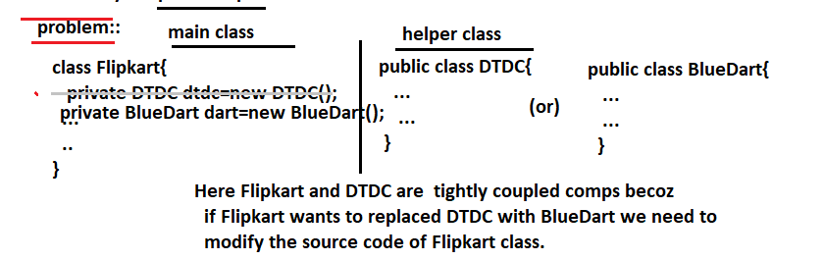

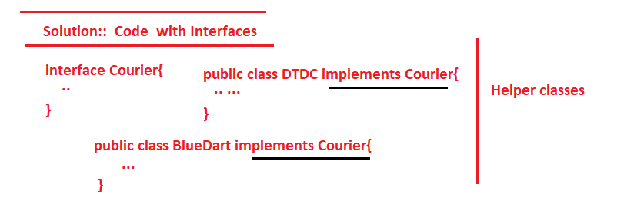

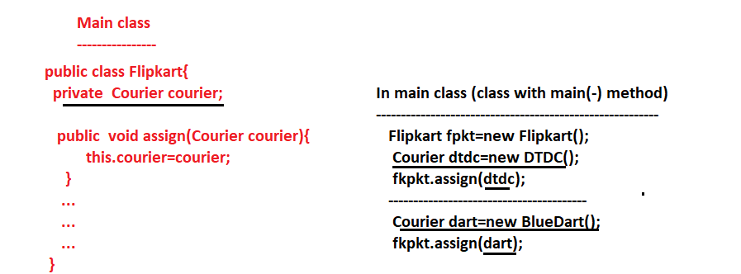

* Here to change DTDC with BlueDart for Flipkart we need not to modify the source code of Flipkart class… interface we are able to do this change from outside of main , helper class… i.e. main class loosely coupled classes here.

**20/04/2022**

**Non-Invasive:-**

* While developing classes for spring App/ Project.. we need not to make those classes implementing spring api supplied interfaces and need not to extend from spring api supplied classes … i.e. classes of App / Project can be moved to other framework for execution. This makes spring framework as the non-invasive framework.

**Aspect Oriented**

* The mandatory logics of application development are called primary logics/ b.logics.

Eg :: opening account , withdraw, deposit , transfer money and etc … in Banking Apps

* The optional logics in application development are called secondary logics or Aspects

Eg :: logging (keeps track of code flow), auditing (keeps track of uses activities), security(checks authentication) and etc…

* In OOP style programming we mix up both primary and secondary logics in the b.methods of a class.

**OOP Style Coding**

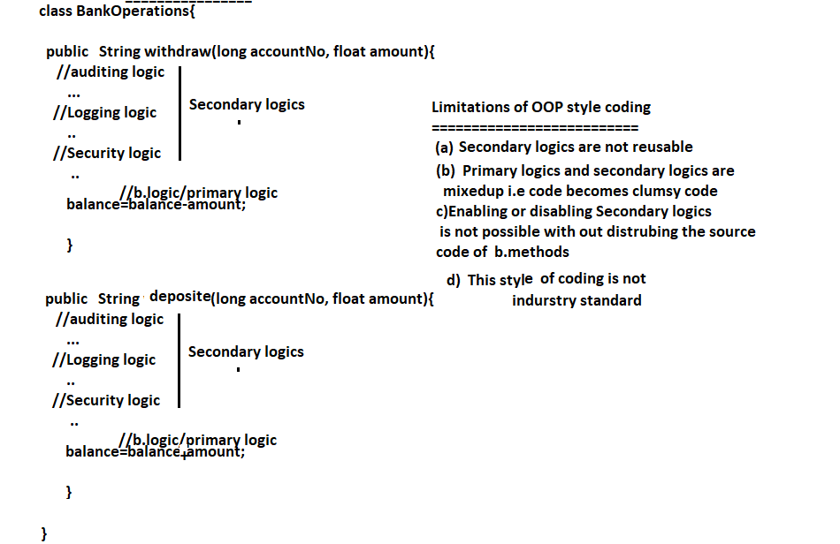

**Note** :: To solve the problems of oop style programming take the support AOP (Aspect Oriented Programming) style programming.

* AOP is not replacement for OOP .. In fact it compliments OOP

**Solution Using AOP :-**

* AOP says separate secondary logics from Primary logics and mix them dynamically at runtime.

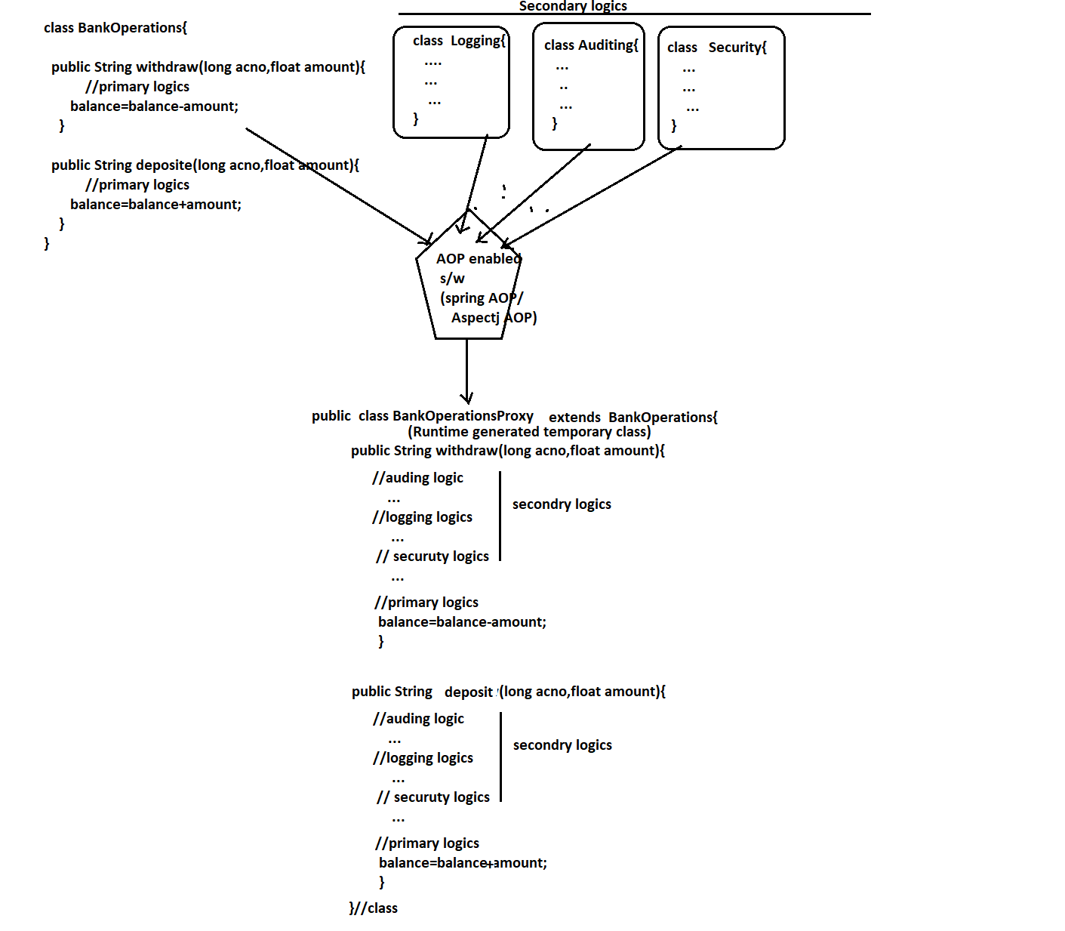

**Advantage of AOP Style Programming :-**

1. Secondary logic / Aspects are reusable
2. Since primary and secondary logics are not mixedup …Code is not clumsy
3. We can enable or disable secondary logics on primary logics with out touching the source code of primary logics..
4. This AOP coding is industry standard.

**Note: Using spring AOP module we can develop primary and secondary logics separately and we can mix them dynamically at run time . This make spring as Aspect Oriented.**

**Dependency Management :-**

* Arranging/ giving Dependent class obj to target class obj is called Dependency Management.

=>The class that takes the support of other class is called target class / main class

=> The class that acts as a helper class to their class dependent class / helper class.

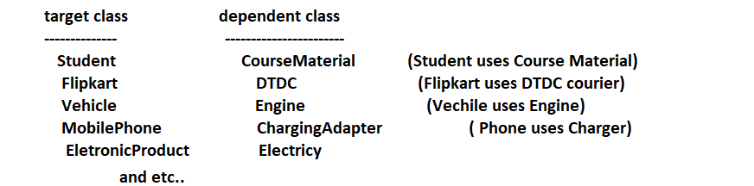

Note :- Generally target and dependent class will be there in HAS-Relationship i.e. Dependent class type property will be taken in the target class as HAS – A Property. (Composit)

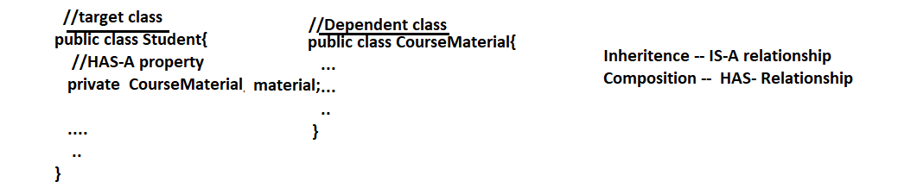

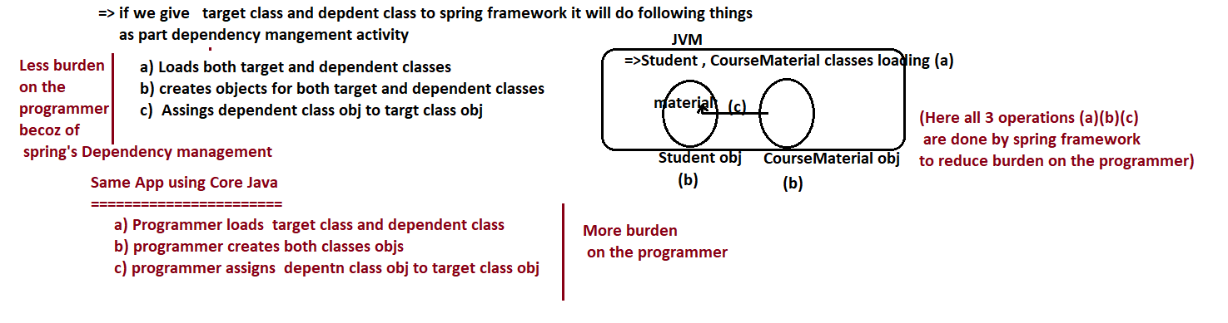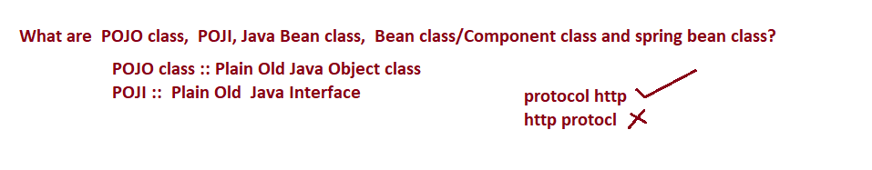

**23/04/2022**

**What are POJO class, Java Bean class, Bean Class/ Component class and spring bean class?**

**POJO class(Plain Old Java Object class):-**

* The ordinary java class with out specialties is called POJO class
* The java class that is not extending are not implementing technology/ framework api classes and interfaces is called POJO class.
* Most of the times, we can compile POJO classes using jdk Libraries(core java setup).

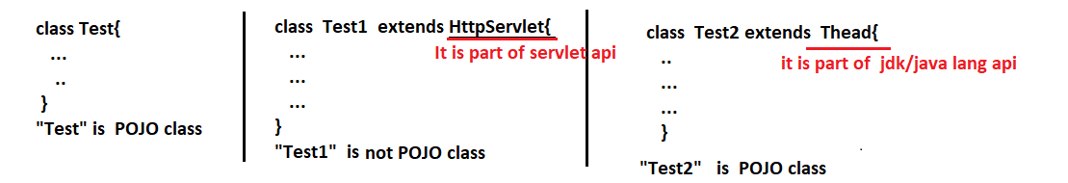

Note :- POJO class is not against of extending from other classes and implementing from interfaces.. It is against from technology / framework api class and against of implementing technology / framework api interfaces.

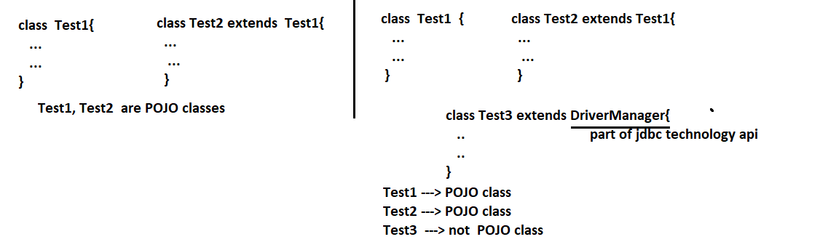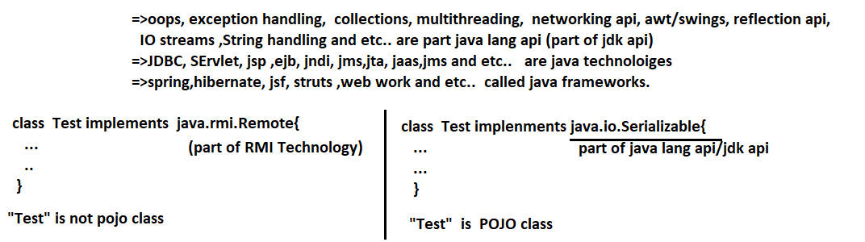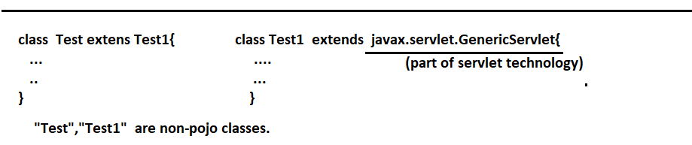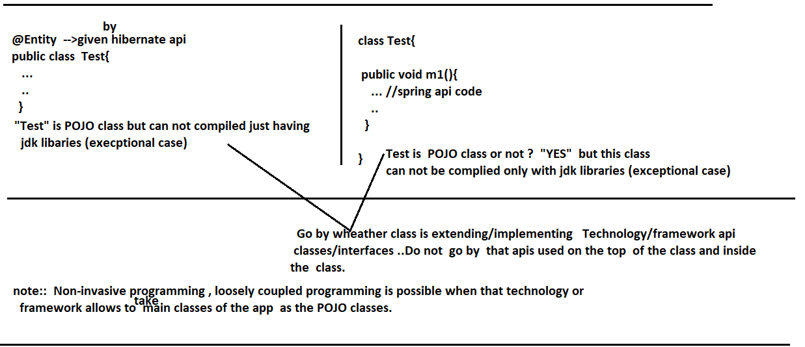

**POJI()Plain Old Java Interface) :-**

* Ordinary interface with out specialities is called POJI.
* The interface that is not extending from Technology/ framework api interfaces is called POJI.
* Most of the times, we can compile POJIs by using JDK Libraries.

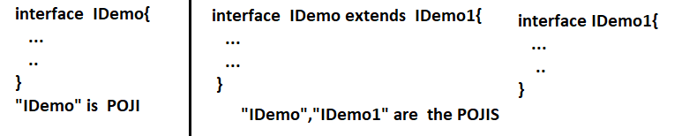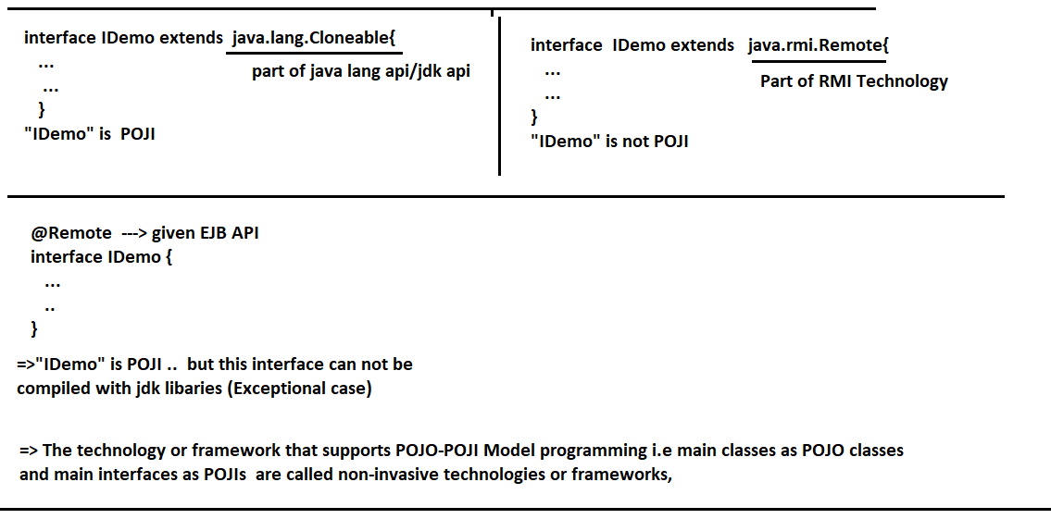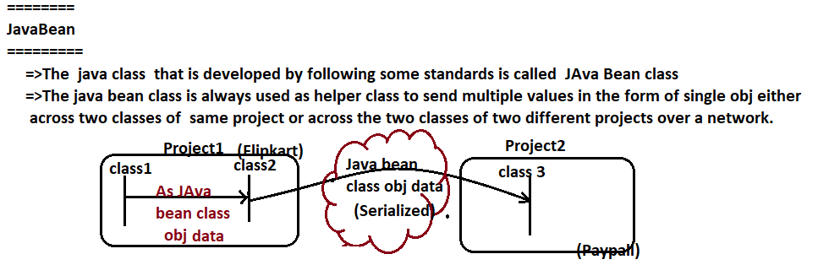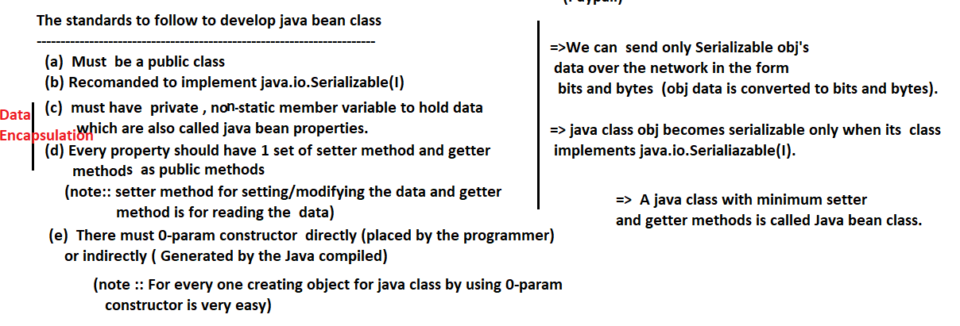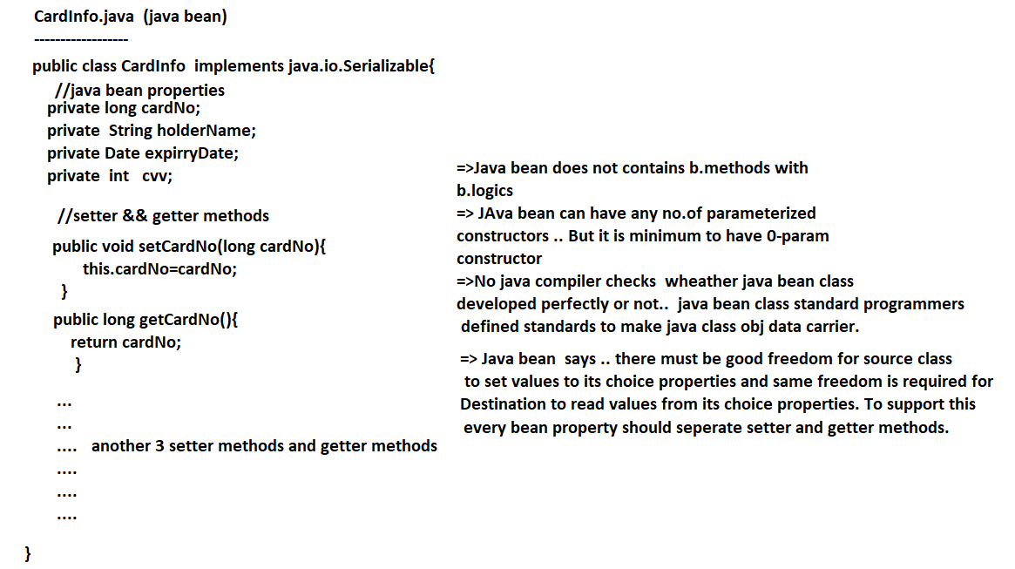

**25/04/2022**

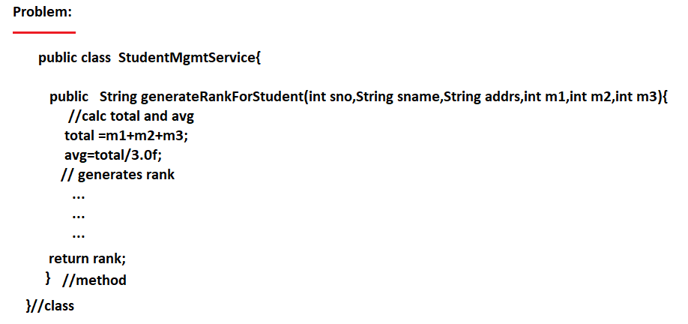

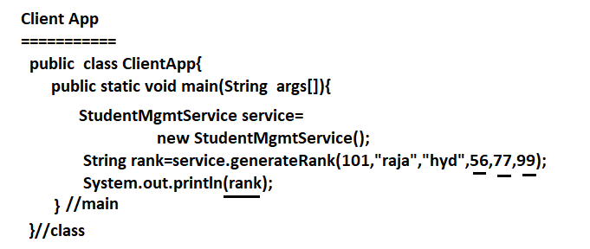

**Designing java method having more than 3 parameters is having the following limitations**

* While calling method we must remember the index/ order of args.
* While calling method we must remember the type of args.
* If we do not know certain arg value … we can not ignore that value … we must pass one or another meaningfull dummy value that .

**Conclusion ::**

* Designing java method having more than 3 params is bad practice … The solution is design the same method having java bean as the param type.

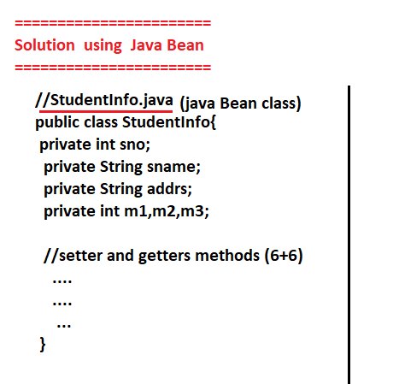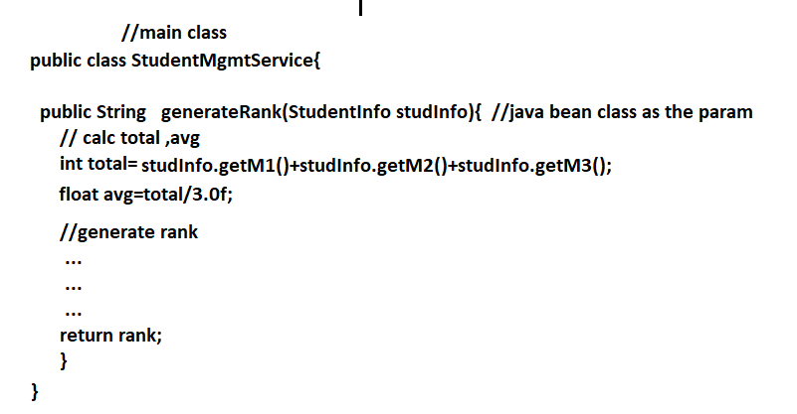

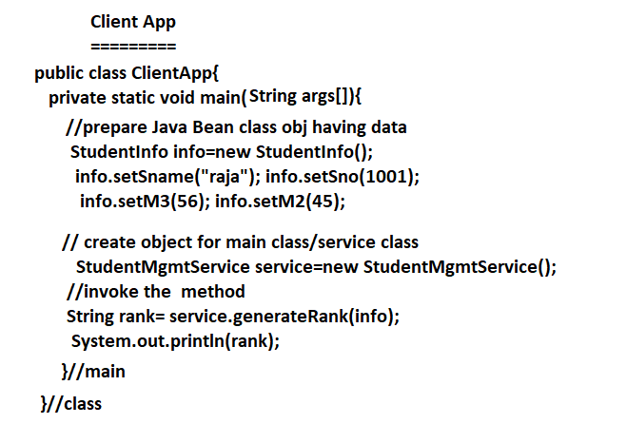

**Advantages of taking java Bean as the parameter type for a method:-**

1. While setting data of java bean class object we need not to worry about index/ order of the values.
2. The names of setter methods helps us to decide the type of bean properties dynamically.

setName(-) indicates name is generally string type of property.

1. If we do not certain bean property value … we can ignore to set them because the bean properties are instance variables and they will get default values for them automatically.
2. Designing java bean as the b.method parameter is industry standard.

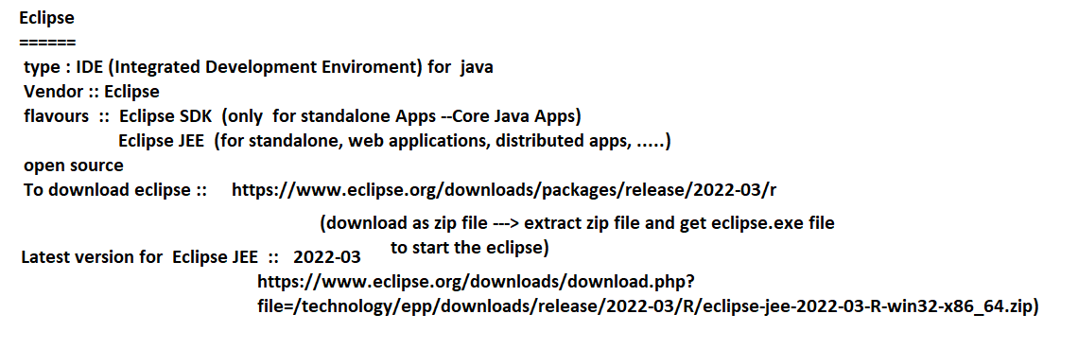

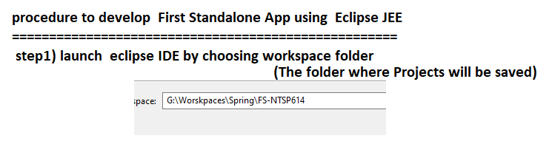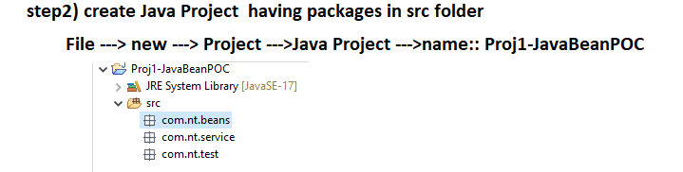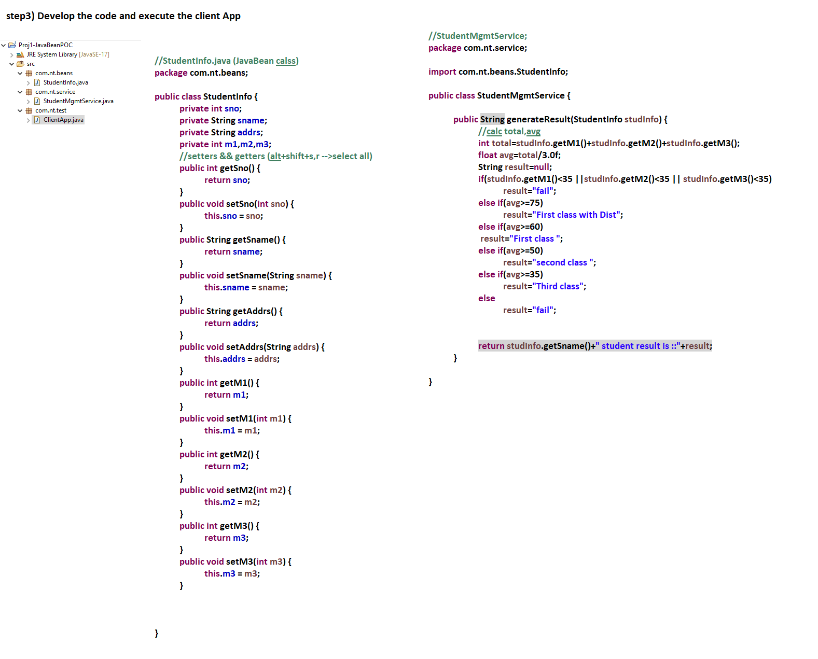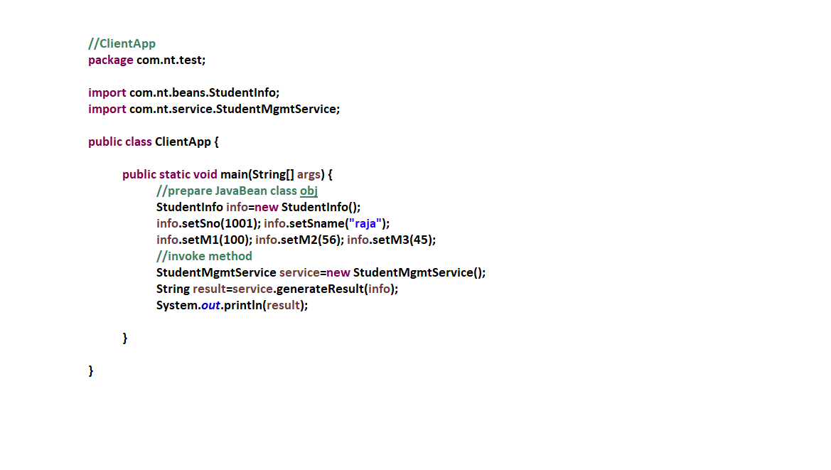

**26/04/2022**

**What are POJO class, POJI , JavaBean class, Bean class/ component class and spring bean?**

* The java class that is developed having state(data) and behavior (logics) and the state(data) will be used inside the behavior is called component/ bean class.
* The member variables of the class represents state because they hold data.
* The methods with logics represent behavior because they hold b.logics.
* Generally bean class or component class is perfectly developed java class having both state and behavior.

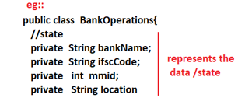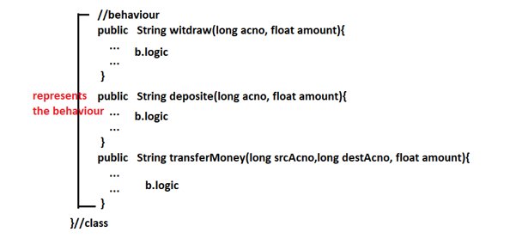

**Note:-** Generally the main classes of the project where b.logics will be placed will be developed as the component classes and the java bean classes will be used as the helper classes to carry data between these main classes.

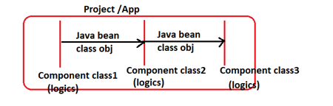

**Container:-**

* Container is a software program that manages the whole life cycle of the given resource(file/class) from birth to death i.e. object creation to object destruction.
* If we give class to a container .. the container only takes care whole life cycle by performing the following operations

1. Loading class
2. Creating object
3. Managing object
4. Calling certain methods as life cycle methods automatically
5. Destroying object(means keeping object ready for garbage collection)

* Container is like an aquarium where resource given to the container is like fish dropped to the aquarium.

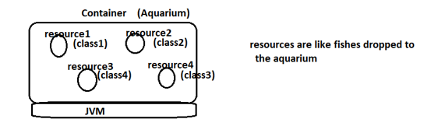

* ServletContainer manages the life cycle of servlet components (java classes).
* JspContainer manages the life cycle of jsp components(file).
* EJBContainer manages the life cycle of EJB components(java classes).
* Spring Container manages the life cycle of spring beans(java classes)

***spring framework gives spring containers as built-in container.

**Spring Bean:-**

* The java class whose object is created and managed by spring container is called spring bean.
* Any java class given by spring api, third party api, jdk api, programmer as user-defined class or by any vendor can be taken as spring bean class.
* Spring bean class can be any class but its object should be created and managed by spring container.
* Spring bean class can be developed pojo class or non-POJO class.
* We cannot take abstract class, interface as the spring bean because they can not be instantiated(object creation is not possible).
* To mark java class as spring bean for spring container to recognize we need to use either <bean> (in xml cfgs) or @Component (in annotation cfgs).
* Giving information about certain resources to container or server of framework or technology is technically called as configurations(cfgs) … For spring container it can done either using xml files or using annotations.

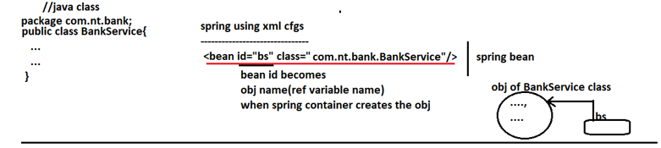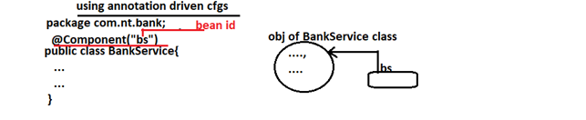

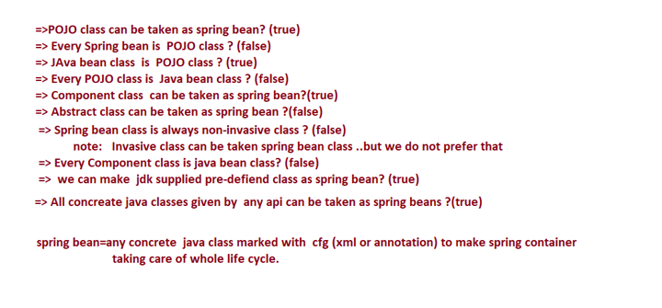

**27/04/2022**

**Spring core Module:-**

* It is base module for all other modules of spring.
* If this module is used alone … then we can develop only standalone Apps.
* This module gives two spring containers as built-in container

1. BeanFactory container (Basic container)
2. ApplicationContext container (advanced container)

* Spring containers are light weight containers because they can be created any where by just istantiating one or another pre-defined classes.

For example by creating object for XmlBeanFactory class we can say spring’s BeanFactory container is ready.



* Servlet container, jsp container are heavy weight because to create and activate them we need to the support the heavy weight WebServer (eg: Tomcat) or Application server s/w (eg : weblogic).
* Spring’s containers (BeanFactory, ApplicationContext) are not alternative for servlet container , jsp containers.
* Spring’s containers are given for spring beans life cycle management and spring dependency management.

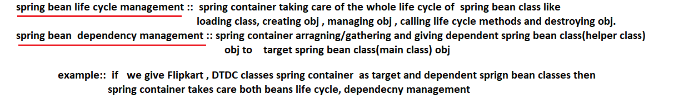

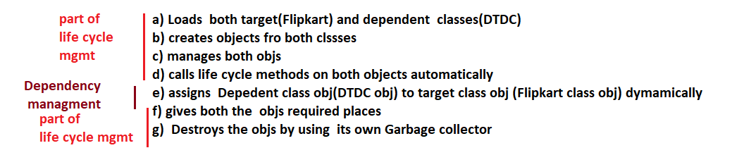

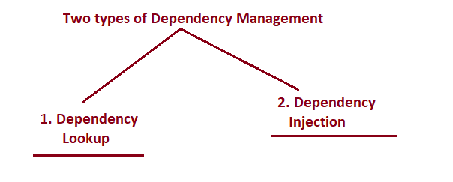

1. **Dependency Lookup :-**

* Here target class writs logic to search and get dependency class obj from different places.
* Target class pulls dependent class obj.

Eg 1: Student (Target) asking for course material (dependent) and get it.

Eg 2 : Java class (Target) getting required dependent class obj from Jndi registry.

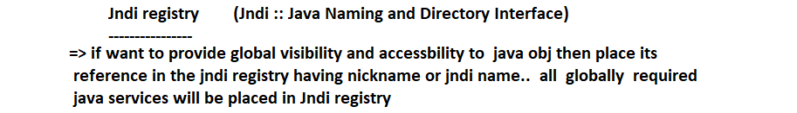

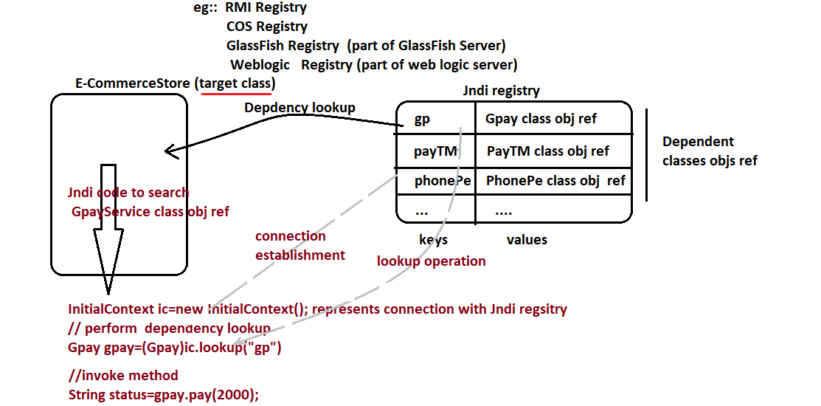



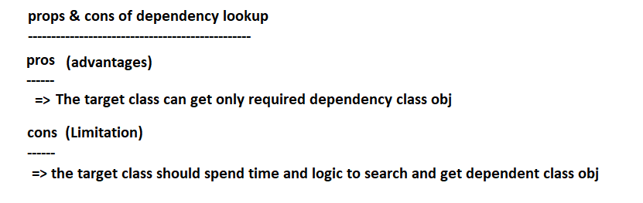

1. **Dependency Injection :-**

**---------------------------------**

* Here the underlying server / container/ framework / JRE/ … dunamically assigns dependent class obj to target class obj.
* Here the underlying server / container / framework / JRE pushes dependent class obj to target class obj.

**Eg 1: Institute assigning course material (dependents ) to student (target) the moment he registers for the course.**

**Eg 2: JVM assigning default values to member variables(dependents) of the class the moment object is created for the class (target class).**

**Eg 3: SerletContainer assigns / injects ServletConfig obj to our servlet class obj the moment ServletContainer create our servlet class obj.**

**Pros and Cons of dependency Injection:-**

**Pros :-**

* The underlying container/ server/ framework/ JRE/… takes care of every process of assigning dependent class to target class obj … No need of searching and getting dependents.

**Cons:-**

* The underlying container / server framework / JRE/ … may inject both necessary and unnecessary and objects.
* Spring supports both Dependency Lookup and Injection…

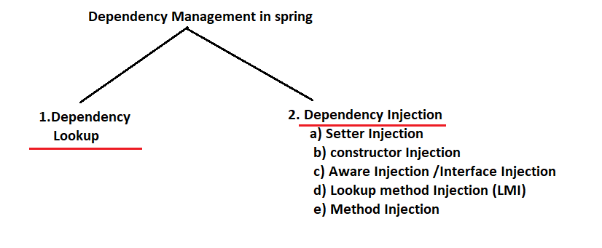

**---------------**

**28/04/2022**

**----------------**

**To Create BeanFactory container … create obj for a java class that implements**

**Org.springframework.beans.factory.BeanFactory(I)**

**All Known Implementing Classes:**

[AbstractApplicationContext](https://docs.spring.io/spring-framework/docs/current/javadoc-api/org/springframework/context/support/AbstractApplicationContext.html), [AbstractAutowireCapableBeanFactory](https://docs.spring.io/spring-framework/docs/current/javadoc-api/org/springframework/beans/factory/support/AbstractAutowireCapableBeanFactory.html), [AbstractBeanFactory](https://docs.spring.io/spring-framework/docs/current/javadoc-api/org/springframework/beans/factory/support/AbstractBeanFactory.html), [AbstractRefreshableApplicationContext](https://docs.spring.io/spring-framework/docs/current/javadoc-api/org/springframework/context/support/AbstractRefreshableApplicationContext.html), [AbstractRefreshableConfigApplicationContext](https://docs.spring.io/spring-framework/docs/current/javadoc-api/org/springframework/context/support/AbstractRefreshableConfigApplicationContext.html), [AbstractRefreshableWebApplicationContext](https://docs.spring.io/spring-framework/docs/current/javadoc-api/org/springframework/web/context/support/AbstractRefreshableWebApplicationContext.html), [AbstractXmlApplicationContext](https://docs.spring.io/spring-framework/docs/current/javadoc-api/org/springframework/context/support/AbstractXmlApplicationContext.html), [AnnotationConfigApplicationContext](https://docs.spring.io/spring-framework/docs/current/javadoc-api/org/springframework/context/annotation/AnnotationConfigApplicationContext.html), [AnnotationConfigWebApplicationContext](https://docs.spring.io/spring-framework/docs/current/javadoc-api/org/springframework/web/context/support/AnnotationConfigWebApplicationContext.html), [ClassPathXmlApplicationContext](https://docs.spring.io/spring-framework/docs/current/javadoc-api/org/springframework/context/support/ClassPathXmlApplicationContext.html), [DefaultListableBeanFactory](https://docs.spring.io/spring-framework/docs/current/javadoc-api/org/springframework/beans/factory/support/DefaultListableBeanFactory.html), [FileSystemXmlApplicationContext](https://docs.spring.io/spring-framework/docs/current/javadoc-api/org/springframework/context/support/FileSystemXmlApplicationContext.html), [GenericApplicationContext](https://docs.spring.io/spring-framework/docs/current/javadoc-api/org/springframework/context/support/GenericApplicationContext.html), [GenericGroovyApplicationContext](https://docs.spring.io/spring-framework/docs/current/javadoc-api/org/springframework/context/support/GenericGroovyApplicationContext.html), [GenericWebApplicationContext](https://docs.spring.io/spring-framework/docs/current/javadoc-api/org/springframework/web/context/support/GenericWebApplicationContext.html), [GenericXmlApplicationContext](https://docs.spring.io/spring-framework/docs/current/javadoc-api/org/springframework/context/support/GenericXmlApplicationContext.html), [GroovyWebApplicationContext](https://docs.spring.io/spring-framework/docs/current/javadoc-api/org/springframework/web/context/support/GroovyWebApplicationContext.html), [ResourceAdapterApplicationContext](https://docs.spring.io/spring-framework/docs/current/javadoc-api/org/springframework/jca/context/ResourceAdapterApplicationContext.html), [SimpleJndiBeanFactory](https://docs.spring.io/spring-framework/docs/current/javadoc-api/org/springframework/jndi/support/SimpleJndiBeanFactory.html), [StaticApplicationContext](https://docs.spring.io/spring-framework/docs/current/javadoc-api/org/springframework/context/support/StaticApplicationContext.html), [StaticListableBeanFactory](https://docs.spring.io/spring-framework/docs/current/javadoc-api/org/springframework/beans/factory/support/StaticListableBeanFactory.html), [StaticWebApplicationContext](https://docs.spring.io/spring-framework/docs/current/javadoc-api/org/springframework/web/context/support/StaticWebApplicationContext.html), [XmlBeanFactory](https://docs.spring.io/spring-framework/docs/current/javadoc-api/org/springframework/beans/factory/xml/XmlBeanFactory.html), [XmlWebApplicationContext](https://docs.spring.io/spring-framework/docs/current/javadoc-api/org/springframework/web/context/support/XmlWebApplicationContext.html)

* We generally use either XmlBeanFactory or DefaultListableBeanFactory classes as the impl classes of BeanFactory(I) to create BeanFactory Container.

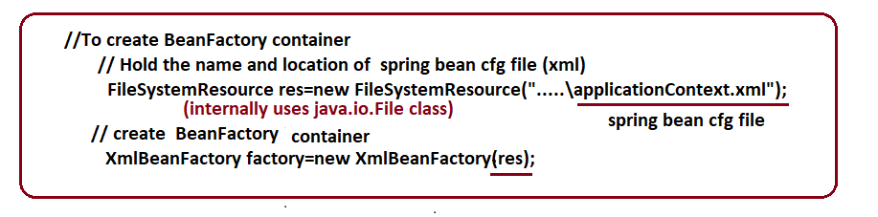

**Spring bean cfg file (xml file) :-**

**-------------------------------------------**

* Any <filename>.xml can be takes as spring bean file … but the recomanded / industry standard name is applicationContext.xml file.
* This file contains
  + Java classes cfg as spring beans
  + Dependency management cfgs
  + Spring bean life cycle cfgs and etc..
* This file gives instructions / inputs Spring container towards making java classes as spring beans and managing their life cycle and dependency.
* Spring container performs all its activities based on instructions collected from spring cfg file.

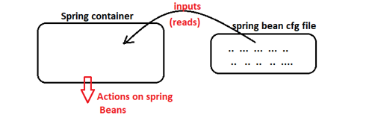

* We can give instructions to spring container in 4 ways or we can develop spring app in 4 approaches.

1. **Using xml driven cfgs** (instructions to spring container will be given using xml file).
2. **Using xml + annotation driven cfgs (**instructions to spring container will be given using xml + annotations**) (*)**
3. **Using 100% code cfgs / Using Java Configuration Approach (**instructions to spring container will be given using annotations + Java code**)**
4. **Using Spring boot approach (**Spring boot = spring ++**)**

Here also instruction spring container will be given using annotations + java code but we also add other features of spring boot.

**Dependency injection as Setter injection using xml driven cfgs approach:-**

**Setter injection:-**

**=>**If the underlying the spring container is using setter method of target class to assign dependent class object to target class object the it is called setter injection i.e. the spring container calls setter method on target class object having Dependent class object as the arg value to assign/ inject dependent class object to target class object.

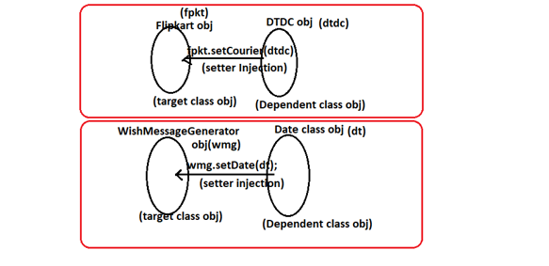

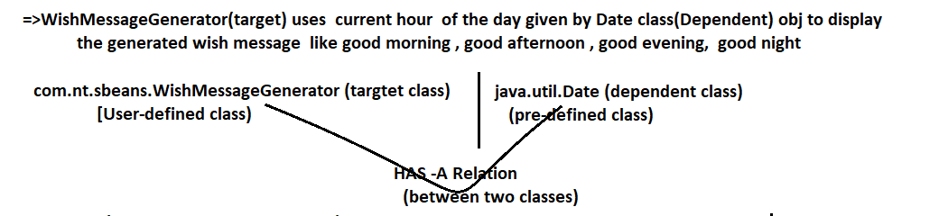

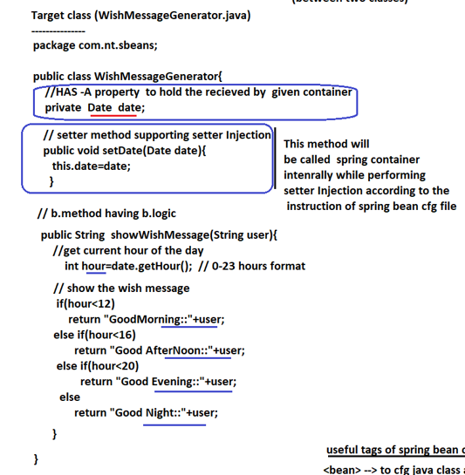

**---------------**

**29/04/2022**

**---------------**

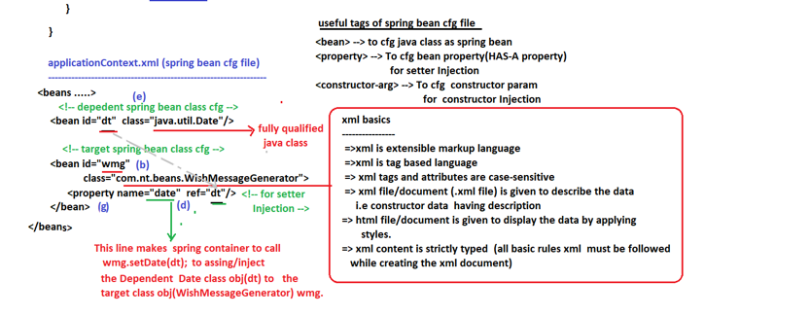

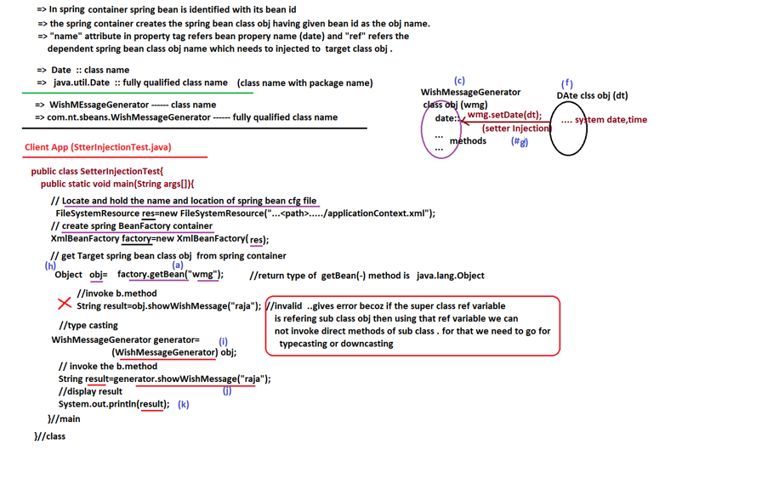

**----------------**

**30/04/2022**

**---------------**

**Maven:-**

**------------**

* It is a build tool simplifying project building process.
* Keeping the project ready for execution is called building the project.
* Different build tools are ant , maven(1) , gradle(2) and etc …
* These build tools can be used with IDE or with out IDE but recomanded to use with IDE.

**Maven features:-**

**----------------------**

* If we add one dependency (jar file) it will help us to download that dependency(jar file) and its dependent jar files directory from internet.

Eg :- spring we add spring-core-<var>.jar file then it will download that jar file and that related dependent jar files to our project directly from the internet.

**Note:-** If the classes of jar1 file are using classes of jar2 file then we can say jar1 file is main jar file and jar2 file is dependent jar file.

* Maven given readymade project templates as maven archetypes that required to create different Projects.

Popular archetype are :: maven-archetype-quickstart 🡪 for standalone Apps

Maven-archetype-webapp 🡪 for web Apps

* Provides the mechanism to park the project/app into war file or jar file or ear file
  + - Jar file for standalone app
    - War file for web application
    - Ear file for enterprise application (jar file + war file)
* Provides the built-in de-compilers to get source code dynamically
  + - .java ----🡪compiler -----🡪.class (Compiler)
    - .class ---🡪 de-compiler --🡪.java (de-compiler)

* Provides built-in setup to perform unit testing of the App and also to generate test report

**Note:-** Programmer’s testing on his own piece of code is called unit testing

**And etc…**

**Note:-** The recent version of Eclipse JEE IDE (from 2018 onwards) is giving built-in support.

In Maven , the jar file (dependency), the plugin (for additional works) and the Project is identified with 3 details.

1. **Artifact id (jar file name/ plugin name / project name)**
2. **Group id (company name)**
3. **Version (jar fiel version/ plugin version/ project version)**

**Procedure to develop first Spring App using eclipse and maven performing setter Injection**

**Required software setup is**

* **Eclipse 2018 + (prefer latest)**

**Step 1)** Launch Eclipse IDE by choosing workspace folder

(D:\Adv_Java\Spring_NT_FS)

**Setup 2)** Create Maven Project using the archetype maven-archetype-quickstart

And giving the following details

1. **Group Id :: nit**
2. **Artifact Id :: SpringCoreProj01-SetterInjection**
3. **Version :: …….(default value)**
4. **Package name :: com.nt.test**

**File menu -🡪 new --🡪 maven Project --🡪 search and select the following archetype---🡪**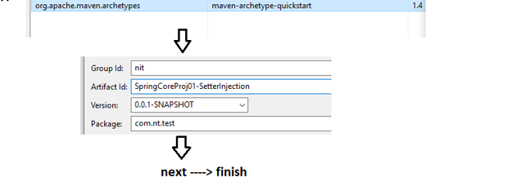

**Step 3) Understand the project directory structure:-**

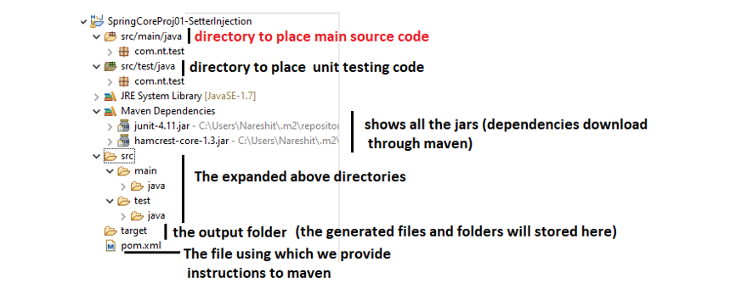

**Step 4) change java version of the project to any latest version (17) using pom.xml**

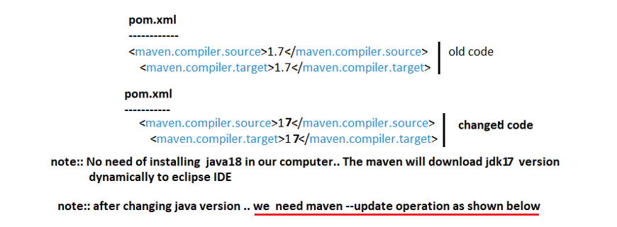

**Step 5) Add the following <dependency> tag in pom.xml file**

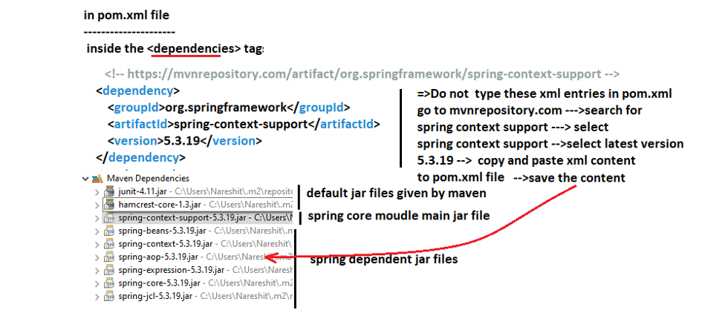

**Step 6) Create the following packages in erc/main/java folder**

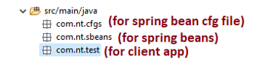

**Step 7) Develop the source code of the application..**

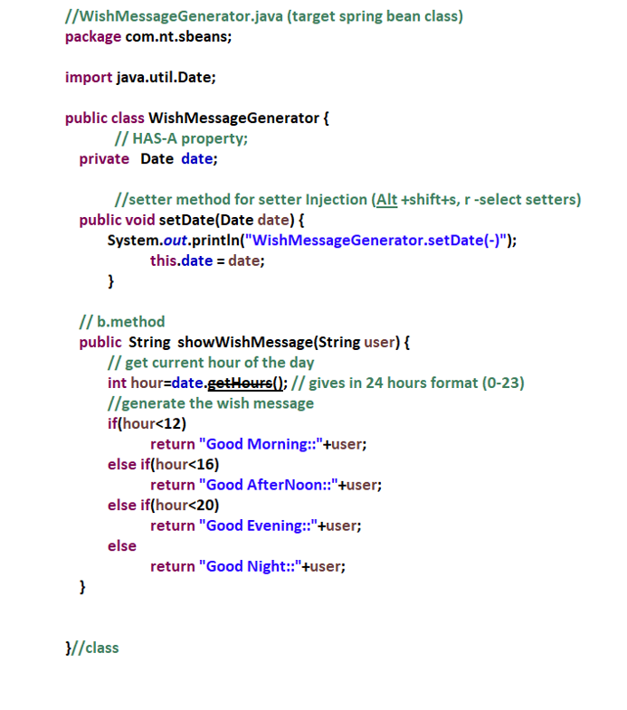

* To use java class of package , we must import the java pkg by specifying the package name .
* Xml schema namespace is library that contains set of xml tags … Every namespace is identified with its namespace url/uri … In order to use xml tags of certain namespace in our xml document we need to import the namespace by specifying its namespace url/ uri and xsd file name.

xsd --🡪 xml schema definitation.

* To make all the spring developers to use common set of xml tags different modules of spring while developing in spring bean cfg file the spring vendors have multiple xml schema namespaces…

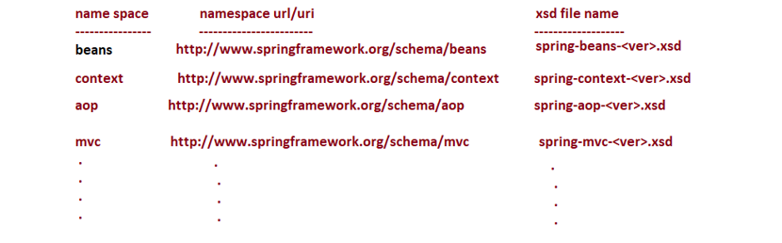

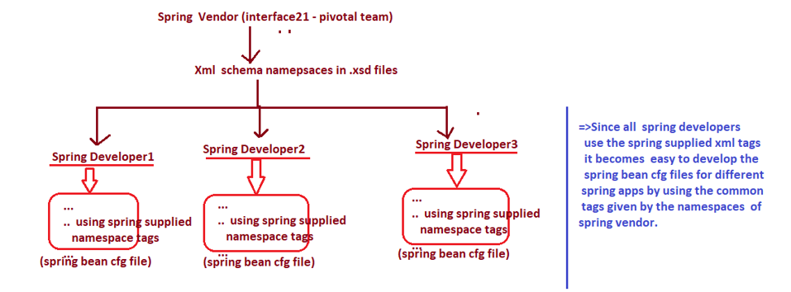

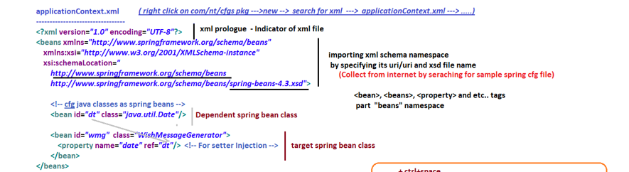

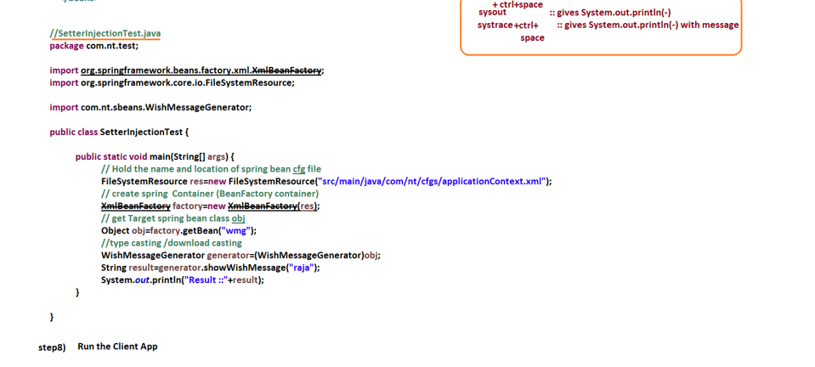

----------------

**04/05/2022**

**-----------------**

Constructor Injection :-

* If the spring container is using parameterized constructor to create target spring class object and also to assign/inject dependent spring bean class object to target spring bean class object is called constructor Injection.
* To specify dependent value / object for each parameter of constructor of constructor we need to use <constructor-arg> tag under <bean> tag.
* If we place <constructor-arg> tag for 3 times under<bean> then the spring container looks for 3 param constructor to create target spring bean class object and for constructor injection.

**Example App:-**

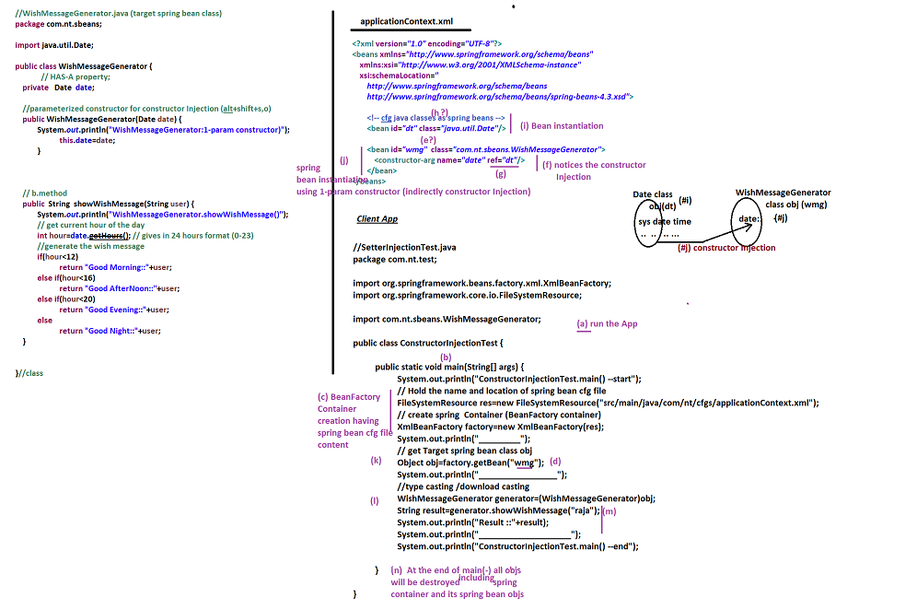

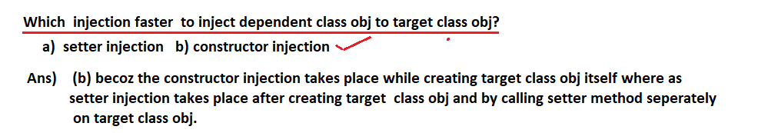

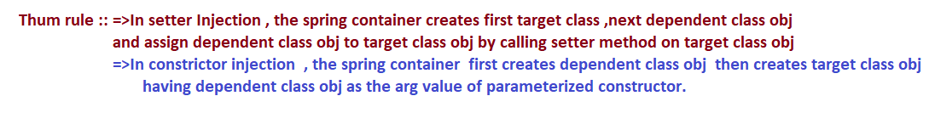

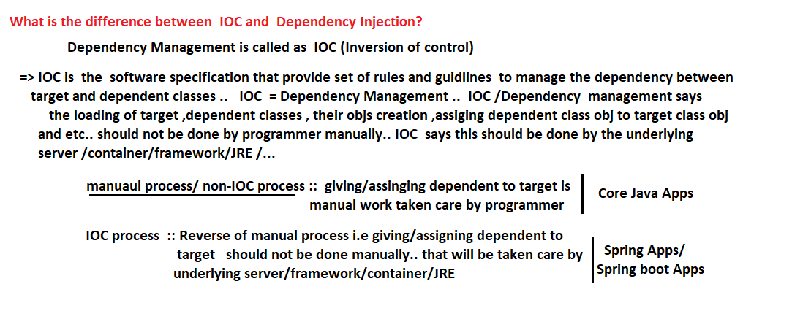

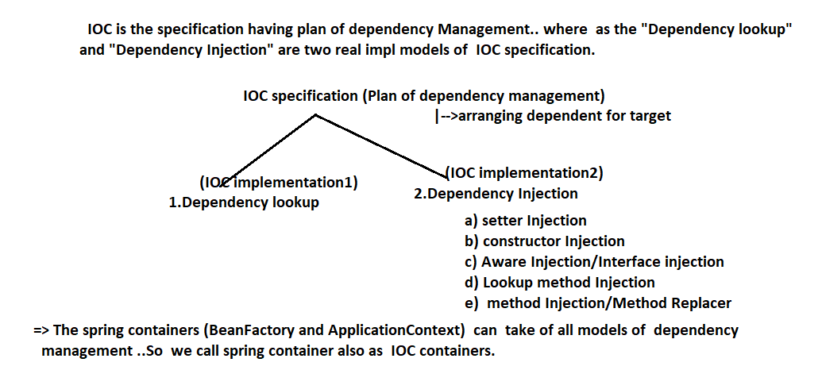



**---------------**

**05/05/2022**

**---------------**

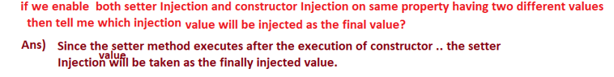

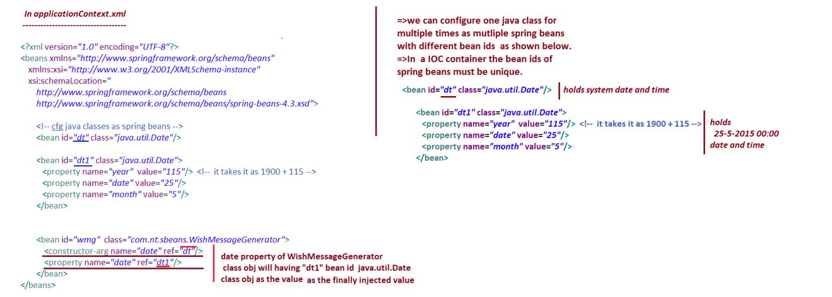

**==========**

**06/05/2022**

**==========**

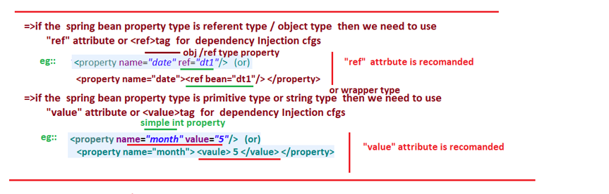

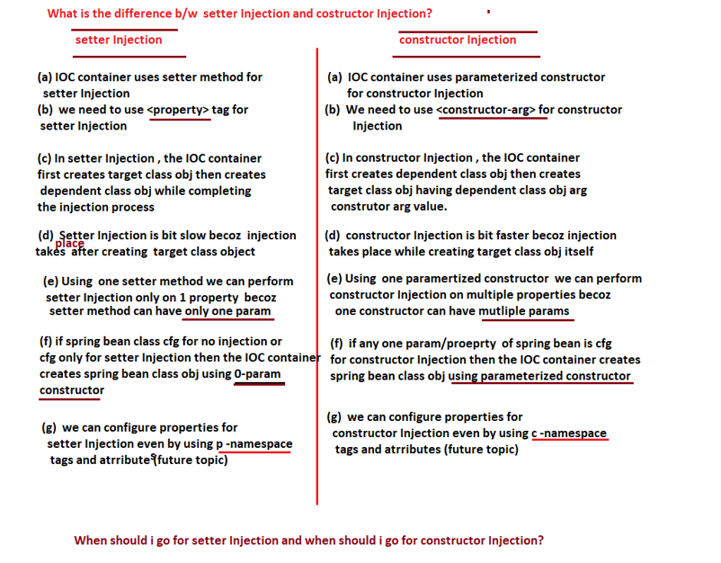

**=========**

**07/05/2022**

**=========**

**When should I go for setter injection and when should I go for constructor injection ?**

**Case 1:-** If all the properties of spring bean class are mandatory to participate in the injection then go constructor injection by taking one parameterized constructor covering all spring bean properties.

**Eg:-** If spring bean class having 10 properties and all those 10 properties must participate in the injection then take one 10-param constructor and go for constructor injection.

**Case 2::** If all the properties of spring bean class are optional to participate in the injection then go for setter injection by taking setter method properties on 1 per property basis.

**Eg:-** If spring bean class is having 10 properties and these properties are optional participate in the injection then take 10 setter methods and go for setter injection.

**Case 3:-** If few properties of spring bean class are mandatory to participate in injection and other few properties optional to participate in the injection then take both setter injection and constructor injection togather .. go for setter injection covering optional properties to participates in the injection and go constructor injection covering mandatory properties to participate in the injection.

**Eg :-** If spring bean class is having 10 properties … in that 5 properties are optional to participate in the injection and another 5 properties are mandatory participate in the injection then for setter injection by taking 5 setter methods for optional properties of injection … similarly go for constructor injection by taking single 5-param constructor for other 5 properties to participate in the injection.

While creating the IOC container by using XmlBeanFactory class , we need to locate spring bean cfg file either using FileSystemResource class object using ClassPathResource class object.

**What is the difference b/w FileSystemResource and ClassPathResource towards locating and holding the spring cfg file ?**

**1)**

**Ans) FileSystemResource :-**

* **Note ::** All files and folders of a computer belongs to different drivers together is called file system of a computer.
* FileSystemResource makes the IOC container to locate the given spring bean cfg file from the specified path of file system and we can give either relative path or absolute path of spring bean cfg file.

**Eg_1:-** 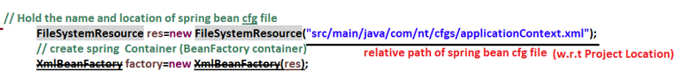

**Eg_2:-  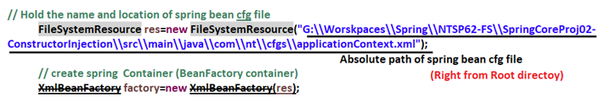2) ClassPathResource :-**

* This Resource object makes the IOC container to locate the given spring bean cfg file from the jar files and directories added to the CLASSPATH/BUILD Path.
* In maven Project the folders “src/main/java” and “src/test/java” are there in CLASSPATH by default.

**Eg 1:-**

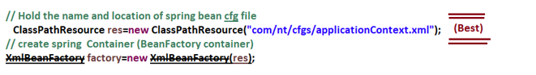

**Eg 2:-**

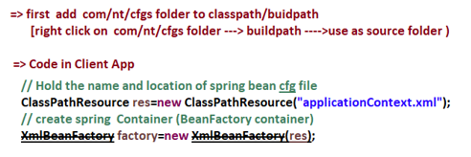

**09/05/2022**

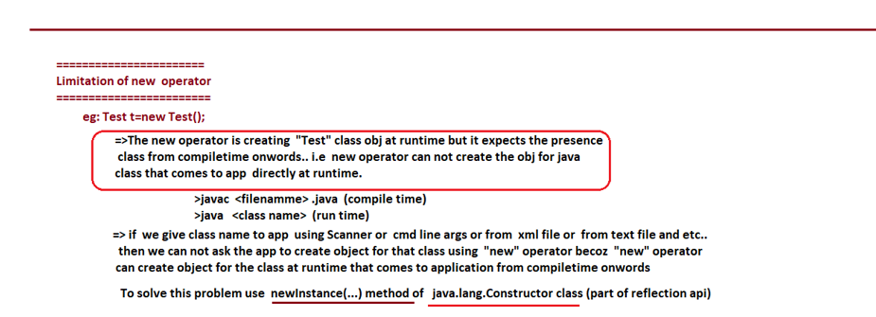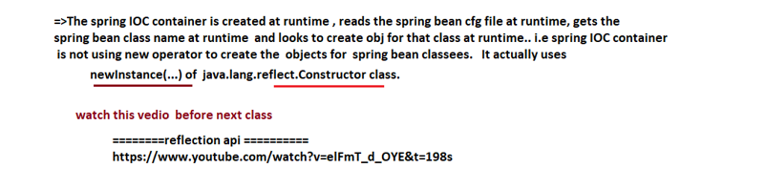

**10/05/2022**

**Solution for this problem is working newInstance() method:-**

**------------------------------------------------------------------------------**

1. newInstance() mwthod of java.lang.Class (deprecated from java9)
2. newInstance(…) method of java.lang.reflect.Constructor (recomanded)
3. **newInstance() mentodof java.lang.Class (deprecated from java9)**

* Deprecated from java9 i.e. this method may be removed in future from jdk apis.
* This method can create obj only by using 0-param constructor i.e. this method can not be used to create the objs for java class using parameterized constructors.
* Better not to use this method … use the alternative method that is newInstance(…) method of java.lang.reflect.Constructor class.

**newInstance(…) :-** var args i.e. we can call this method having variable no. of arguments like 0 args, 1 args, 2 args, 3 args,…

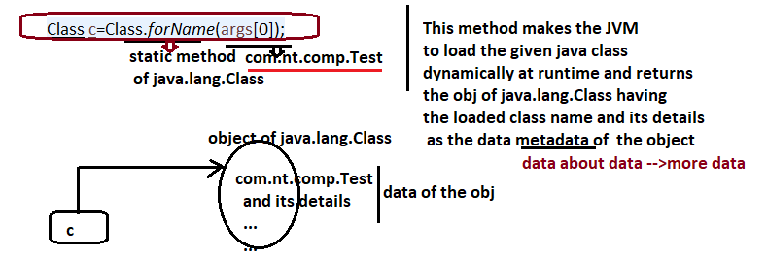

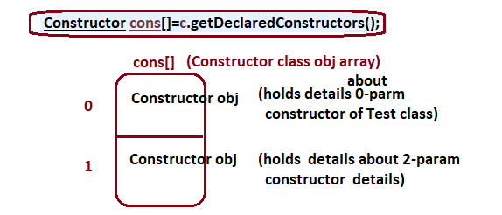

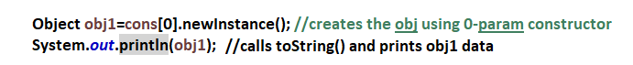

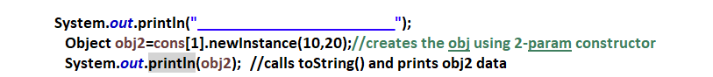

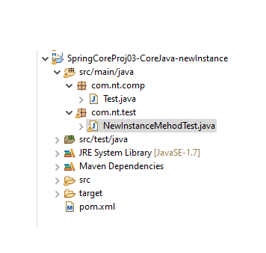

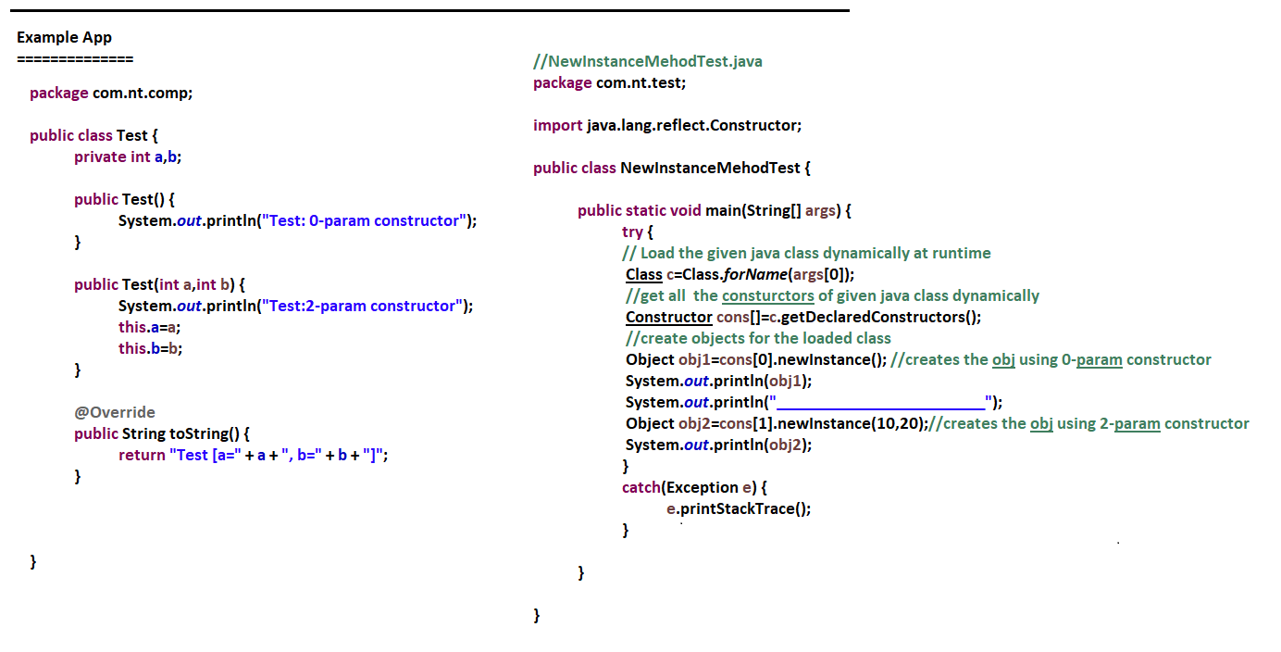

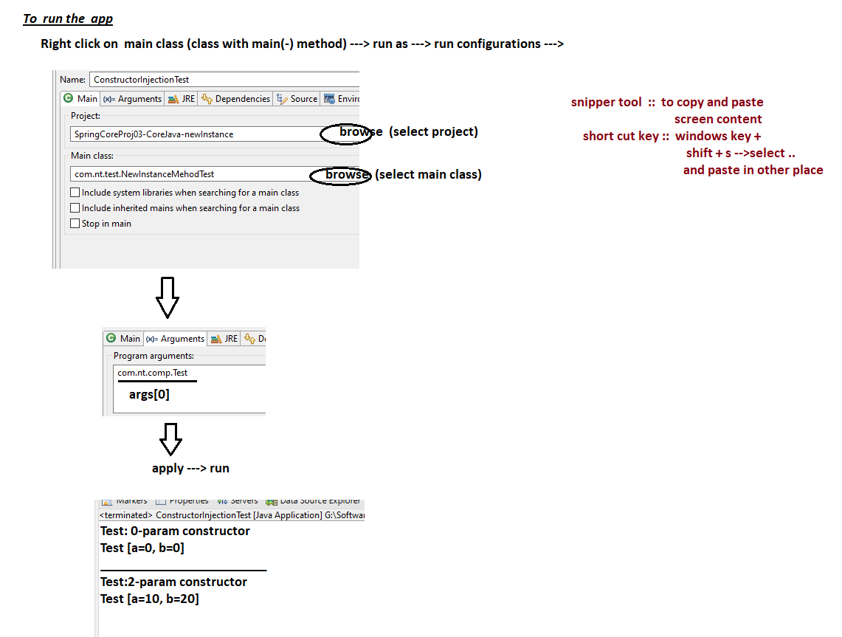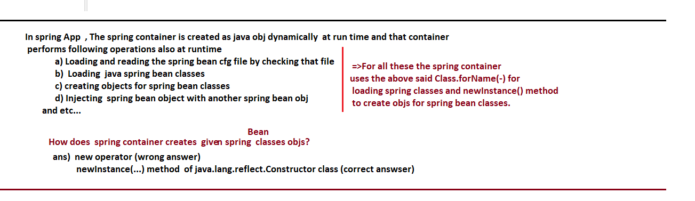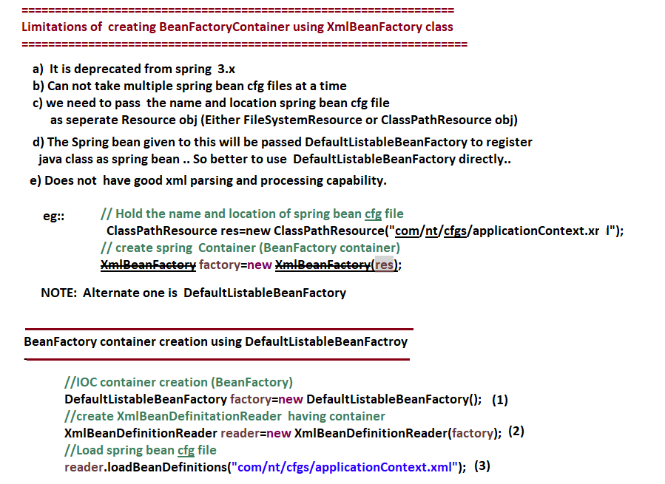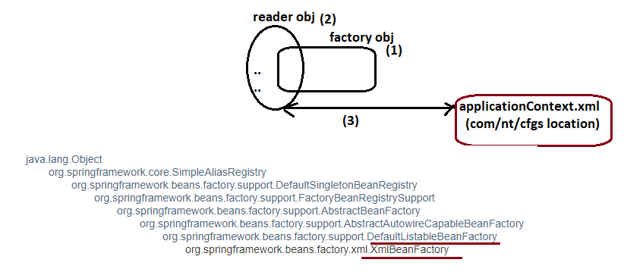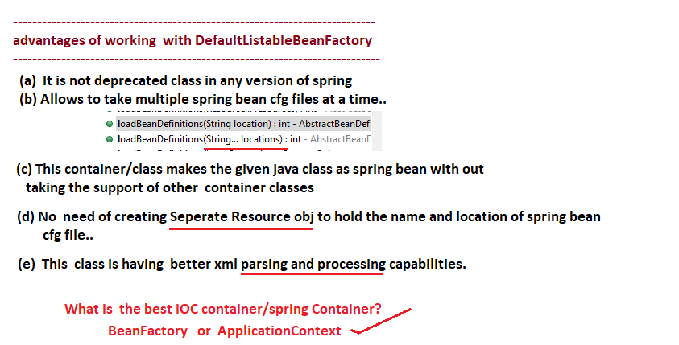

**11/05/2022**

**======================**

**“class” property in Java App:**

**=======================**

* Built-in threads in Java App are :: GC thread, main thread.
* Built-in member variables/ properties in Java App are :: “class”,”length”.
* Built-in reference variables in Java app are :: “this”,”super”.

=>To get the length / size of the array we use “length” property.

int a[] = new int[]{10,20,30};

int size = a.length; // gives the size of the array.

=>To get object of java.lang.Class representing any given java class we can use “class” property.

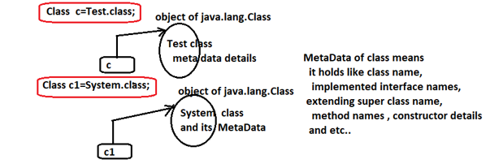

**=>”class”** is the public static variable of every java class that returns object of java.lang.Class holding current class name and its details (MetaData).

=>System.class does not mean .class file name of System class .. It is “class” property (static property) invoked on the System class that returns the object of java.lang.Class holding the class name and its details.

**In Java Programming**

**======================**

* “class” is keyword eg: class <ClassName>{…}
* “class” built-in property name eg: Class c = System.class;
* Java.lang.Class is pre-defined class eg: Class.forName(“java.util.Date”); (Class ==> java.lang.Class )
* class is oops terminology/ principle
  + (eg :: class, object, encapsulation, inheritance and etc … are oops principles)
* **“class”** is file extension representing byte code of each java class

**Test.java -🡪 compile -🡪 Test.class**

**Demo.java -🡪 compile 🡪 Demo.class**

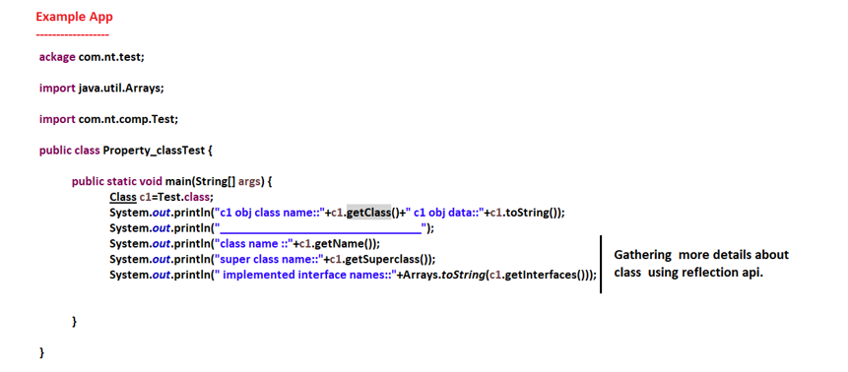

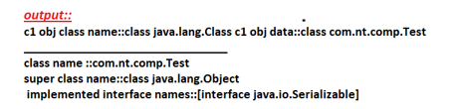

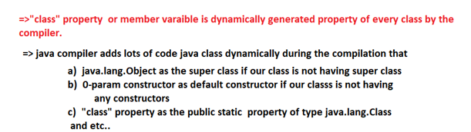

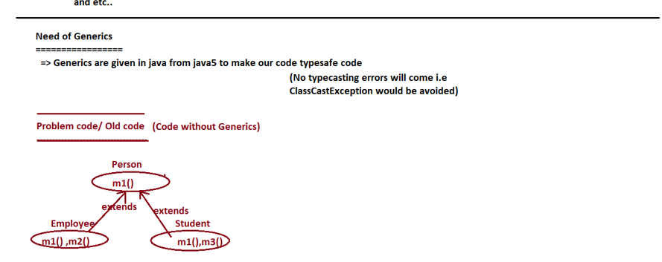

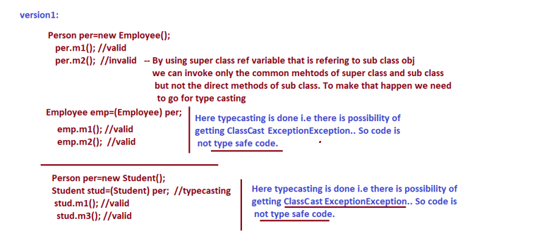

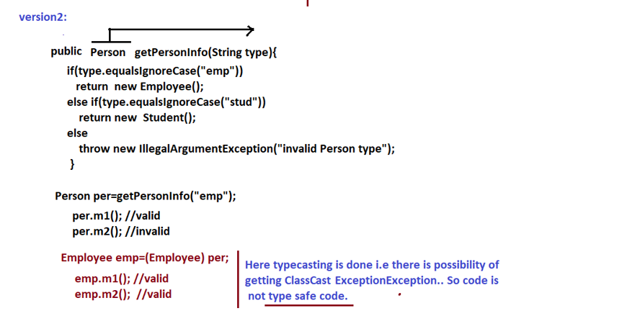

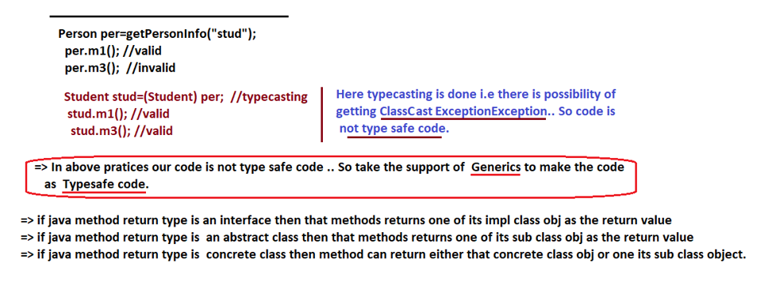

**12/05/2022**

**====================**

**Solution using Generics**

**====================**

**<T> --🡪 type declaration**

**T ----🡪 using the <T> as the return type.**

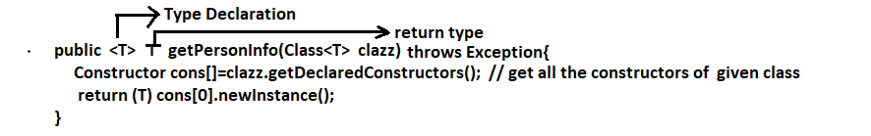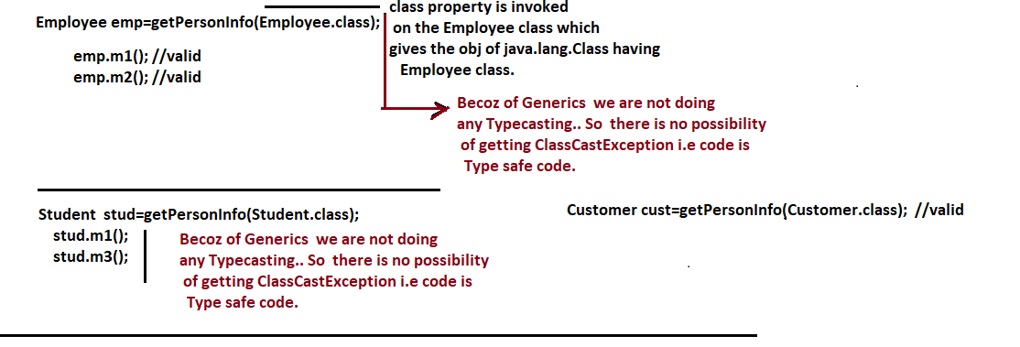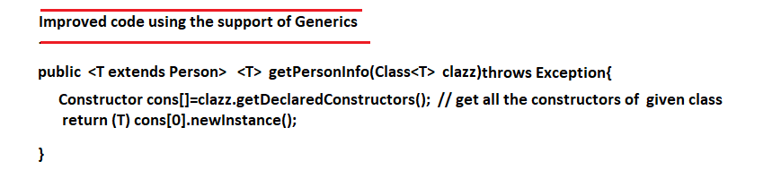

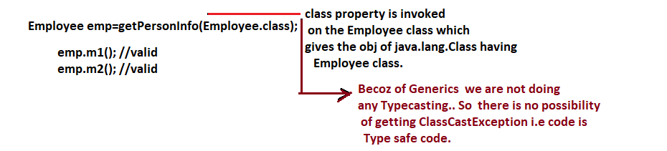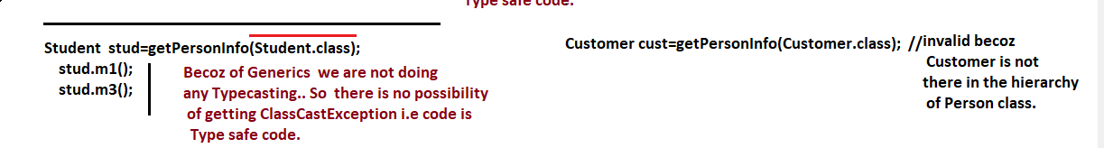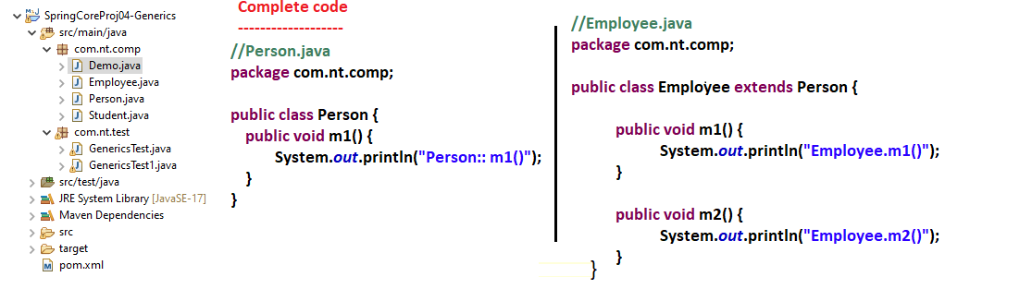

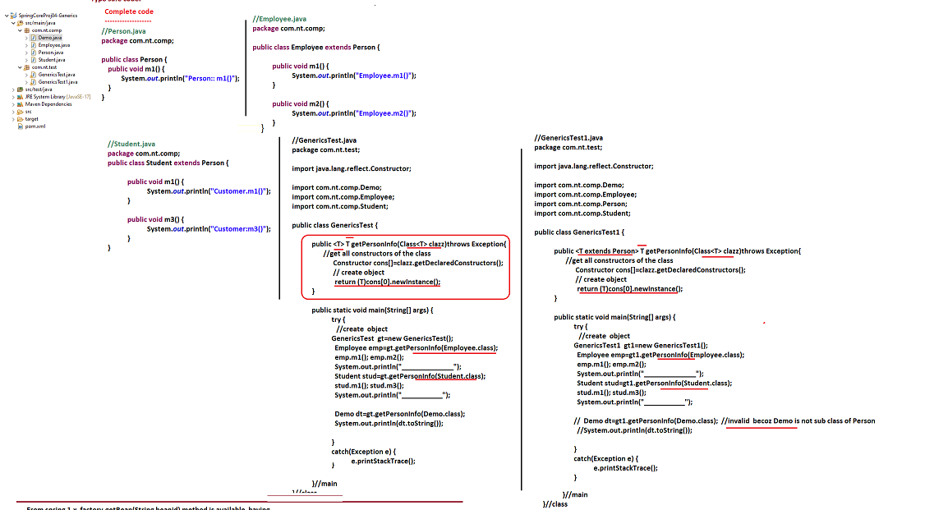

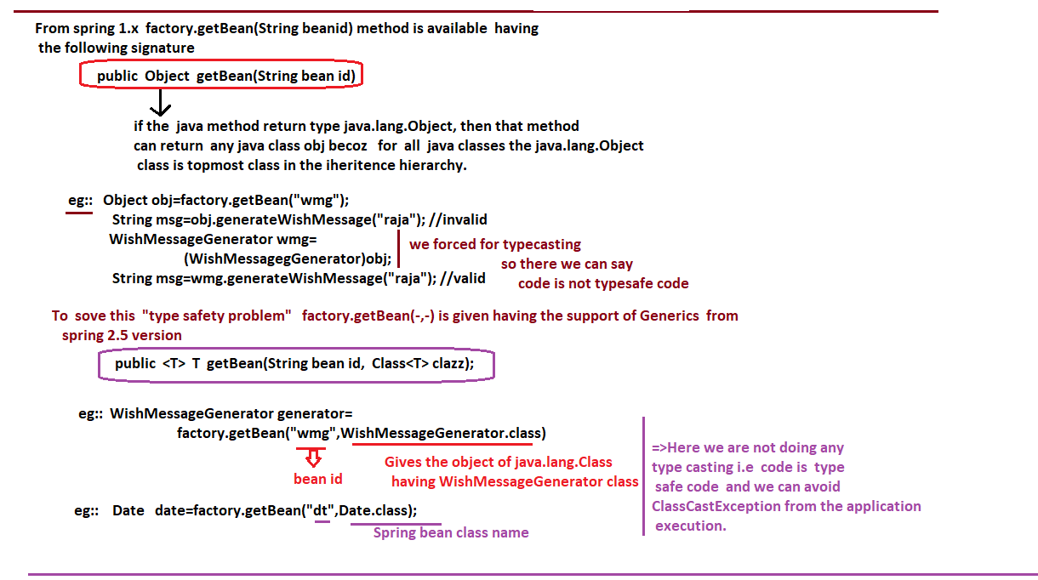

**Follow the given recomandations while developing spring Apps as improvisions**

1. **Use DefaultListableBeanFactory class to create BeanFactory container**
2. **Use factory.getBean(-,-) that takes bean id , class name as java.lang.Class obj as the argument values as shown below.**

**=================**

**Improved Client app**

**=================**

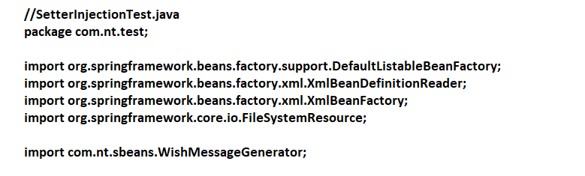

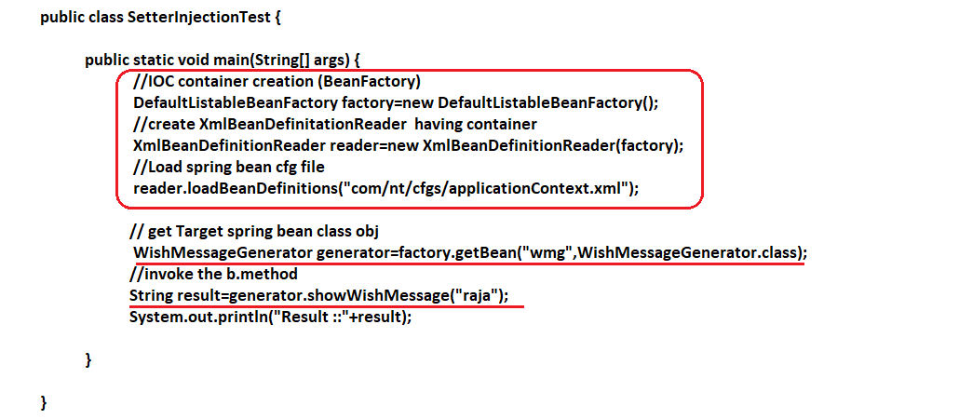

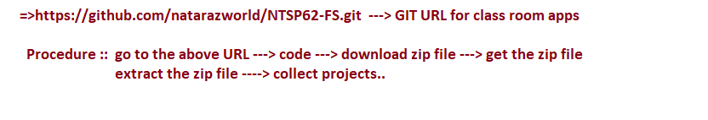

**13/05/2022**

**------------**

**Plugin:-**

**------------**

* Plugin is patch software that provides additional functionalities to the existing software or software app.

Eg1:: Amazon fire stick added to normal TV to make it as smart TV

Eg2:: Extensions added to the Browser to get more facilities in the browser

Eg3:: Plugins added to Eclipse IDE to get more features in Eclipses.

* STS(Spring Tool Suite) is spring supplied IDE for spring and spring boot programming .. To bring same facilities to Eclipse IDE we need to add STS plugin to Eclipse IDE.
* Eclipse JEE IDE + STS Plugin is more suitable and recommended one for industry projects.

**---------------------------------------------------------**

**Procedure to add STS plugin to Eclipse IDE**

**---------------------------------------------------------**

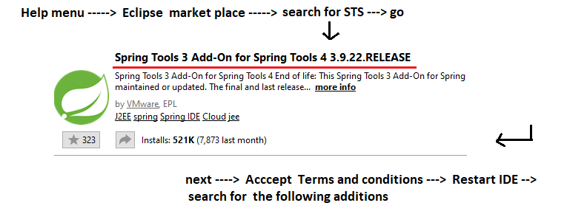

**-----------------------------------------------------------------------**

**Procedure to remove installed plugin from Eclipse IDE**

**------------------------------------------------------------------------**

**Help menu -------------🡪 Eclipse market place -----------------🡪 installed tab ------------------🡪 select the plugin -----------🡪 uninstall.**

**---------------------------------------------------------------**

**Benefits of STS plugin in spring programming**

**---------------------------------------------------------------**

* We can select xsd name space while creating spring bean cfg file
* We can add xsd namespaces dynamically to spring bean cfg file.
* In spring bean cfg file we get lots auto suggestions while writing the entries.
* Simplifies the spring programming.
* Simplifies the spring boot programming

and etc……………….

-------------------------------------------------

**Facilities in STS plugin to Eclipse IDE**

**--------------------------------------------------**

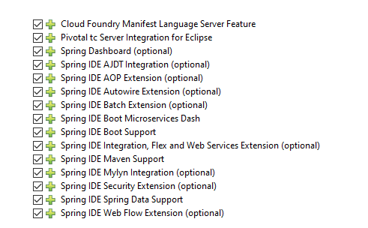

**--------------------**

**Design Patterns**

**---------------------**

* These are best practices having set of rules to solve the reoccurring problems of application development.
* Design Pattern are best practices to develop the software apps effectively.
* If we develop our software apps by using programming languages or technologies or frameworks then there is possibility of getting some side effects in terms of memory , coupling , performance and etc… To resolve these problems the best solutions that are given are called Design Patterns.
* The best solution for reoccurring problem is called Design Pattern … where as the worst solution for reoccurring problem is called anti- patterns.
* Senior developers Documented problems and solutions (both design pattern and anti patterns) … So that next generation developers can realy utilize these design patterns to develop apps more effectively.
* Every Design pattern is 3 part rule which says Design pattern is a **1) solution fro a 2) problem in a** **3) context (situation)**
* In java , JEE Programming two types of design Pattern are popular

1. **GOF Patterns (GOF :: Gang of Four)**

**------------------------------------------------------------**

* These patterns are given to address all problems related to Object oriented programming towards standalone app development.

**(Erich Gamma, Richard Helm, Ralph Johnson, and John Vlissides are GOF team)**

* These patterns can be implemented in any OOP language.
* Eg:: singleton class , factory pattern, builder pattern, AbstractFactory pattern and etc… (23 pattern are there)

1. **JEE Patterns**

**------------------------**

* These patterns are by sun Ms to address the problems to related Layered application development that takes place by using Java, JEE Technologies like JDBC, JNDI, Servlet, Jsp and etc…
* These patterns must be implemented only in Java, JEE env … not in another language.

Eg:: DAO, FrontController, Application Controller, Composite View, Intercepting filter and etc…(20+ patterns).

**==========**

**14/05/2022**

**==========**

**Factory Pattern ::** Different object will be created in different ways … some objects will be created using 0-param constructor , some other will be created using parameterized constructors, some objects will be created using factory methods … if programmer getting classes from other programmers or pre-defined / third party apis then knowing the process of creating object and using that process while creating objects is very tedious job.

**Solution:** Use Factory Pattern that says I provide abstraction on object creation process i.e. if u ask for object of certain class it creates and returns object by hiding / abstracting object creation process from the developers.

* Factory Pattern gives one of the several related classes obj based on the data we supply … T make the classes as the related classes we need to take those either having common super class or having common implementing interface.

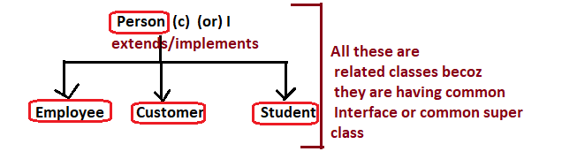

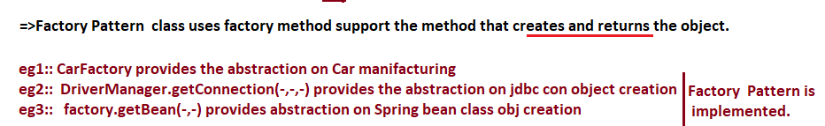

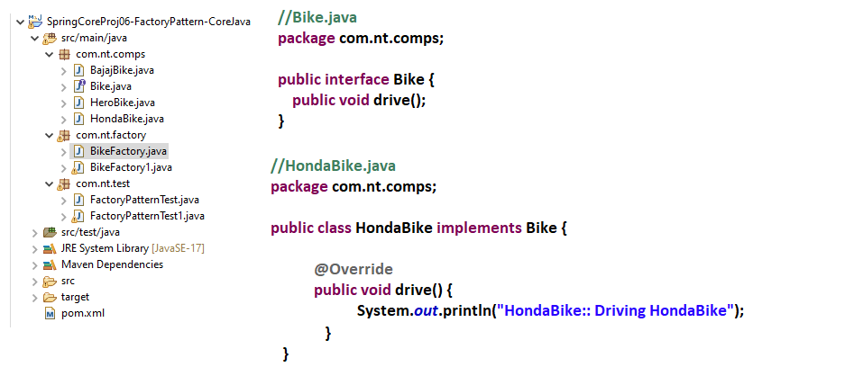

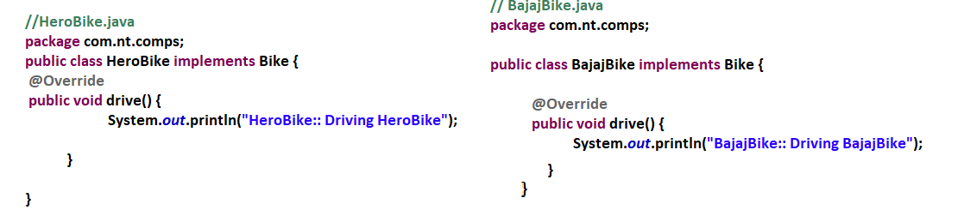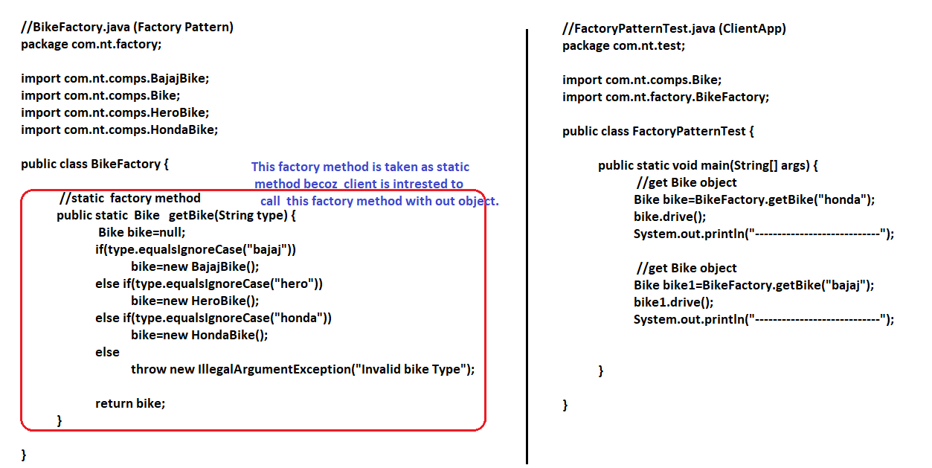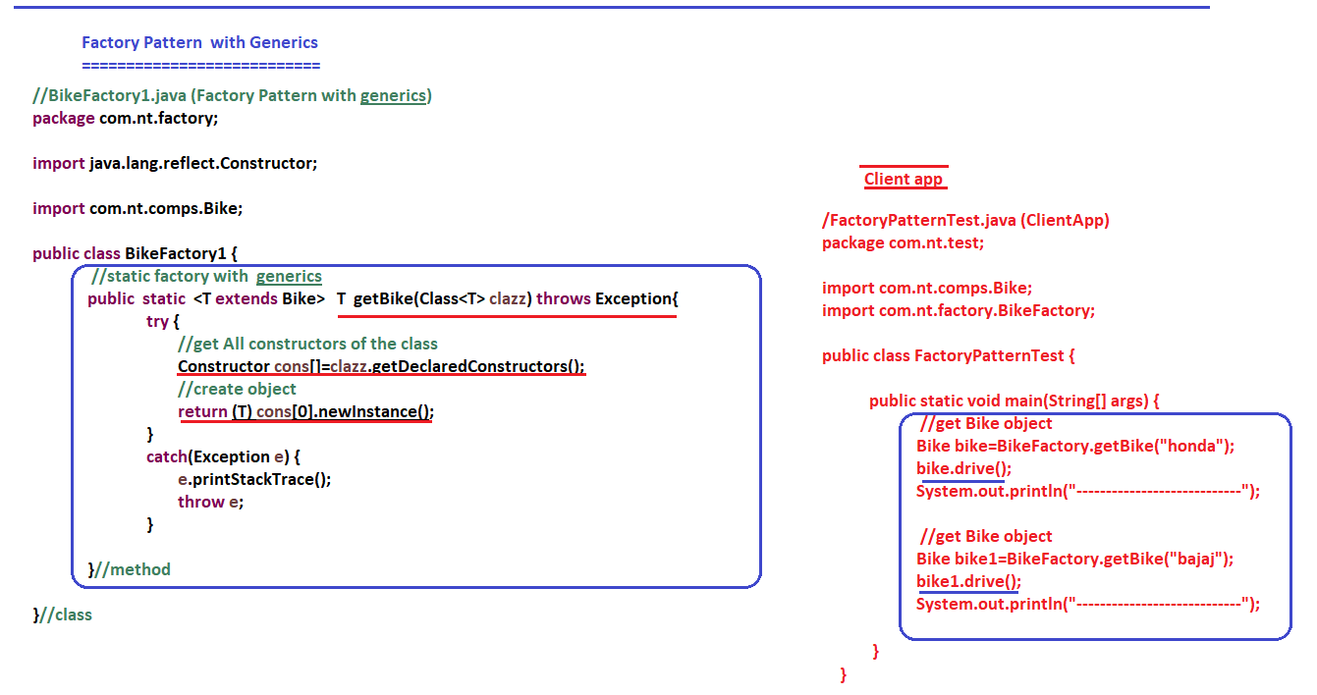

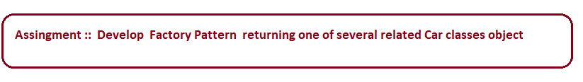

**16/05/2022**

**=============**

**Strategy Pattern**

**==============**

* It is GOF Pattern … and can be implemented in any OOP Language.
* This pattern has become popular in spring … but it is not spring specific pattern.
* It is mostly used in spring , spring boot Apps development.
* This pattern says, Develop the comps of dependency management (target and dependent classes) as loosely coupled interchangeable parts.
* To implement this pattern we need to follow 3 principles/ rules.

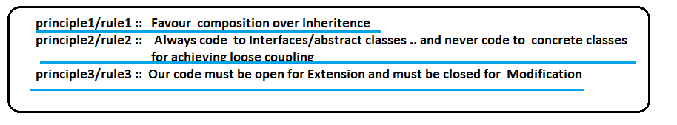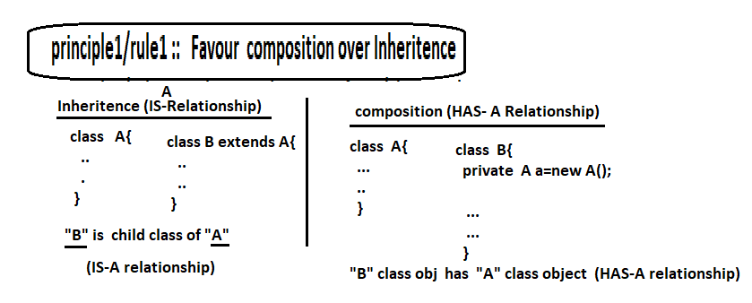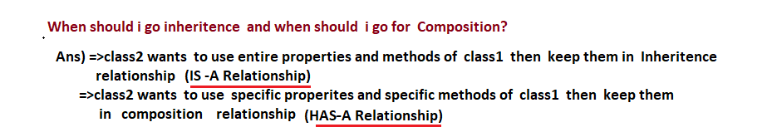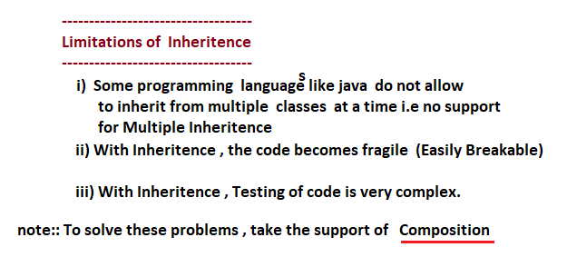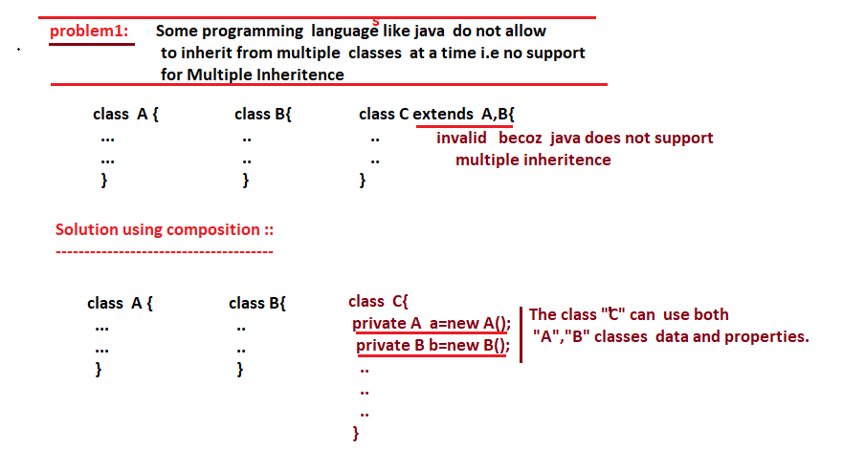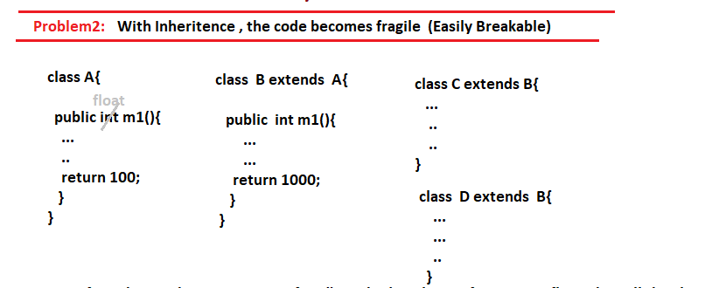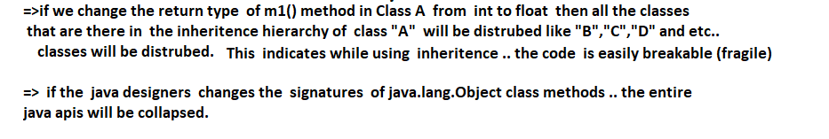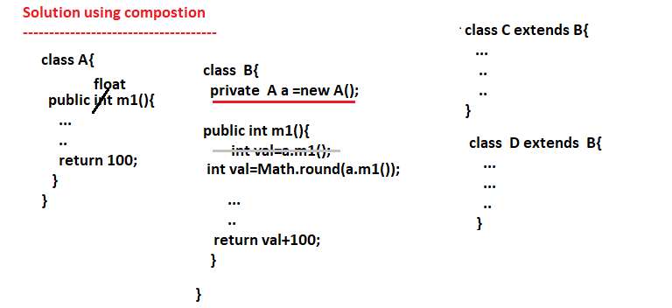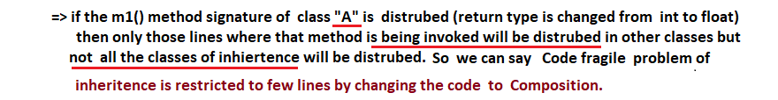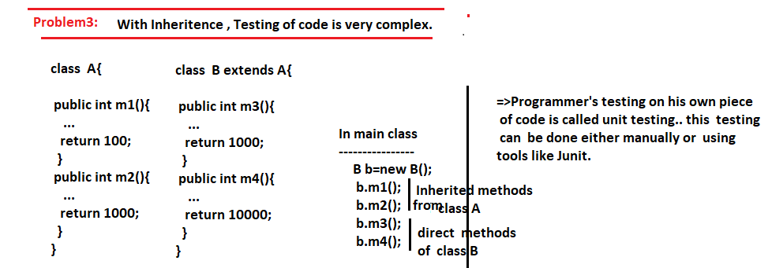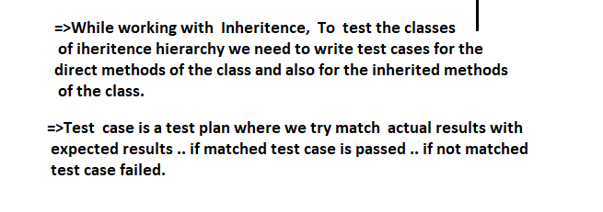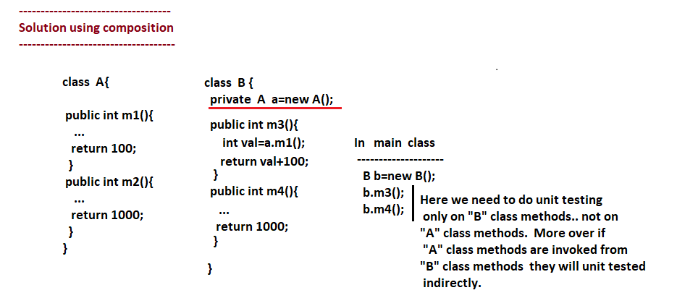

**17/05/2022**

**Principle2/ rule2 :: Always code to Interfaces/ abstract classes … and never code to concrete classes for achieving loose coupling:-**

* If the degree of dependency is more between the comps then we can say they are in tight coupling .

**Eg::** Fan and switch (we can not run the fan with out switch)

**Eg::** CPU Box and Monitor/ Console (We can not operate CPU Box with out console)

* If the degree of dependency is less between the component then we can say they are in looseccoupling.

**Eg :: TV and Remote (we can operate with or with out remote)**

**Eg :**: **Laptop and mouse**

**Eg :**: **Audio device and Head Set**

**Eg :**: **Mobile phone and Internate.**

**Problem :: (Tight Coupling)**

**-------------------------------------**

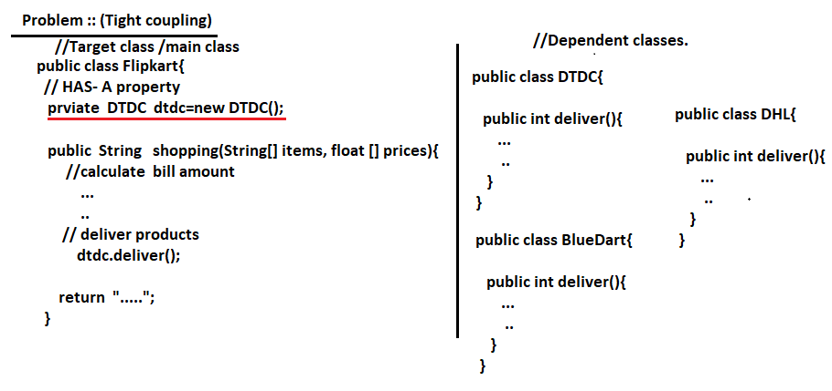

* If Flipcart class (target class) want to change its Courier from DTDC to BlueDart we need to the modify the source code of Flipkart class i.e. there is tight coupling between Flipkart and DTDC.

**Solution :: (Loose coupling by using Interfaces) :-**

* Make all Dependent classes implementing common Interface or extending from common class and that common interface / common class reference variable as the DAS-A property of target class as shown below.

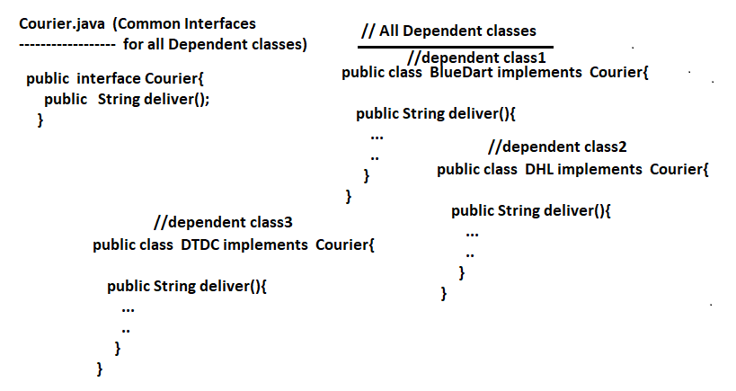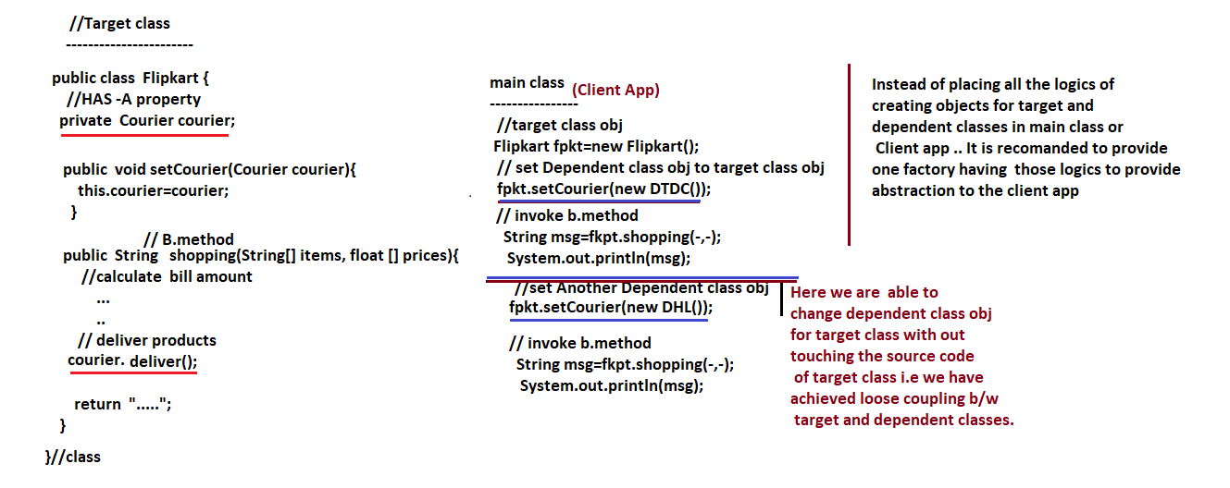

**Principle3/ rule3 :: Our code must be open for Extension and must be closed for Modification :-**

* If we implement rule2/ principle no2 perfectly … our code automatically becomes ready for extension i.e. we can develop more dependent classes implementing the common interface which indicates our code in open for extension.
* Either by taking classes as final classes and by taking the methods of classes as final methods we can make our code closed for modification because final classes can not be sub classes and final methods super class can not be overridden in the sub classes.

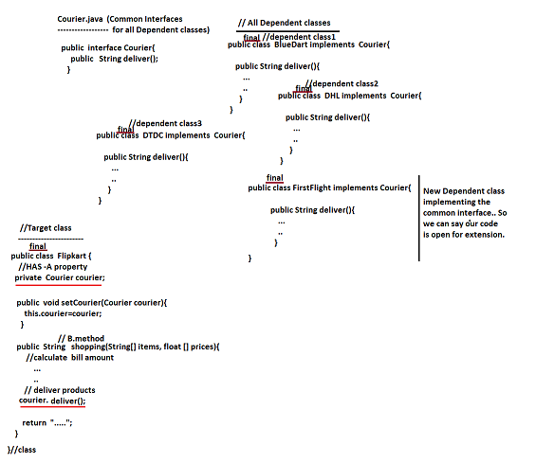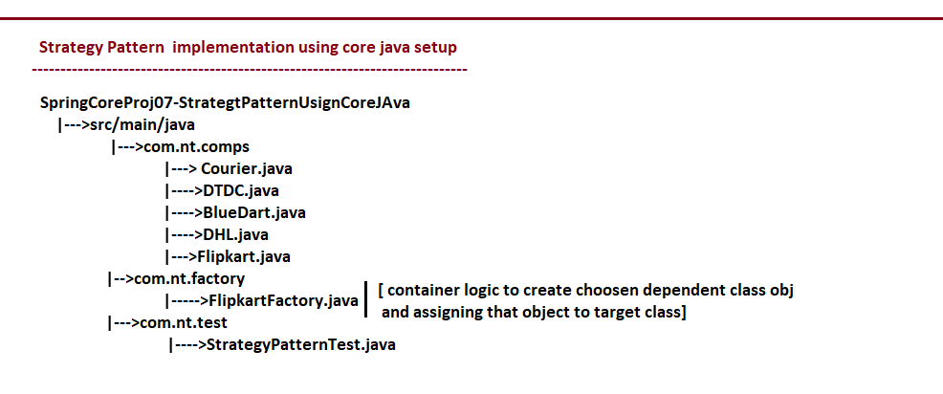

**18/05/2022**

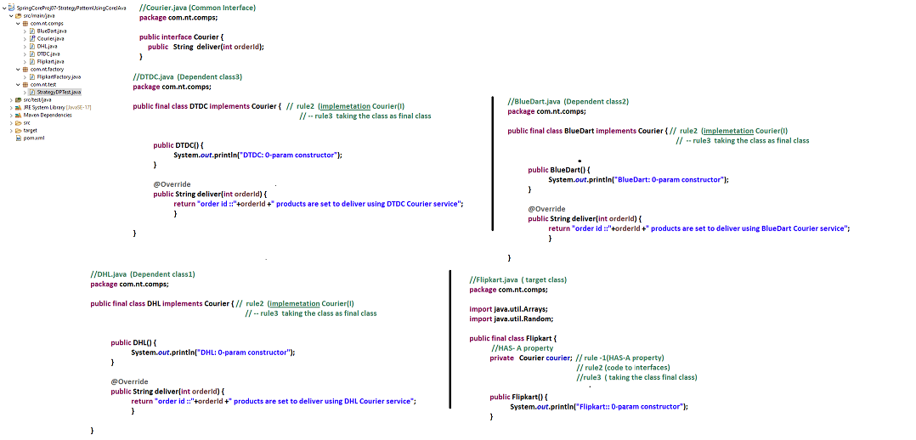

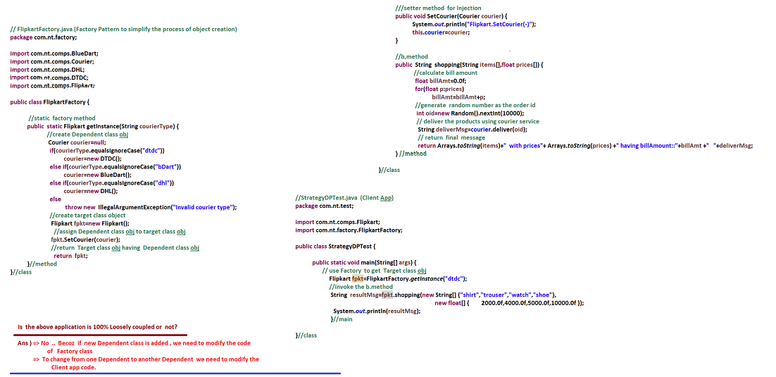

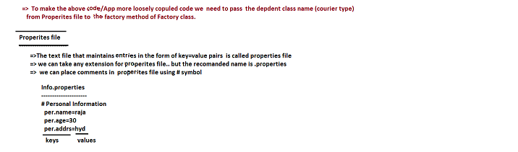

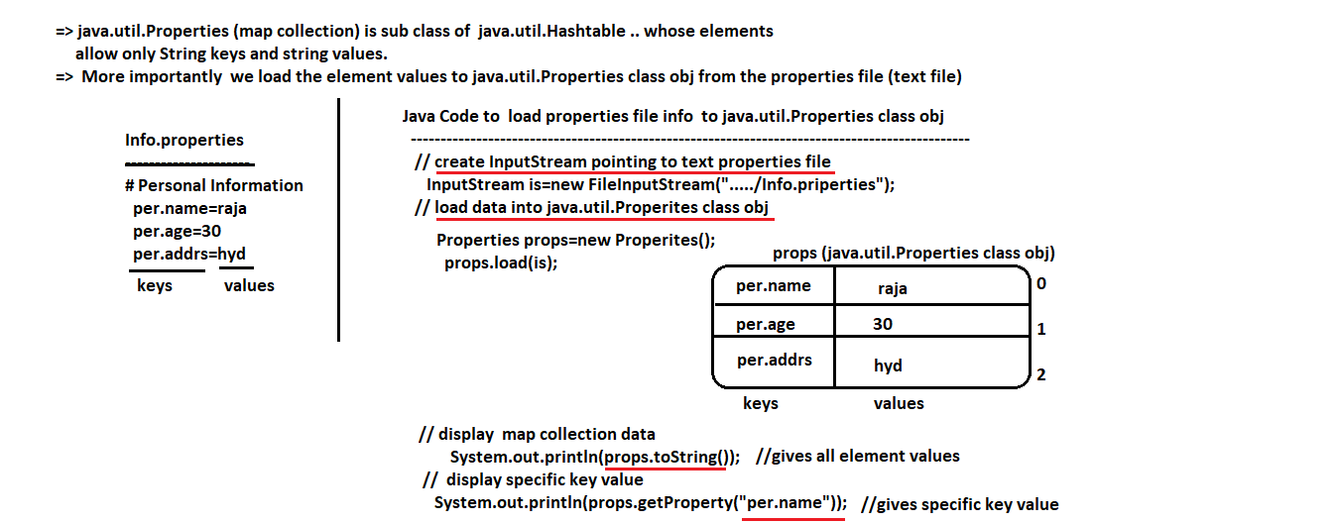

**==**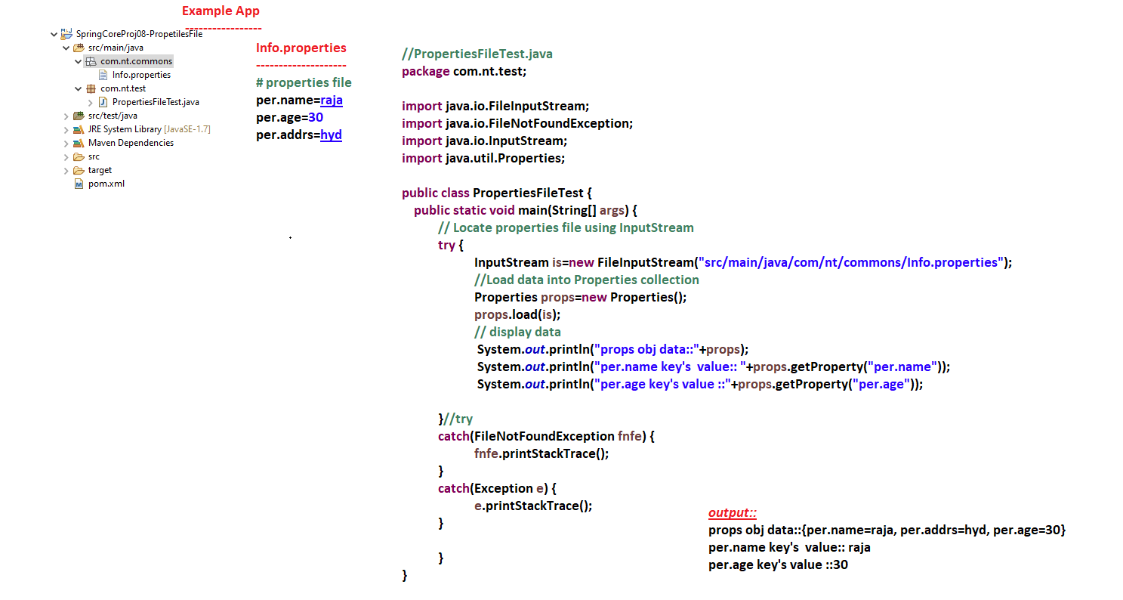

**===============================**

**19/05/2022**

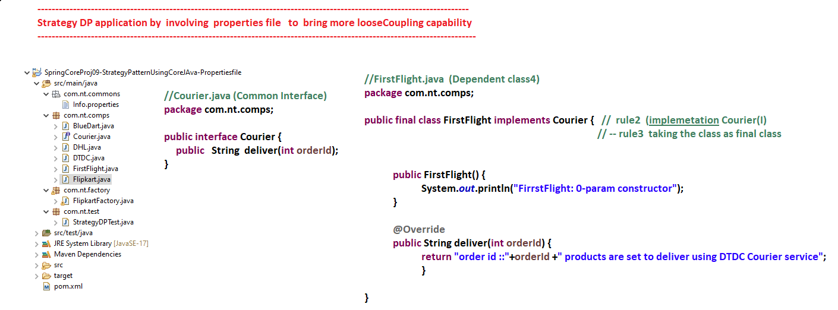

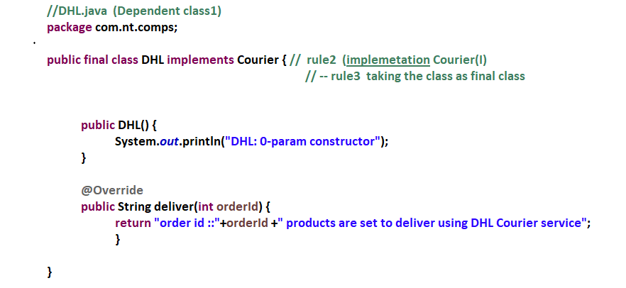

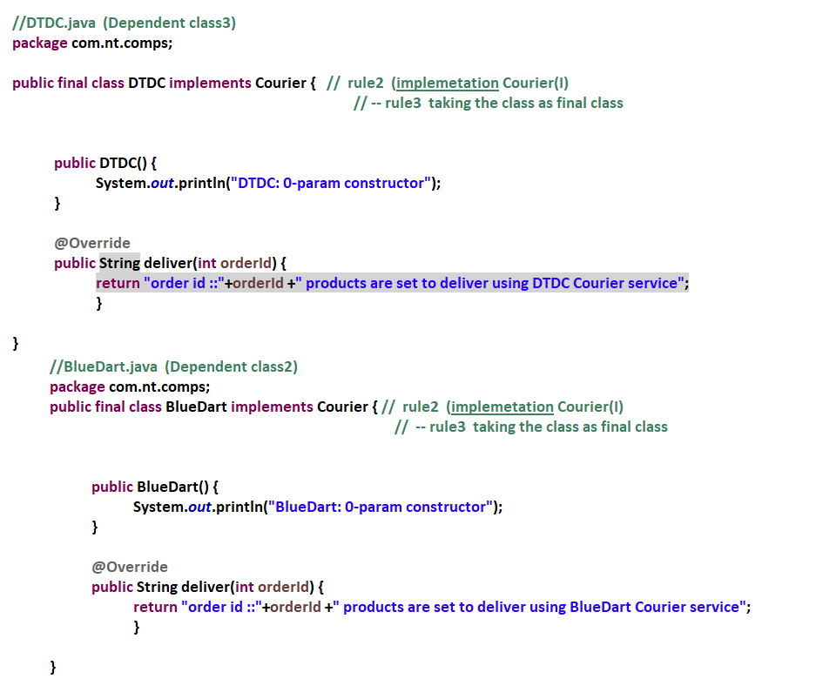

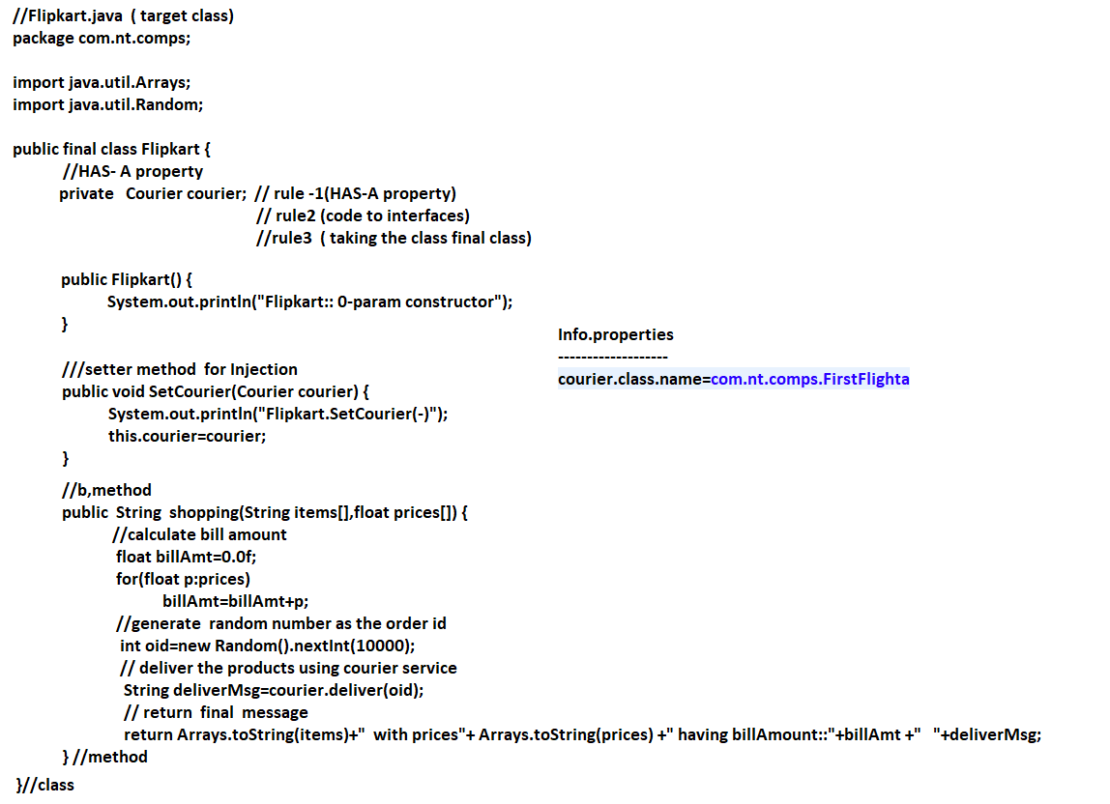

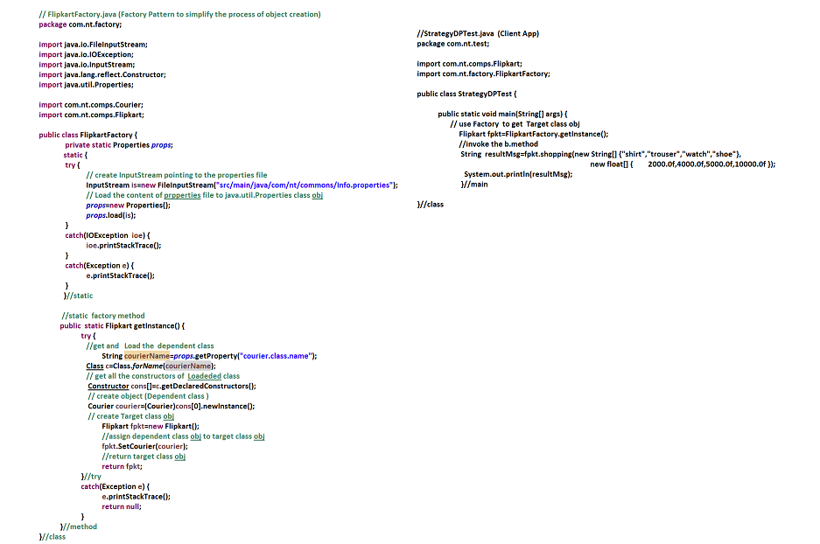

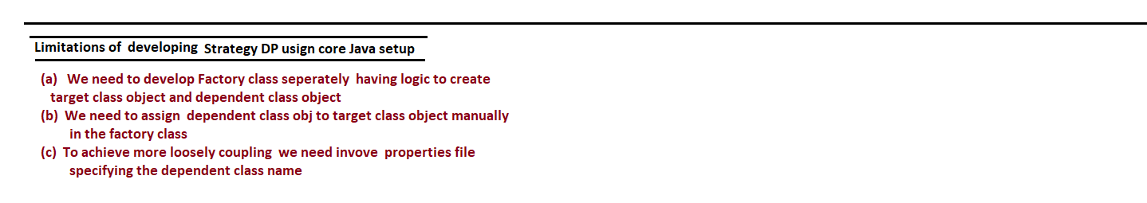

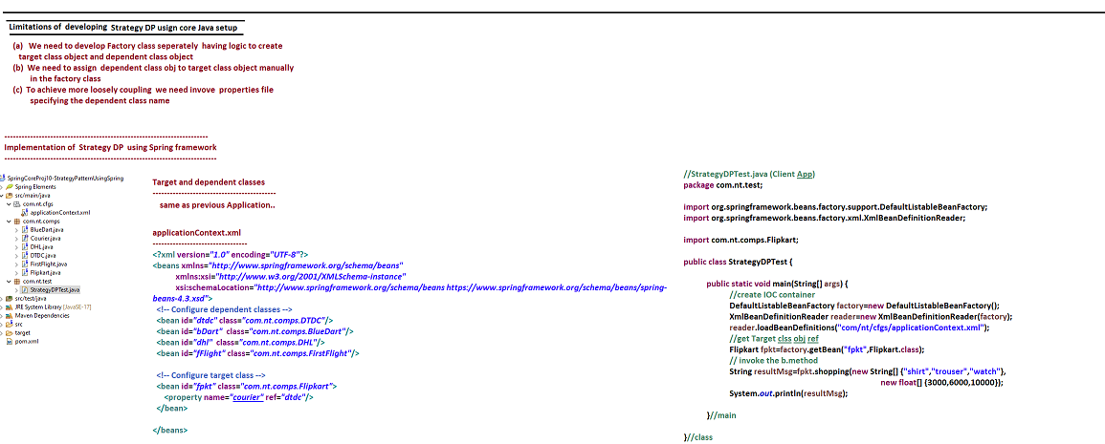

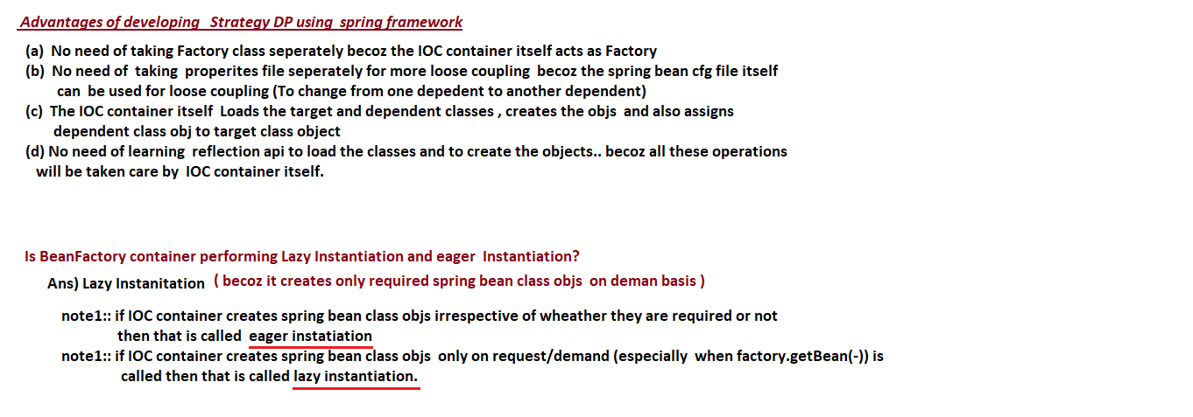

**20/05/2022**

**P-NameSpace and C-NameSpace**

**---------------------------------------------**

* In XSD (Xml Schema Definitation) , the namespace is library that contains set of readily available Xml tags.
* Every xml namespace is identified by its namespace uri
* The spring supplied XSD namespace are

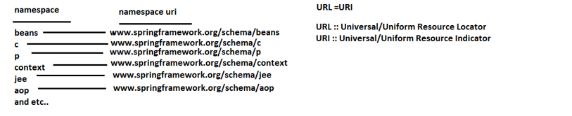

* In order to use the tags certain namespace in our xml document we need to import the namespace by specifying the namespace uri/url.

**-------------------**

**C-NameSpace**

**--------------------**

* To perform constructor injection cfgs instead of using the length <constructor-args> tags we can use c-namespace support in <bean> tag itself as the short cut.



**---------------------**

**P-NameSpace**

**----------------------**

* To perform setter Injection cfgs , instead of using the length <property> tags we can use p-namespace support in the <bean> tag itself as the shortcut.



**Note:-** If we use p-namespace and c-namespace effectively then there is no need of using <constructor-args> tags and <property> tags to perform constructor Injection and setter Injection respectively.

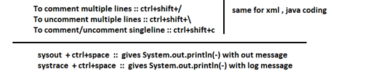

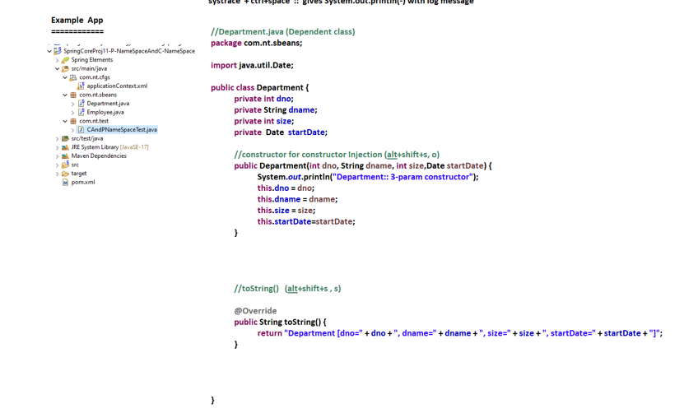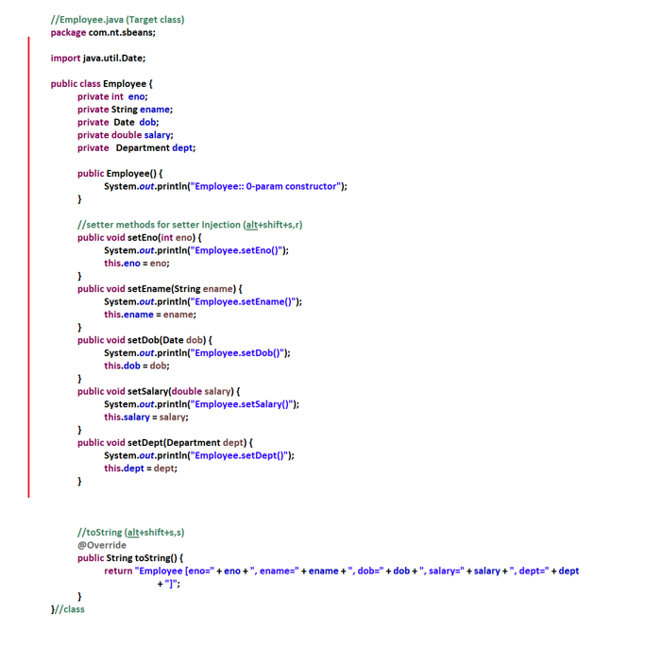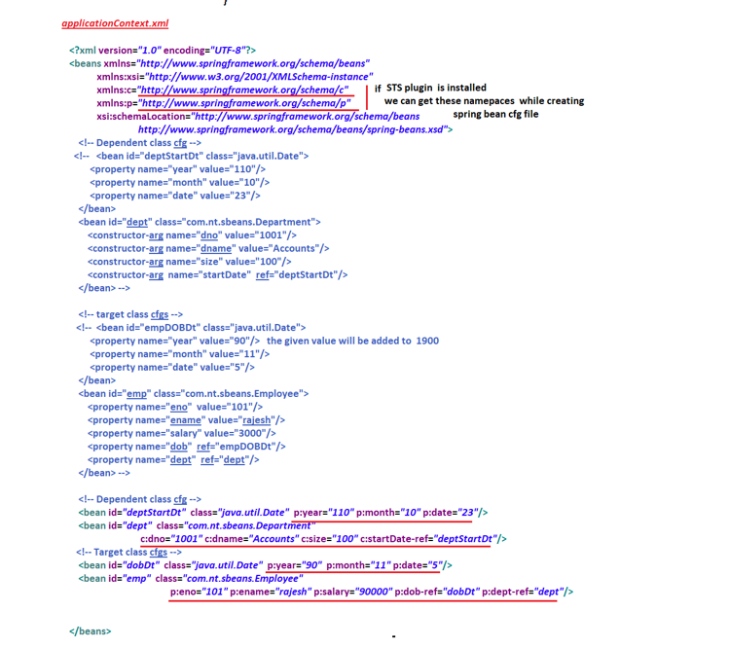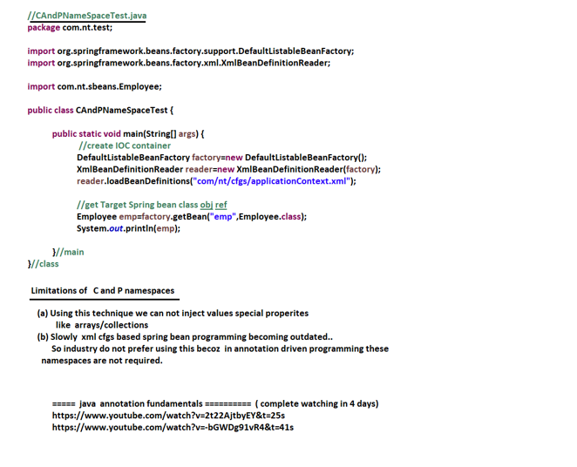

**21/05/2022**

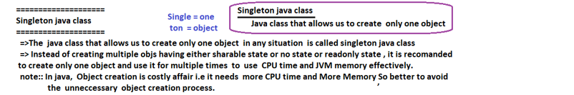

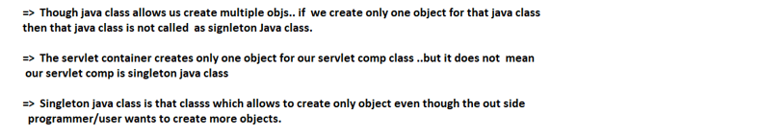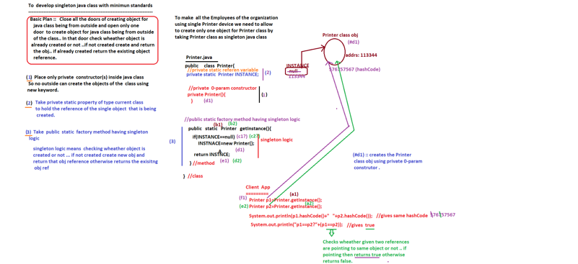

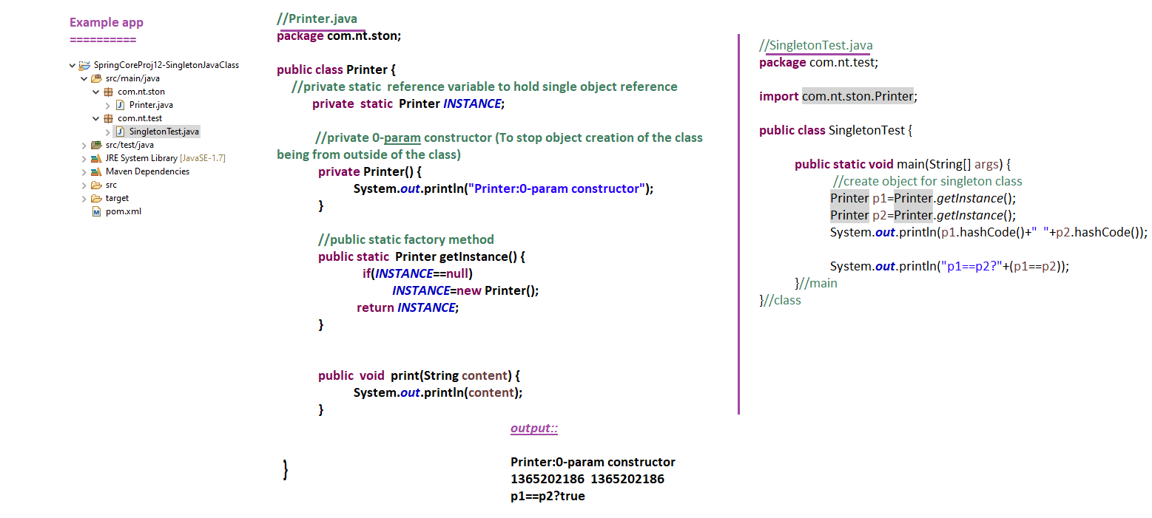

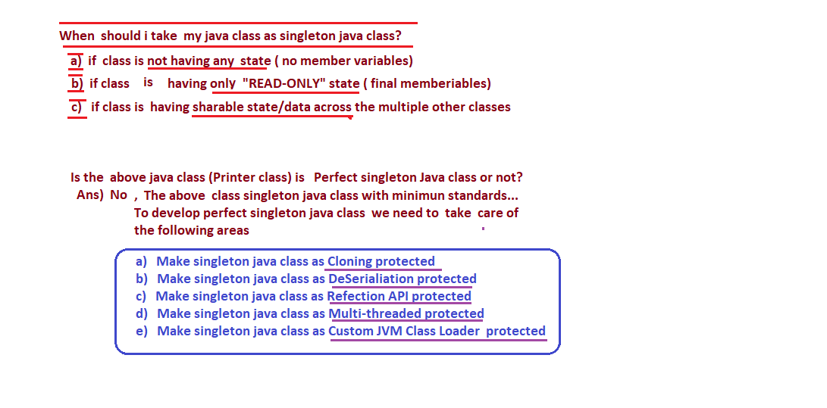

**23/05/2022**

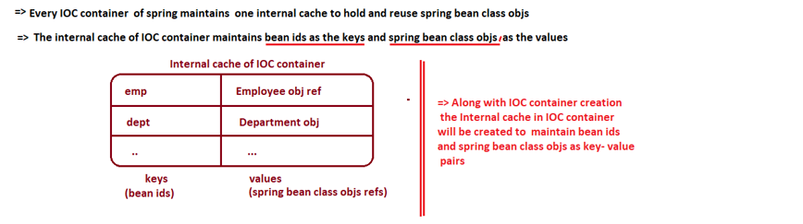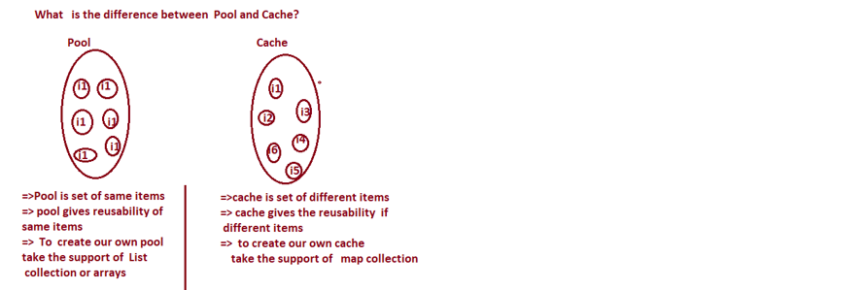

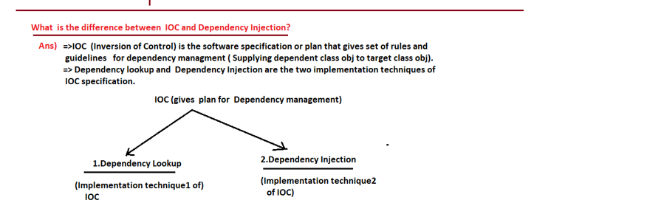

**Why Spring Supplied Containers are called IOC containers?**

**Ans )** Because they are capable performing both Dependency lookup and Dependency Injection Operations on spring beans.

IOC = Inversion of Controller i.e. taking everything in to its controller and making the programmer/ developer free from most of the activities.

* Since spring containers takes care of majority activities related to dependency management So we can say the spring containers as the IOC container.

Note : - With out spring containers, the programmers need to take care of multiple aspects related to Dependency Management i.e. programmer controls every things … While working with spring containers the majority activities of dependency management will be taken care by the Spring container itself So the Spring containers are called IOC containers.

**----------------------------**

**Spring Bean Scopes :**

**-----------------------------**

* We can make spring containers/ IOC container to keep spring bean class objects in different scopes.

**Spring Bean Scope in 5.X**

**------------------------------------------------**

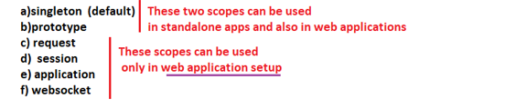

* In xml driver cfgs, we need to use “scope” attribute of <bean> tag to specify spring bean scope .
* In annotation driven cfgs, we need to use @Scope annotation to specify the spring bean scope.

**================**

**Scope = “singleton”**

**================**

* IOC container creates only one object for spring bean class with respect to bean id.
* The multiple calls to factory.getBean(-,-) method with bean id gives same spring bean class obj ref.
* The IOC container keeps the singleton scope spring bean class obj refs in the Internal cache of IOC container having bean ids as the keys and spring bean class obj refs as values.
* If no scope is specified the default scope of spring bean is “singleton”.
* IOC container does not make spring bean class as singleton java through the scope is taken as “singleton” but it give singleton behavior by creating only object for spring bean with respect to bean id.

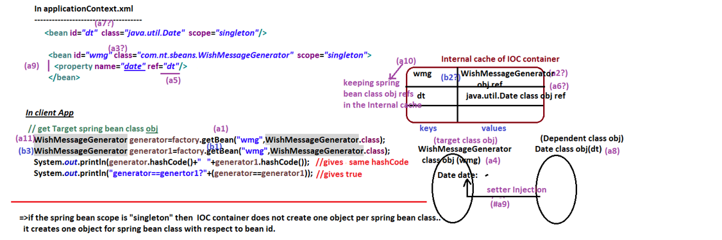

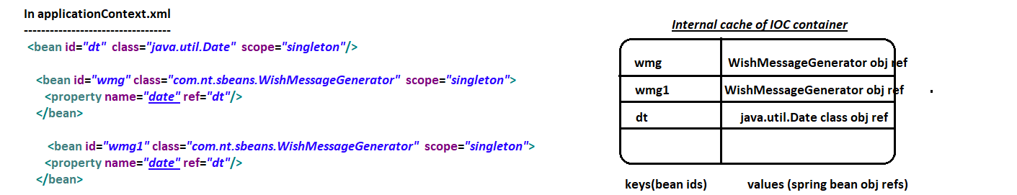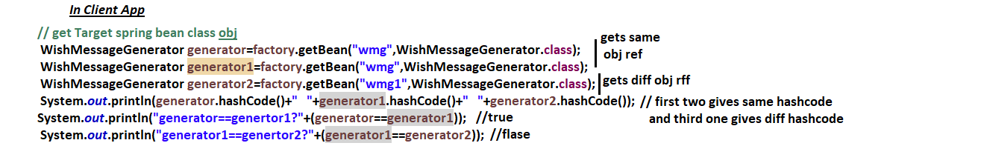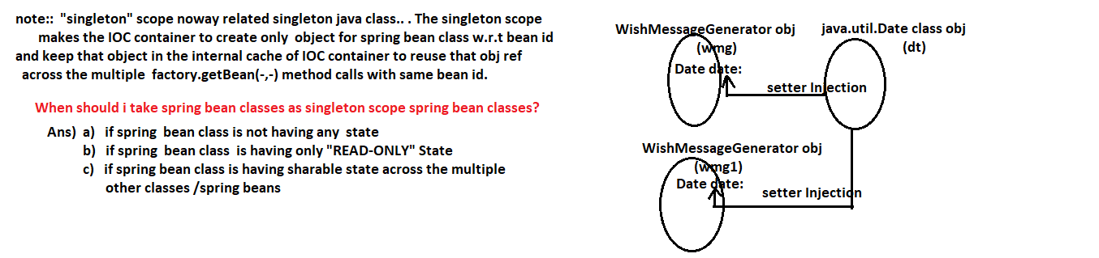

**24/05/2022**

**--------------------------**

**scope = “prototype”**

**---------------------------**

* The IOC container creates new object for spring bean class for every factory.getBean(-,-) method call.
* If the spring bean scope is “prototype” , the IOC container does not keep Spring bean class obj in the internal cache of IOC container due this for every factory.getBean(-,-) call one separate spring bean class obj will created.

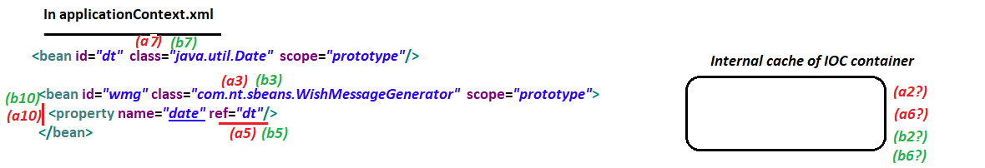

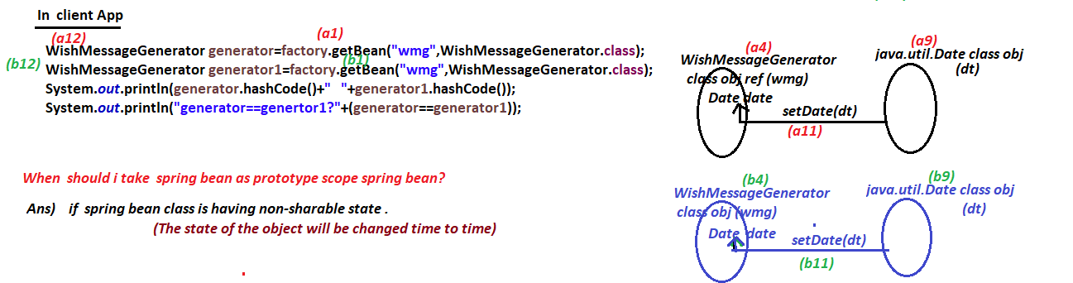

**------------------------**

**scope = “request”**

**------------------------**

* This scope can be used only in web application environment.
* IOC container keeps the spring bean class obj as request attribute value.
* request scope means the spring bean class obj is specific each request that comes to web application.

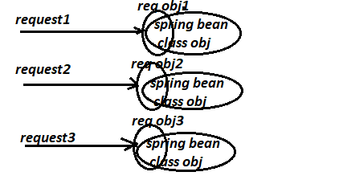

* if we use “request” , “session”, “application”, “websocket” , scope in standalone Ap then we get

Exception in thread “main” java.lang.IllegalStateExcepton:No Scope registered for scope name ‘request’**… So it is recomanded to use them only in web application setup.**

**----------------------**

**scope=”session”**

**-----------------------**

* IOC container keeps the spring bean class obj in session scope i.e. as Session attribute value
* Since HttpSession/Session object is specific to each browser s/w of a client machine we can say the “session” scope spring bean class obj is also specific to browser s/w of a client machine.
* This scope can be used only in web application env…

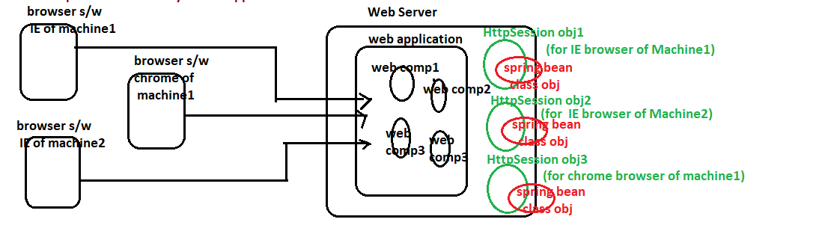

**----------------------------**

**scope = “application”**

**-----------------------------**

* This scope can be used only in web application env…
* IOC container keeps spring bean class object in ServletContext obj which is one per web application i.e. spring bean class obj will be created on one per web application.

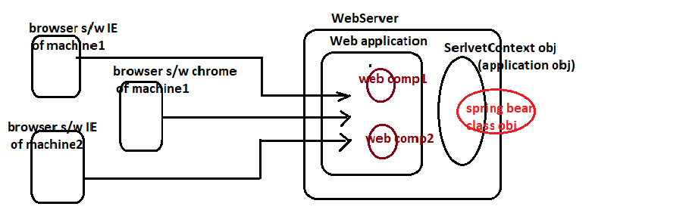

**----------------------------**

**scope = ”websocket”**

**----------------------------**

* websocket is a protocol that runs on the top of protocol http to support full duplex communication between browser and application.
* Protocol http supports only half duplex communication (Client gets things from server only on the request)

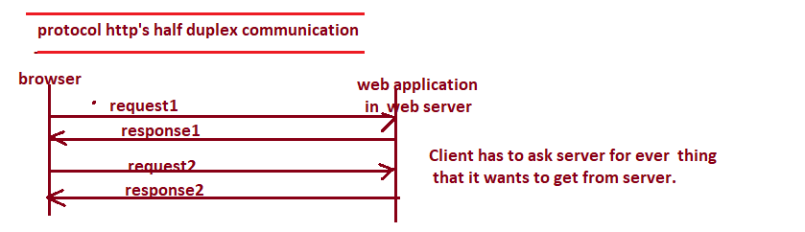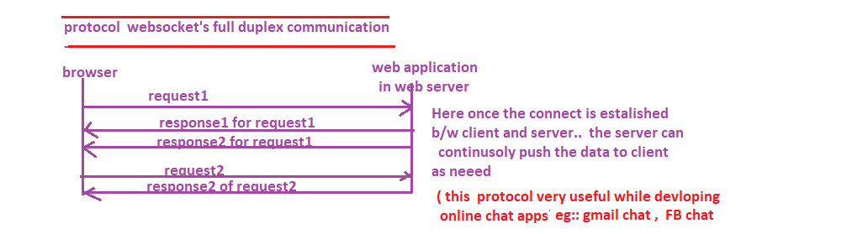

**----------------**

**Conclusion**

**-----------------**

scope = “singleton” :: one object for spring bean w.r.t. bean id.

scope = “prototype” :: for every factory.getBean(-,-) method call new object will be created for spring bean.

scope = “request” :: For every request given to web application new obj will be created for spring bean.

scope = “session” :: For every browser s/w of client machine that is giving requests to web application . new obj will be created for spring bean.

scope = “application” :: For entire web application one object will be created for spring bean.

scope = “websocket” :: To support full duplex communication the spring bean class obj will be created in . websocket mode.

**===========**

**25/05/2022**

**===========**

**ApplicationContext Container**

**========================**

* It isextension of Bean Factory container
* ApplicationContext Container = BeanFactory Container ++

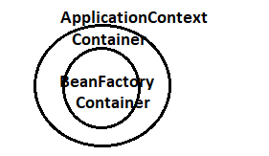

* ApplicationContext contains gives all the features of BeanFactory container and additional fetures. The additional features are

1. Pre-instantiation / easer Instantiation singleton scope spring beans
2. Ability to work properties file
3. Support for I18n (Internationalization)
4. Support for event handling.
5. Ability to stop or close the Container.
6. Automatic registration of BeanProcessors
7. Support to work with Annotation driven , 100% code driven and springboot driven cfgs and etc…

**Note :-** Most recommended IOC container (99 times out of 100 times) is the ApplicationContext container.

* To create ApplicationContext container (IOC container) we need to create object for java class that implements org.springframework.context.ApplicationContext(I) directly or indirectly.
* The ApplicationContext(I) extends from the BeanFactory(I) either directly or indirectly.

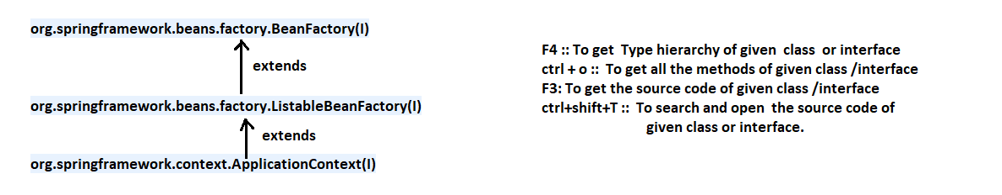

* There are multiple important implementation classes for ApplicationContext(I)

----------------------------------------

**a) FileSystemXmlApplicationContext**

**----------------------------------------**

* Create the “AC” (ApplicationContext) container by locating the given spring bean cfgs file from the specific path of the File System.

**Ex :: FileSystemXmlApplicationContext ctx =**

**New FileSystemXmlApplicationContext(“src/main/java/com/nt/cfgs/applicationContext.xml”);**

* Suitable for standalone Apps

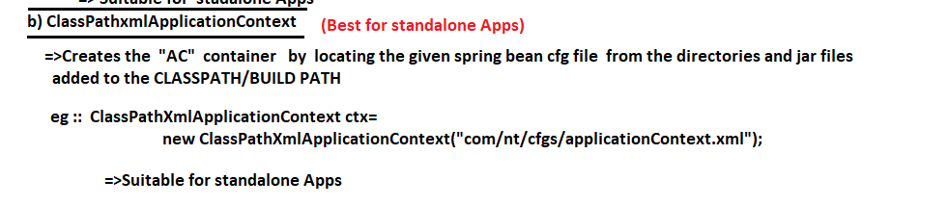

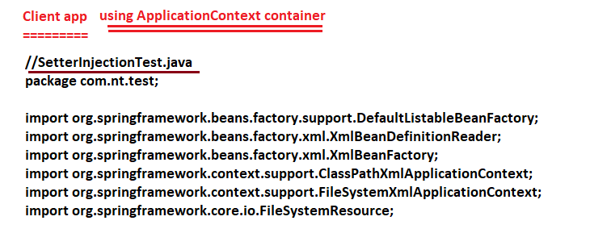

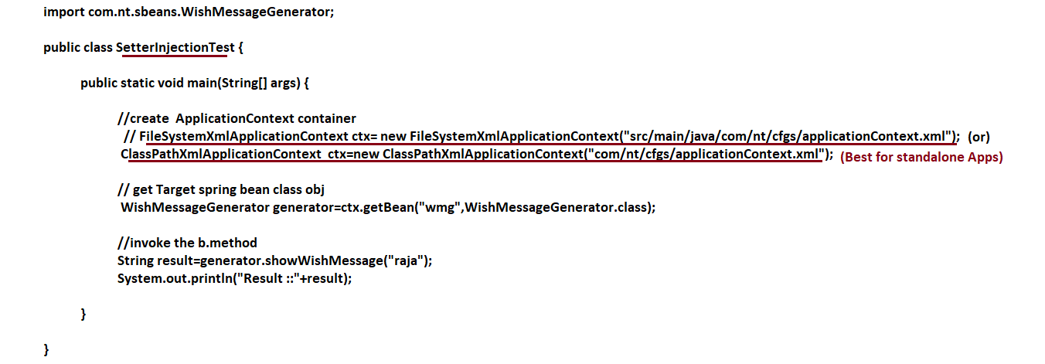

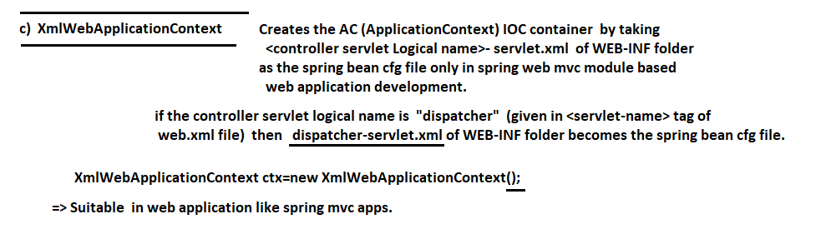

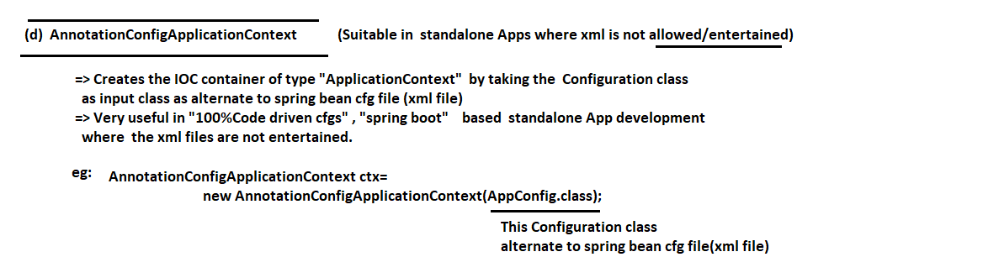

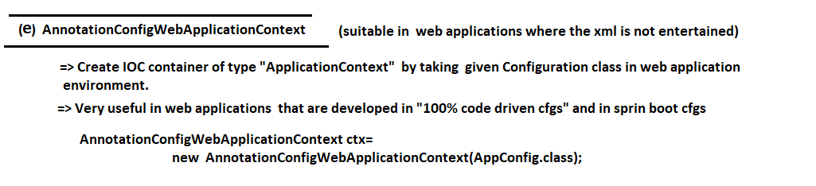

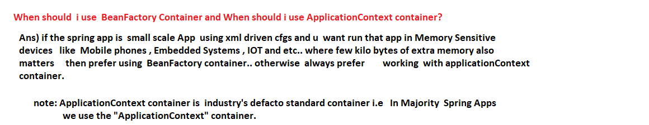

**==========**

**27/05/2022**

**==========**

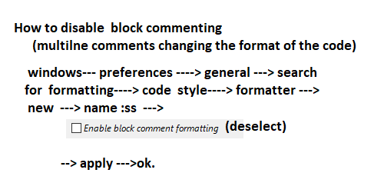

**ApplicationContext container feature1**

1. **Pre-instantiation/eager Instantiation singleton spring beans:**

**-----------------------------------------------------------------------------------**

* Creation object for spring bean class only when is asked/ demanded or requested then it is called lazy/ late instantiation … The BeanFactory IOC container creates all its spring bean class objes through Lazy instantiation process.
* Creating object for spring bean class the moment IOC container is created irrespective of whether it is asked/ requested/ demanded or not is called pre-instantiation/ eager instantiation.
* ApplicationContext creates performs pre-instantiation/ eager instantiation only on the singleton scope spring beans i.e. the objects for singleton scope spring beans will be created the moment the ApplicationContext Container is created.

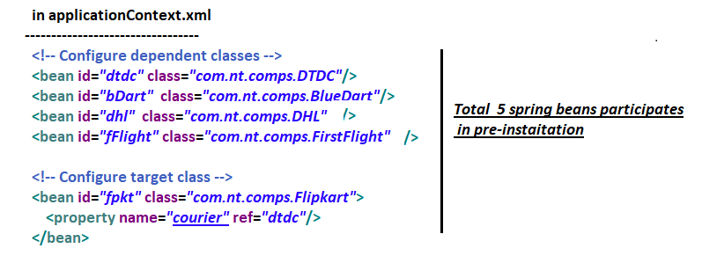

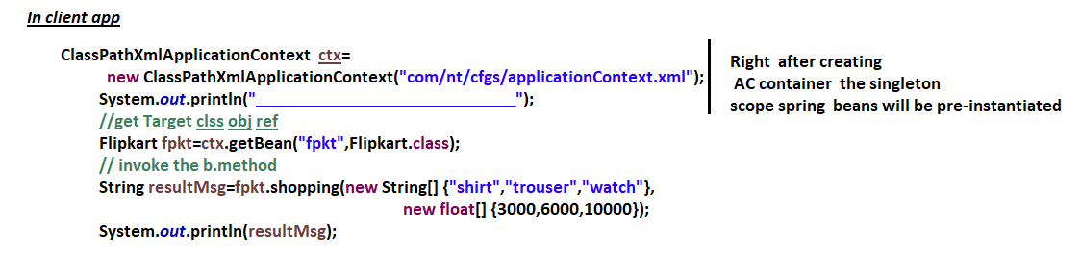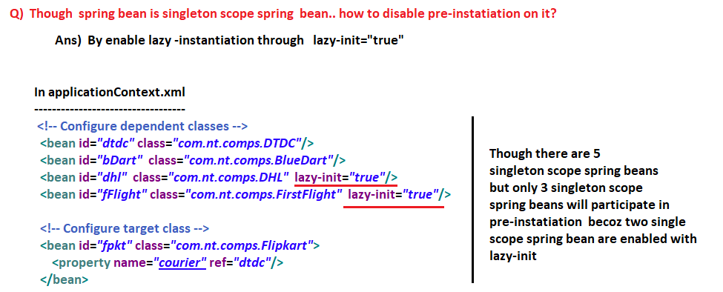

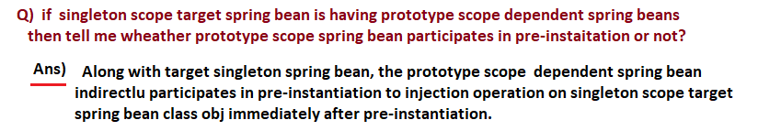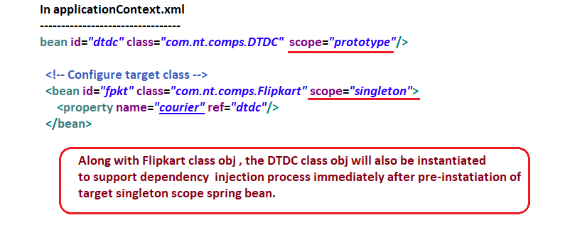

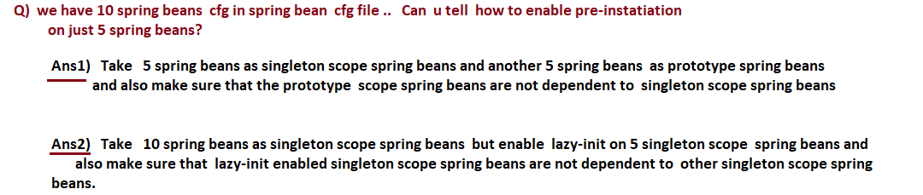



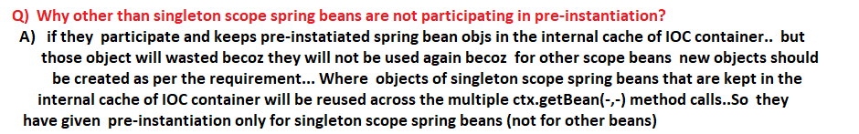



**==========**

**28/05/2022**

**==========**

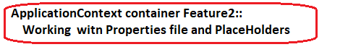

**Properties file:**

**---------------------**

* The Text file that maintains entries in the form of key=val pairs is called properties file.
* By configuration properties file in spring app we inject values to spring bean properties from the properties with the support of placeholder ${<key>}.

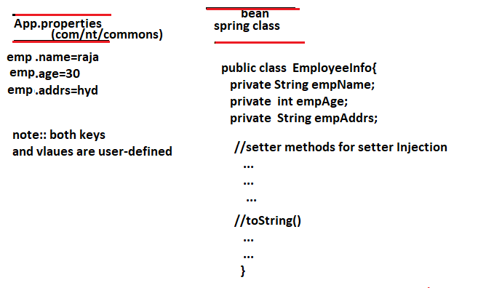

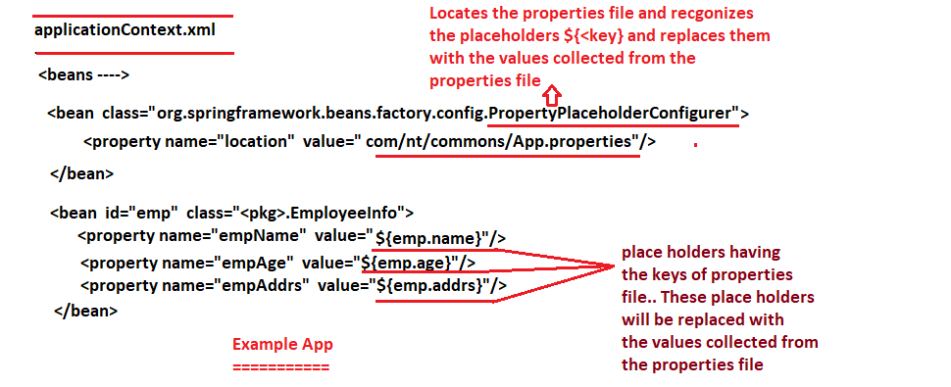

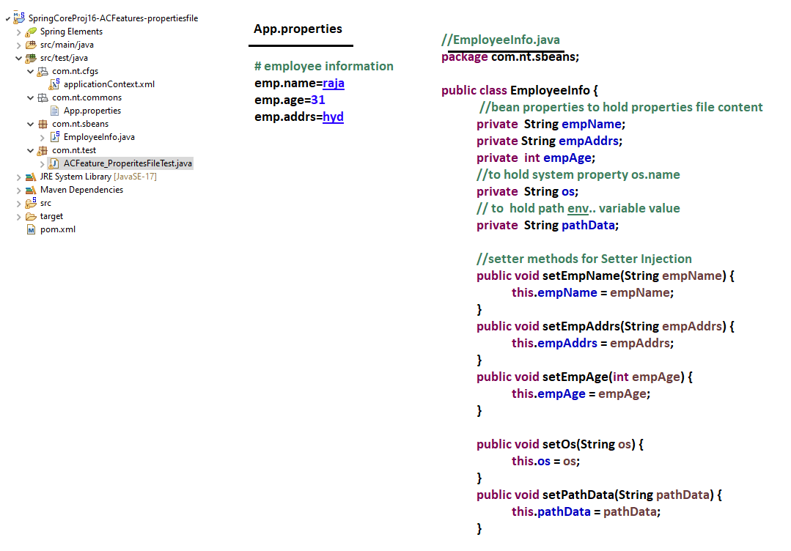

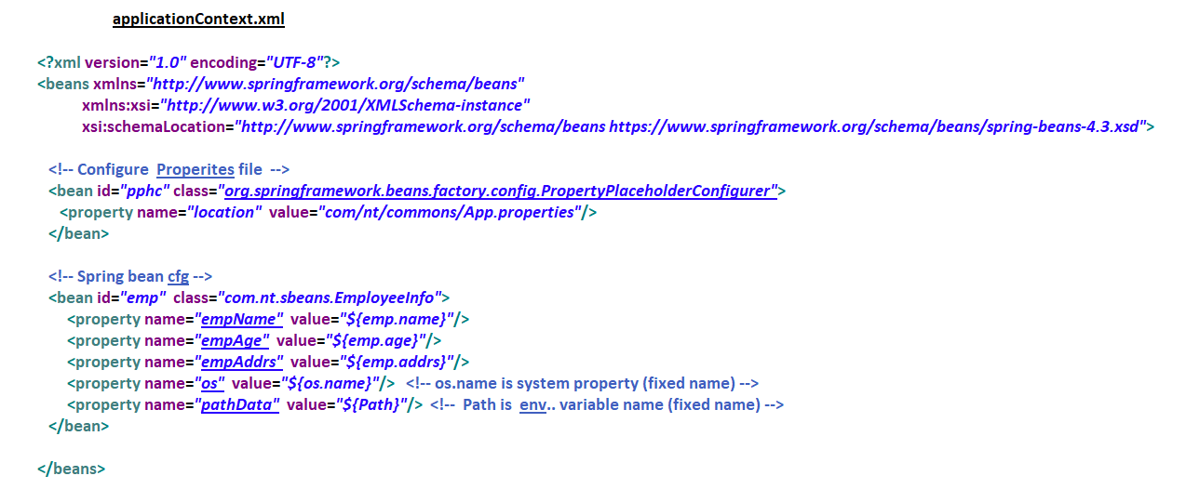

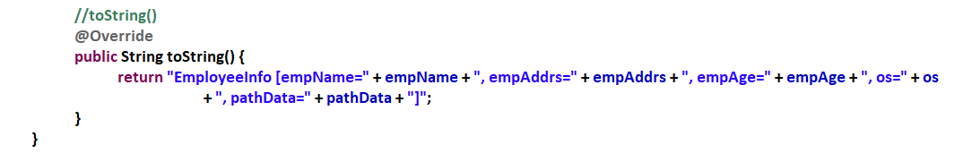

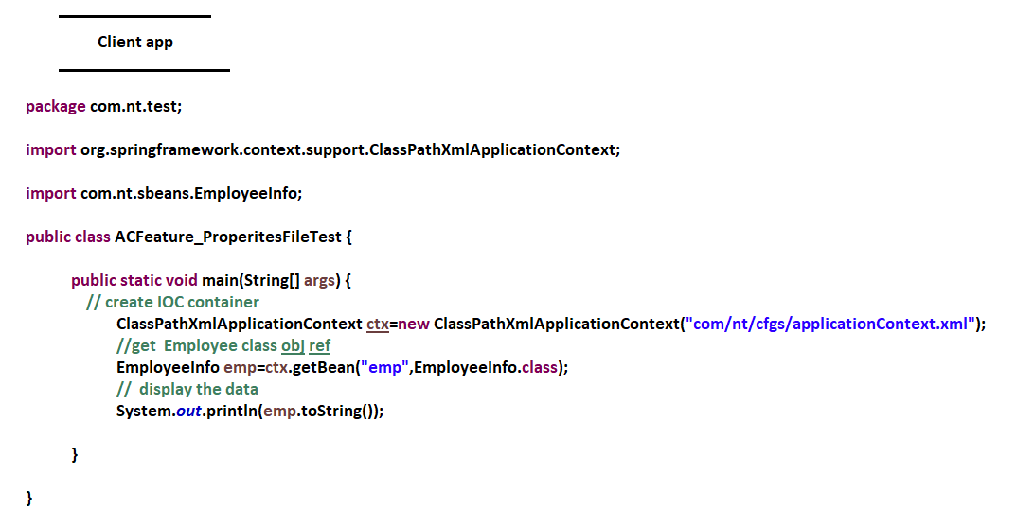

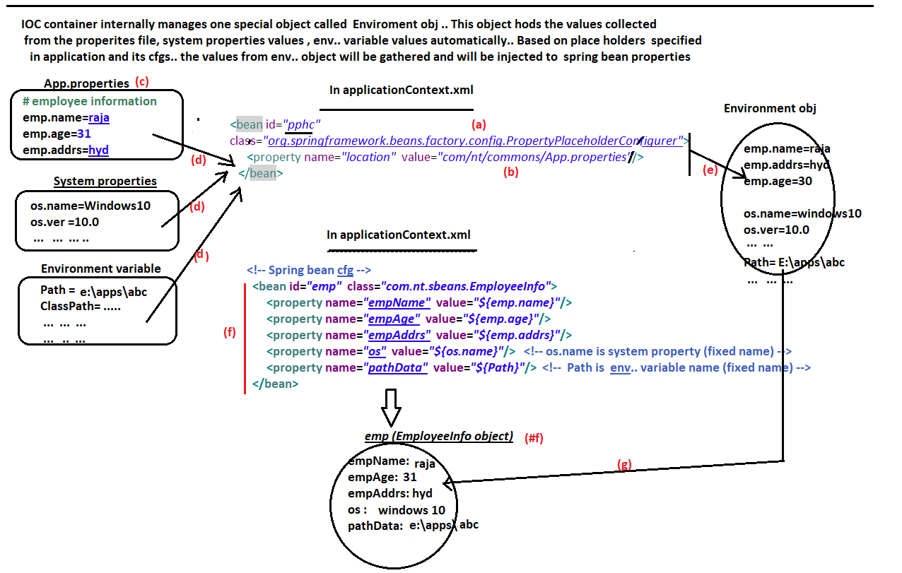

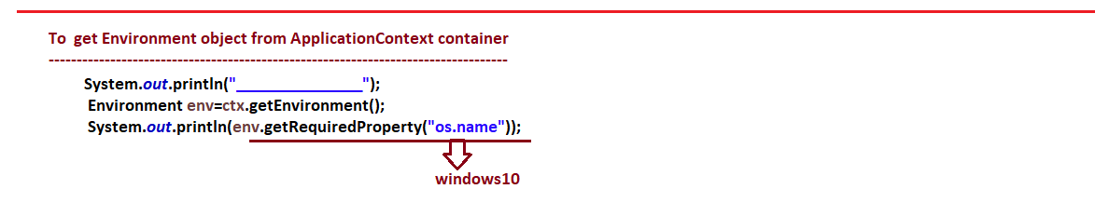

**-------------------**

**30/05/2022**

**-------------------**

**I18n(Internationalization) in spring**

**-----------------------------------------------**

* Internationalization is having 20 letters so In short cut it is written as I18n.
* We apply I18n on our App … our app becomes ready to work for multiple locales.
* Locale means language + country
  + En-US (English as it speaks in USA)
  + Fr-FR (French as it speaks in France)
  + De-DE (German as it speaks in Germany)
  + Hi-IN (hindi as it speaks in India)
  + En-AU (English as it speaks in Australia)
* While applying Internationalization on the application , we need to take care –
  + A) Presentation labels (Labels should be changed according to the chosen Locale)
  + B) date formats
  + C) time formats
  + D) number formats
  + E) currency symbols
  + F) content identification (left to right (eg :: English , Indian language) or right to left (Arabic , Urdu and etc … )).
* Since java is based Unicode character set (65,535 characters support is there) it allows to display presentation labels in different language.
* Websites or Apps where I18n is applied google, FB, google maps, Instagram and etc …
* BeanFactory does not support I18n because it does not direct support for properties …
* ApplicationContext container supports I18n … For that we need to use ctx.getMessage(…) to get message from the properties that is activated based on the Locale.

**===================================**

**Steps to develop Spring App by enabling I18n**

**===================================**

* Step1) Prepare multiple properties files on 1 per locale basis including one base properties file
  + App.properties (base properties file … generally contains English labels)
  + App_fr_FR.propeties (properties file for Franch locale)
  + App_de_DE.properties (properties file for German locale)
  + App_hi_IN.properties (properties file for Hindi locale)

**Note:-** If no matching properties file is found … the app picks up the base properties file.

**Note :-** Use Google translate to get labels in other language…

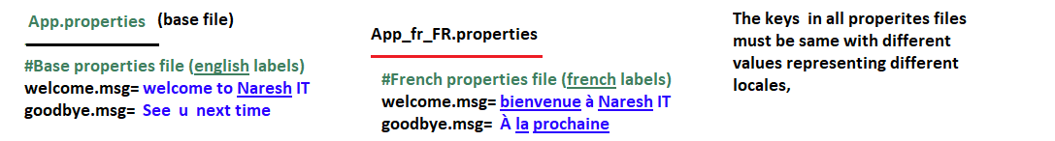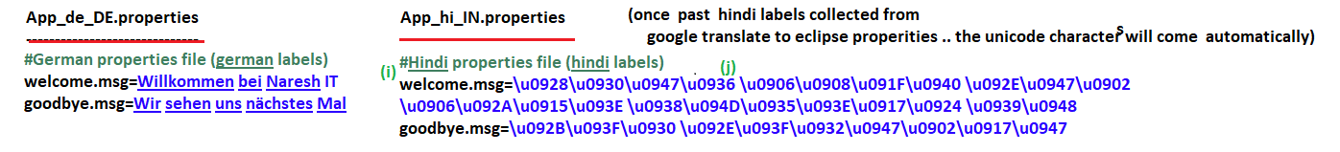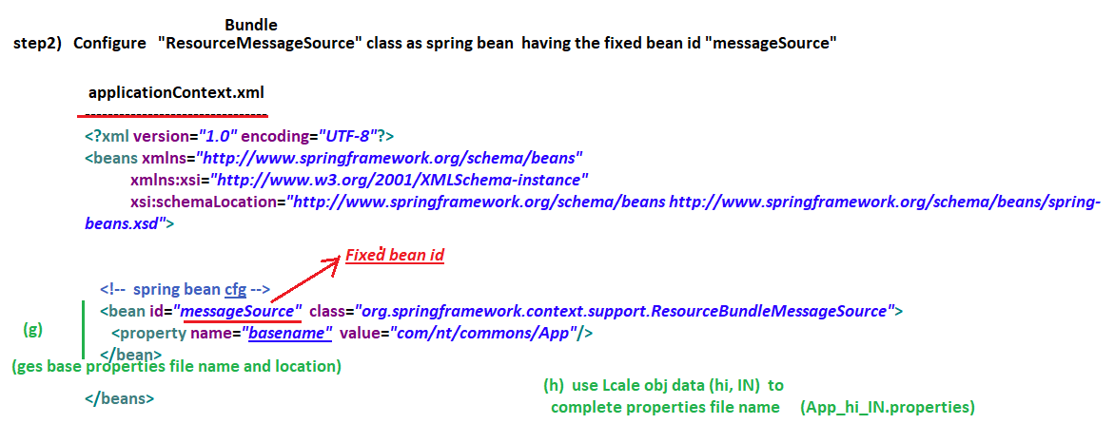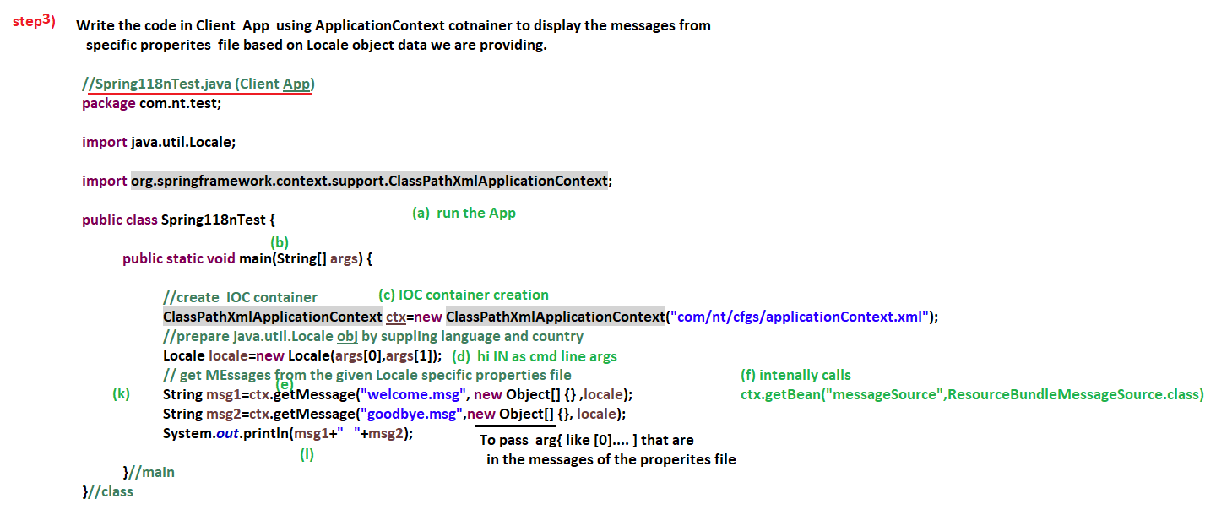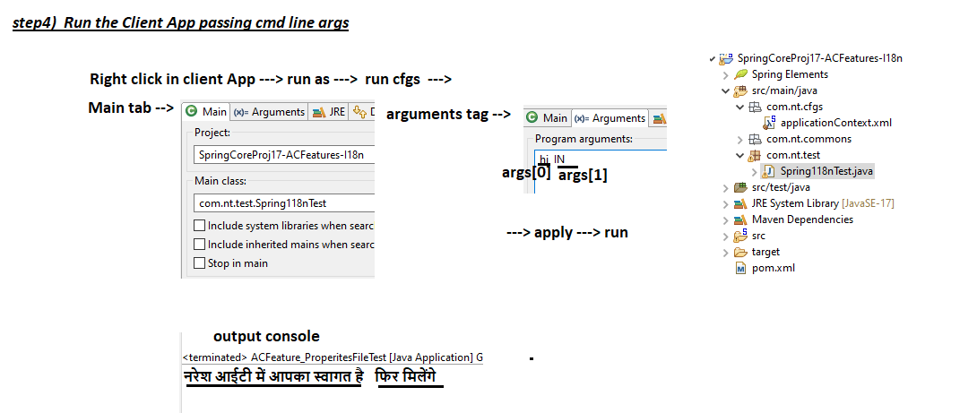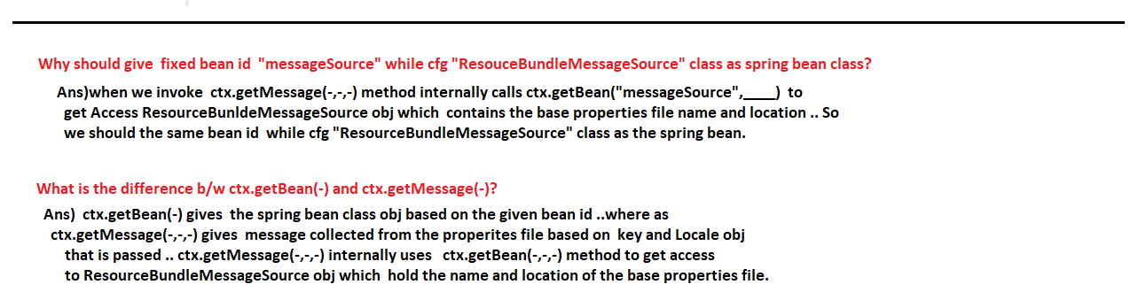

**-------------------**

**31/05/2022**

**-------------------**

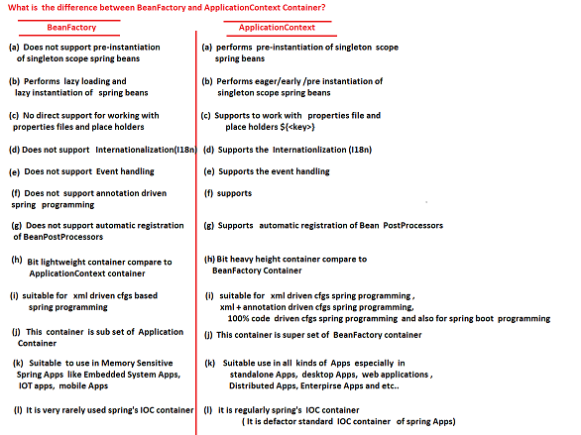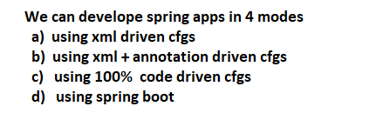

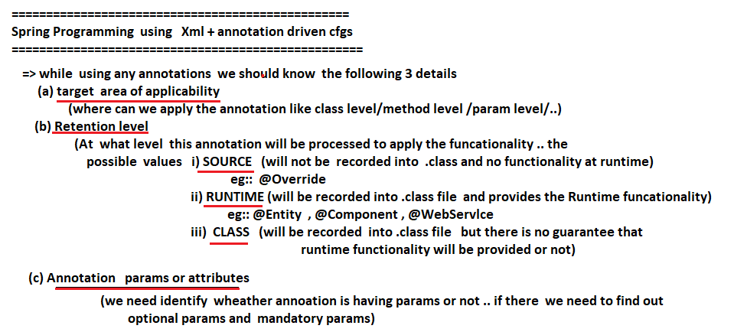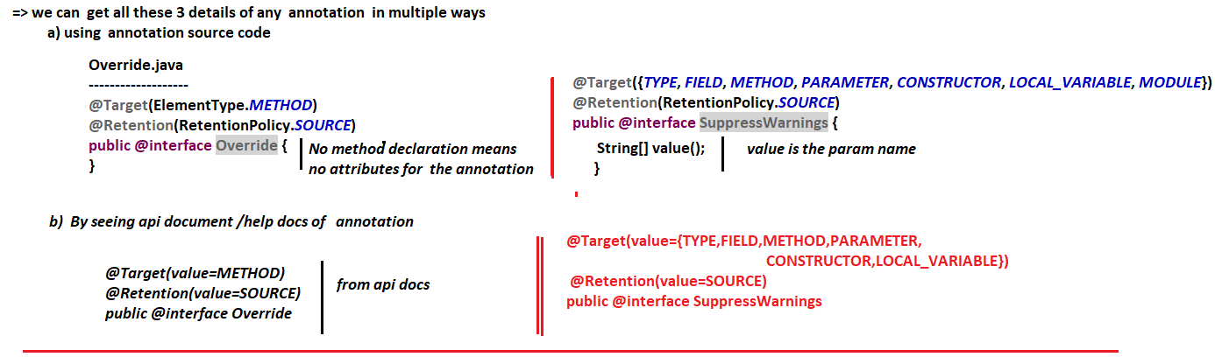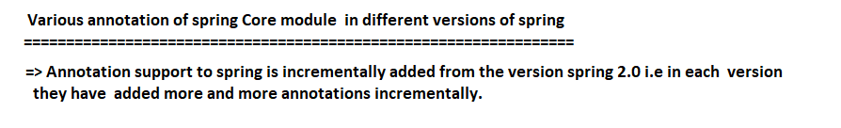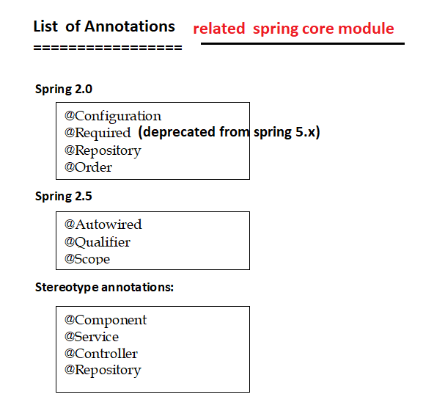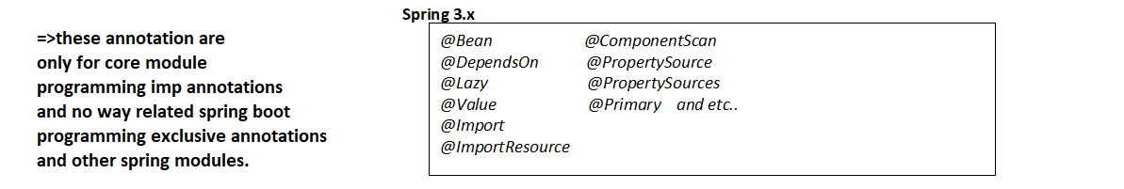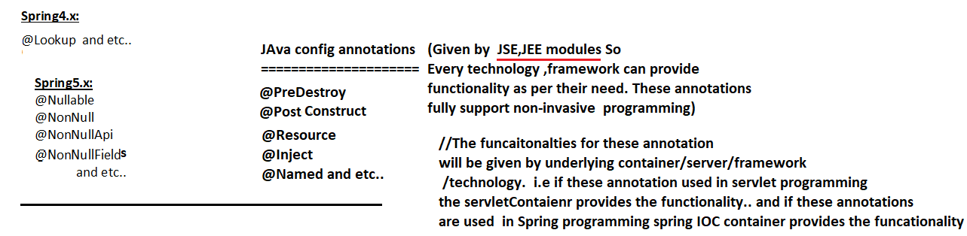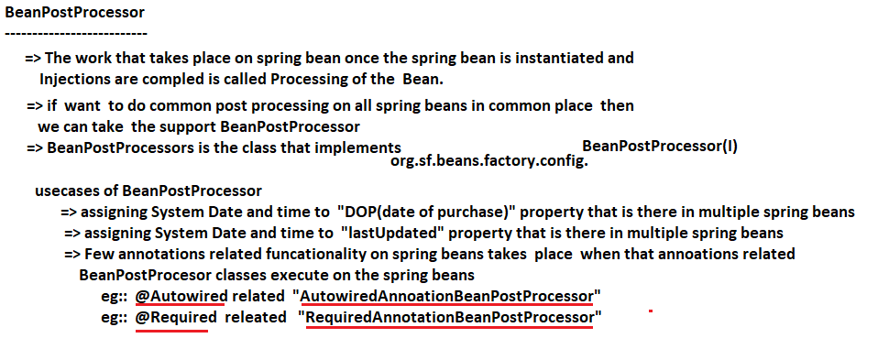

**---------------**

**02/06/2022**

**---------------**

**@Autowired**

**------------------**

* This annotation is applicable at method level, field level, constructor level.
* Can perform Field Injection (new), setter injection, constructor Injection, arbitrary method injection(new) on target spring bean class object by declaring the department spring bean class obj dynamically or automatically either based on Type or bean name/ bean id.
* The process of assigning department class object to target class is called wiring / injection … if this takes automatically or dynamically then it is called autowiring / autoInjection i.e. we need to explicitly specify dependent spring bean … because it will be detected dynamically based on the type or name/id.
* To apply the functionality of @Autowired annotation on the spring bean where it is placed … we need to configure its BeanPostProcessor as spring bean that is “AutowiredAnnotationBeanPostProcessor”.

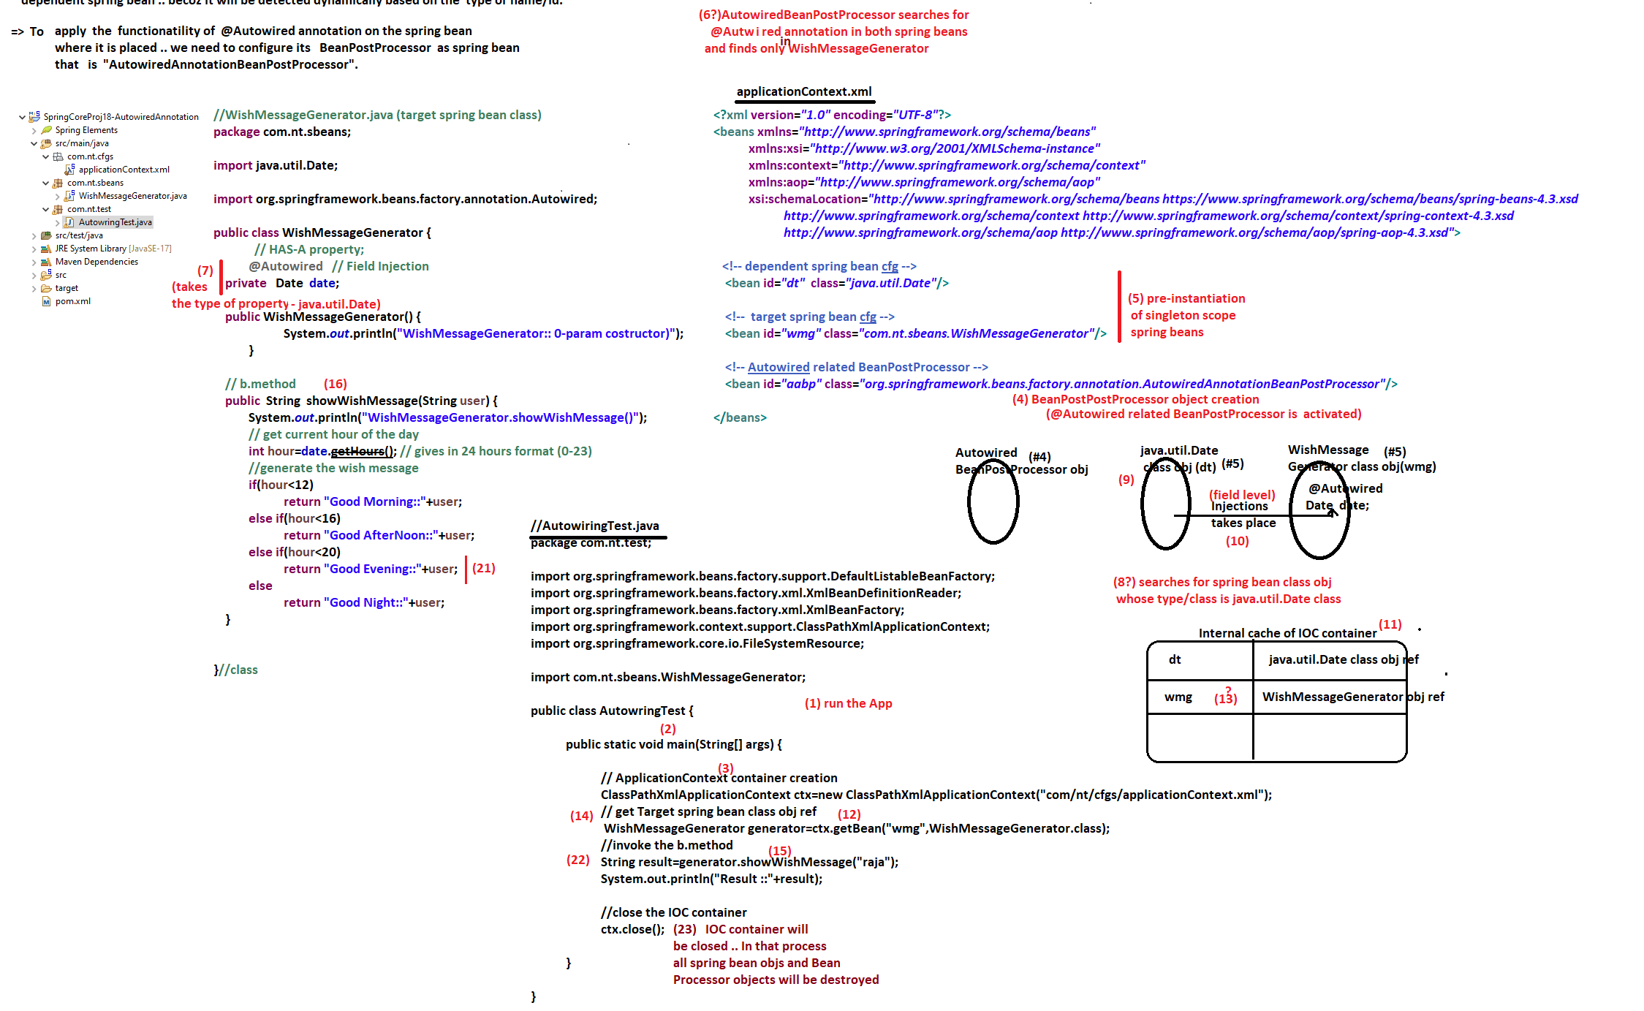

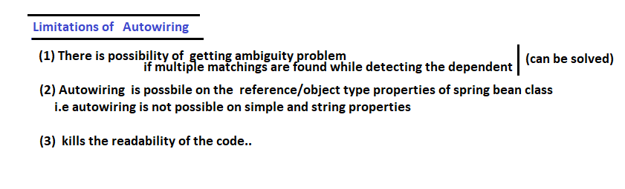

**---------------**

**03/06/2022**

**---------------**

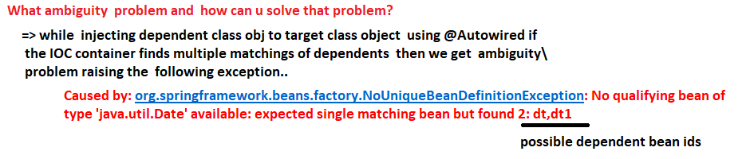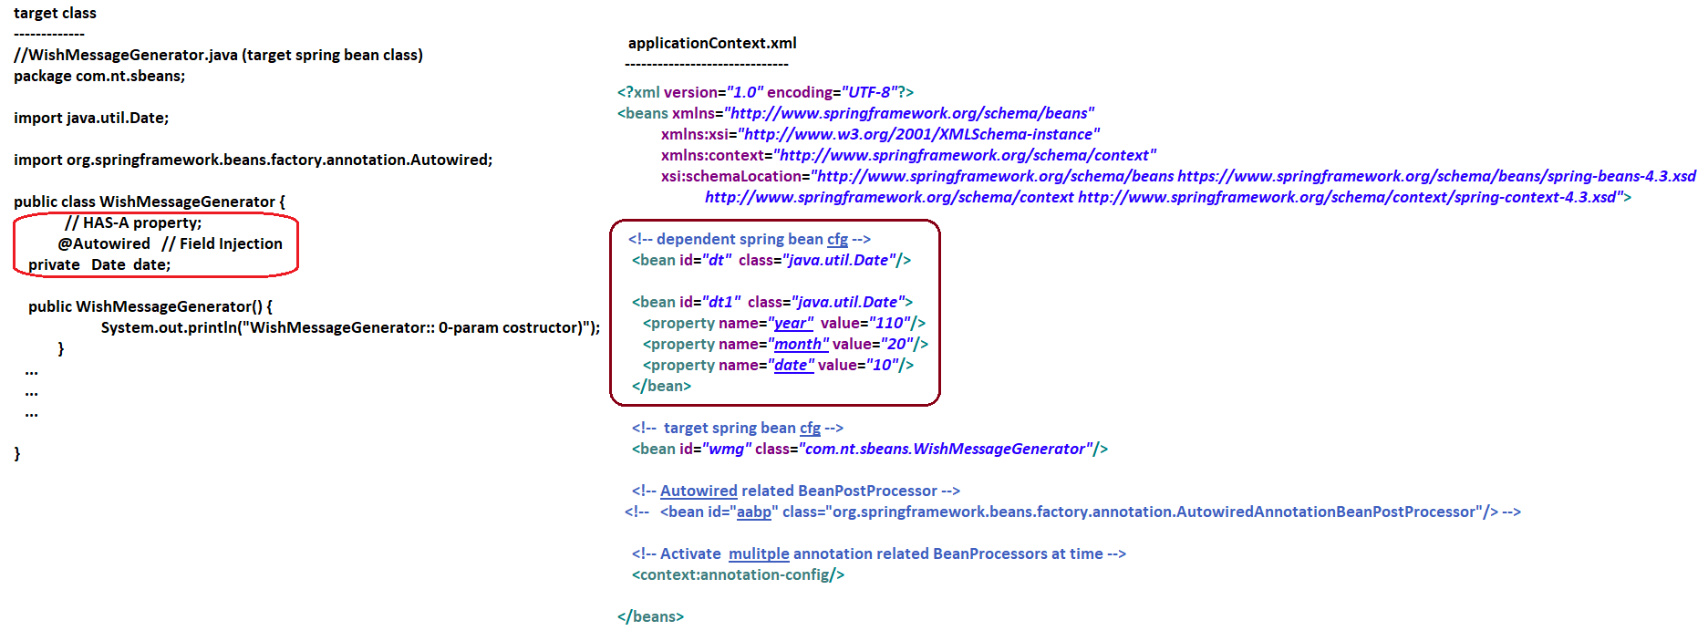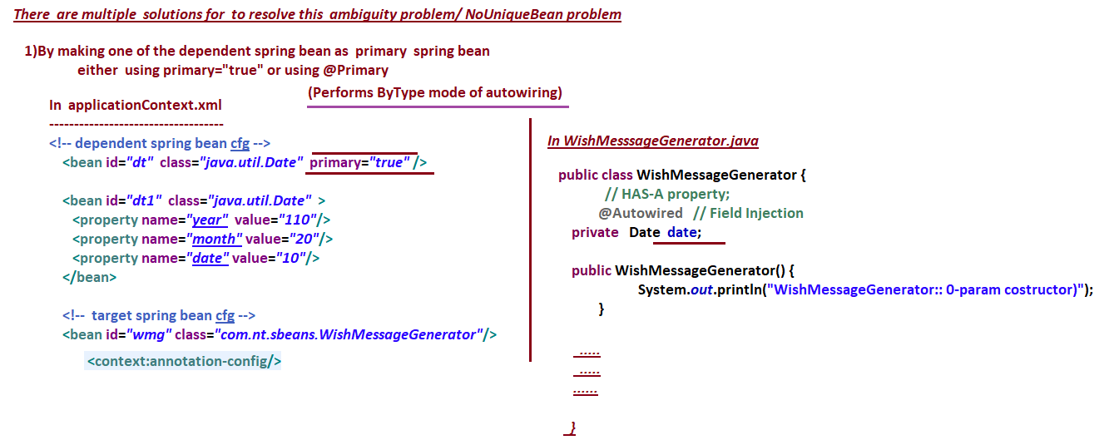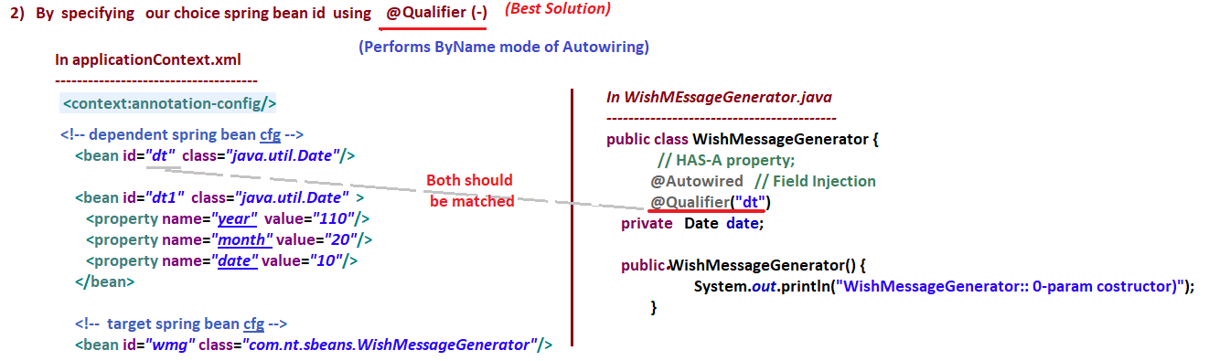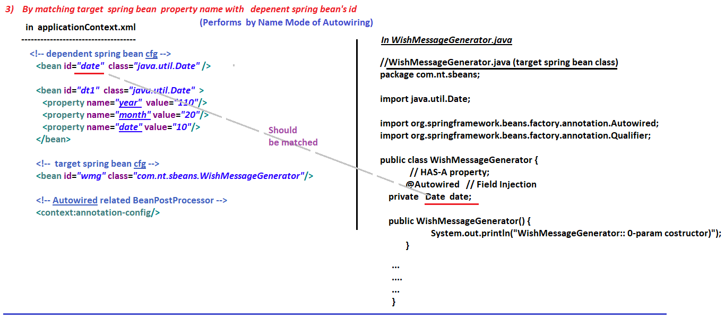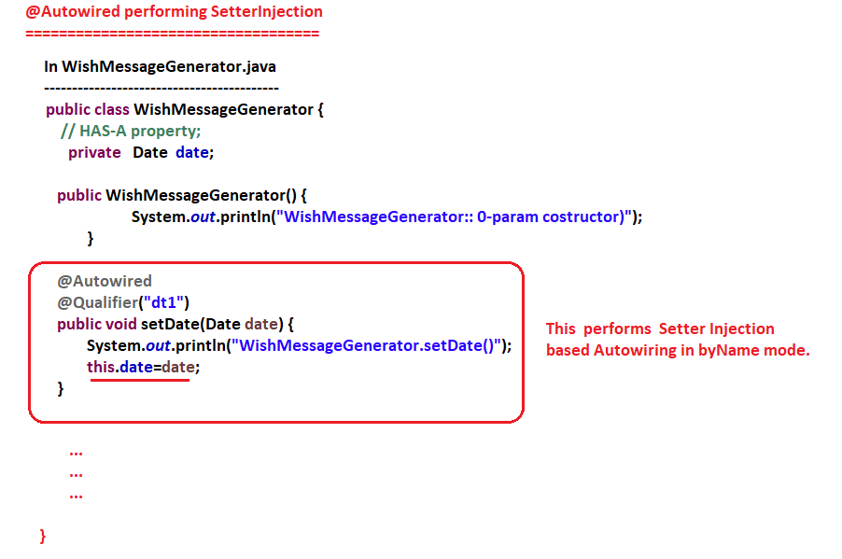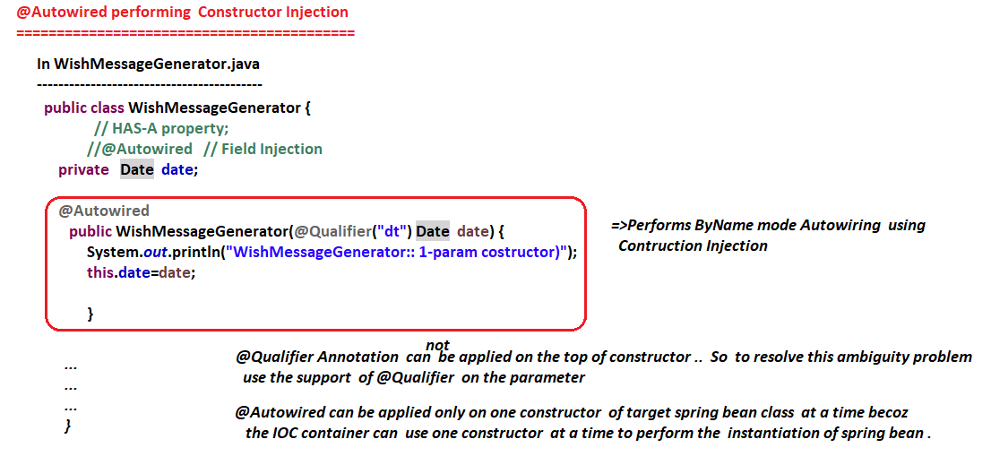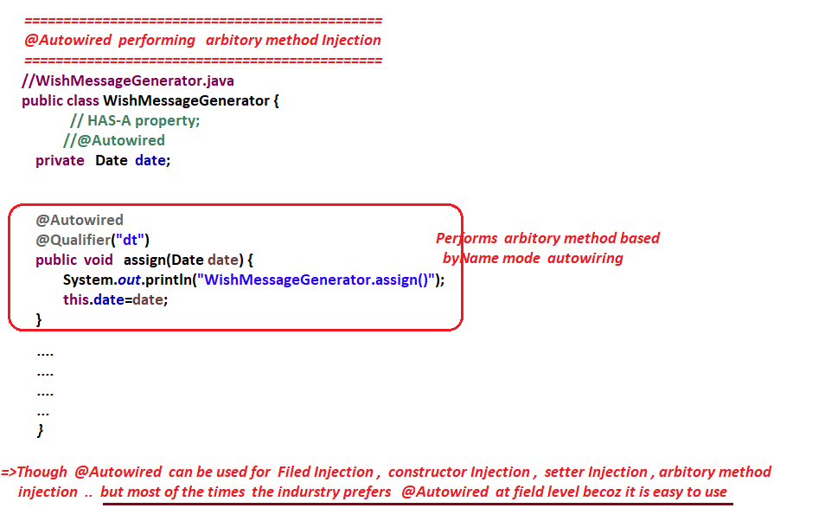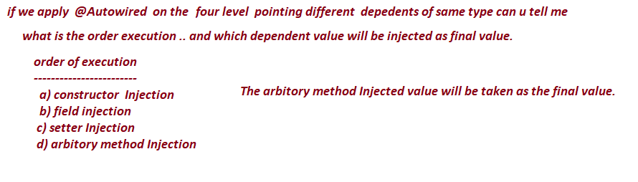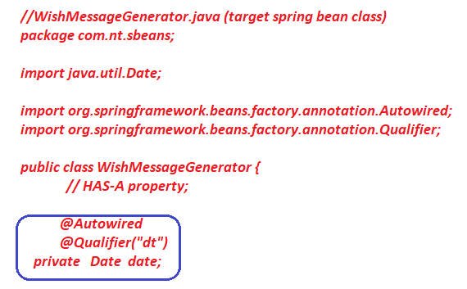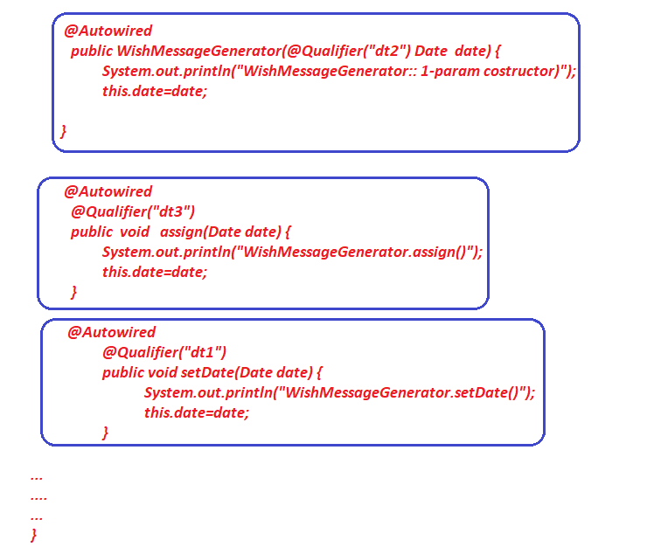

**-----------------**

**04/06/2022**

**-----------------**

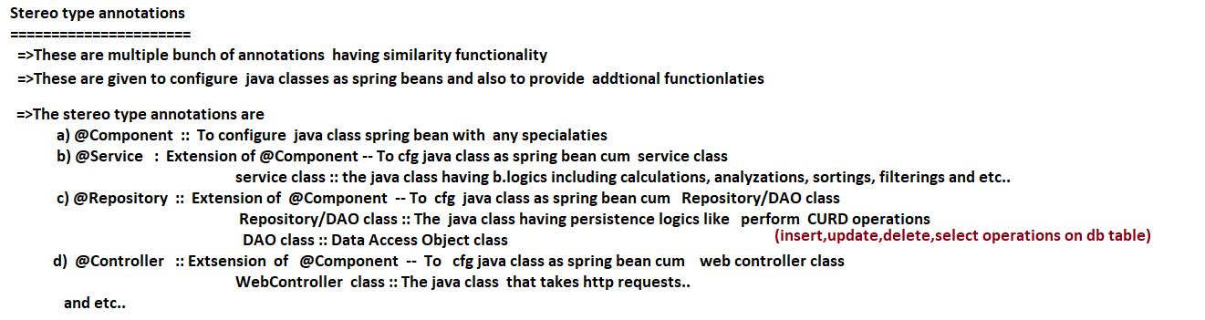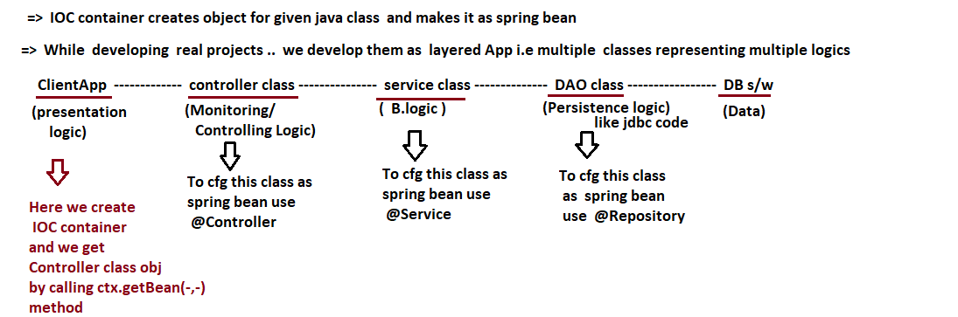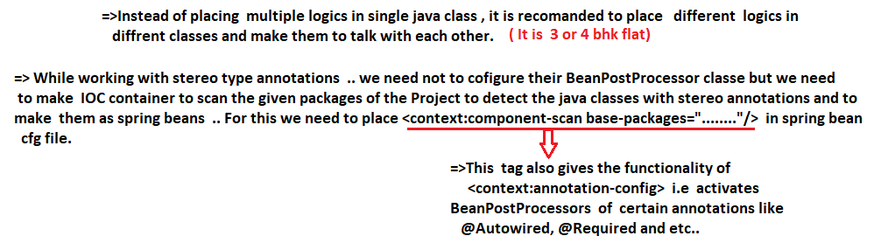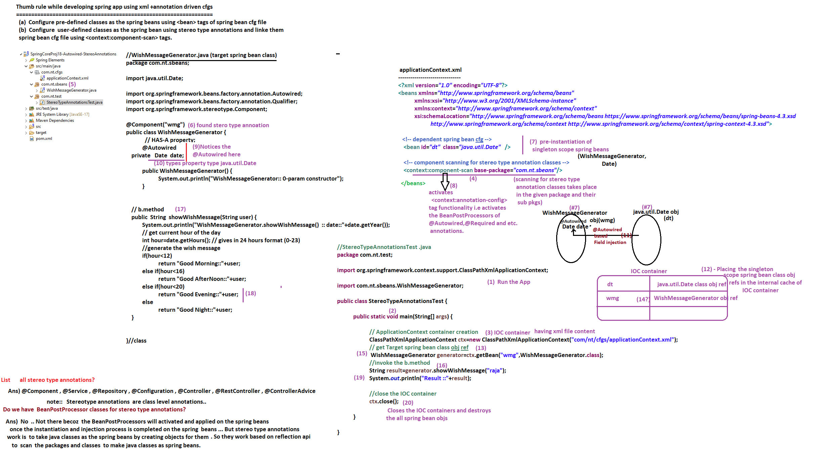

**--------------**

**06/06/2022**

**--------------**

**Spring core Annotations**

**===================**

**@Scope :: To specify the Scope of spring bean**

**@Lazy :: To enable lazy instantiation for singleton scope spring beans**

**@Primary :: To make certain dependent spring bean as Primary bean (equal to primary = “true”)**

**When the ambiguity problem is raised in the dependency Injection process.**

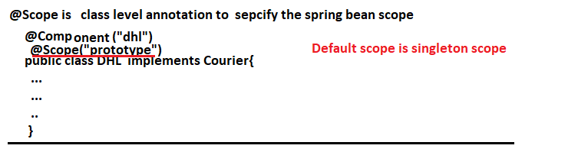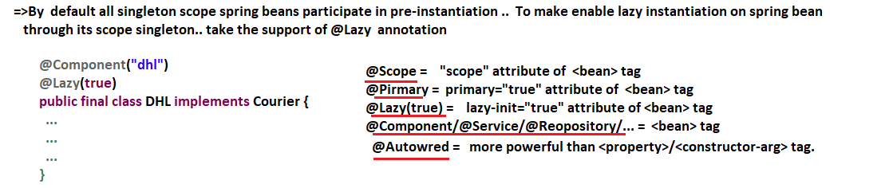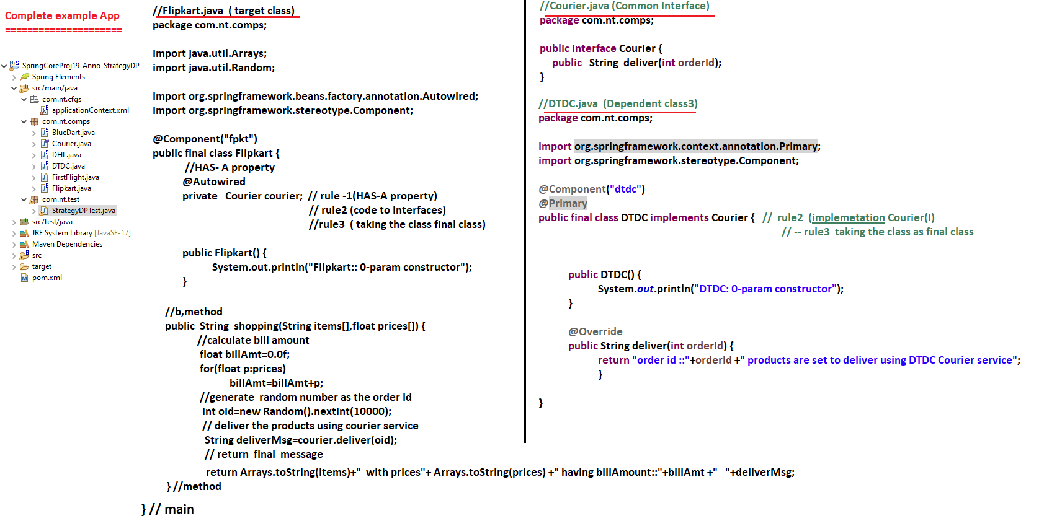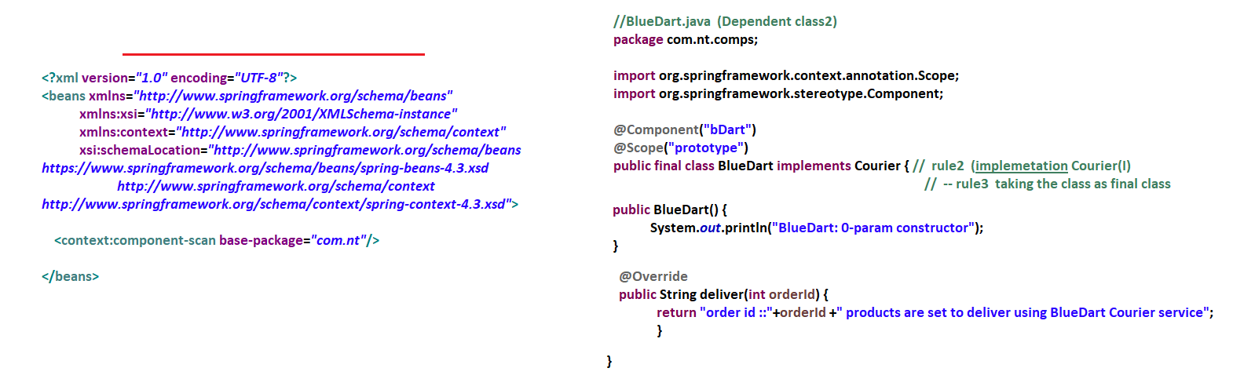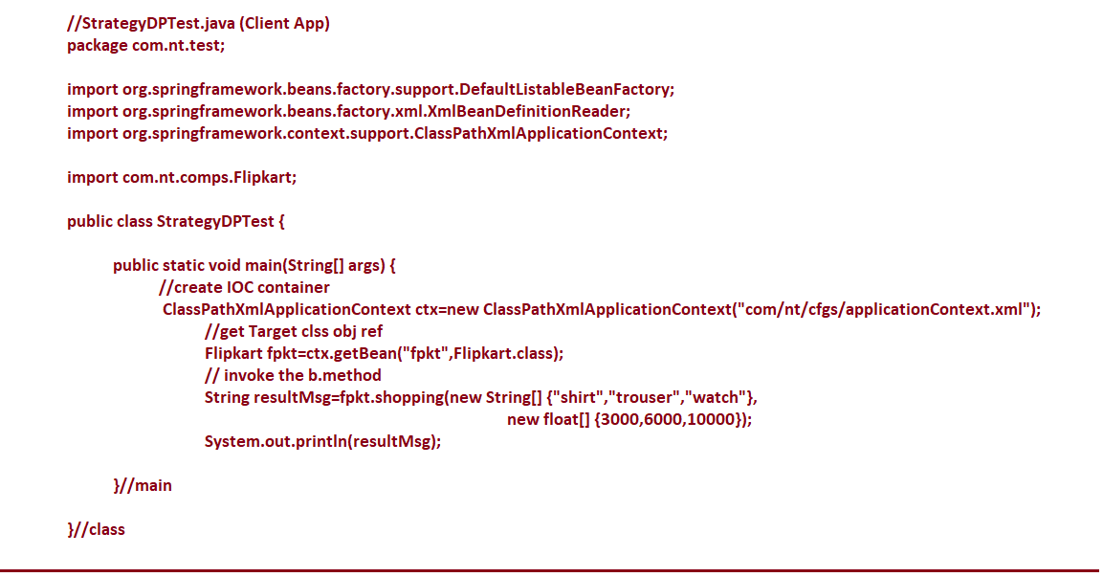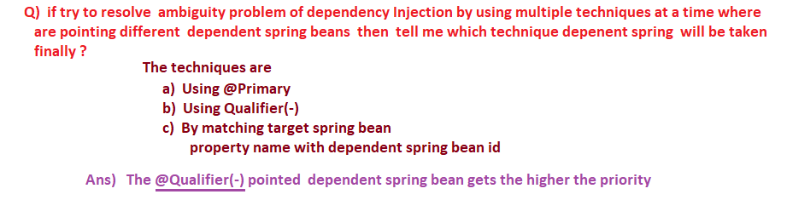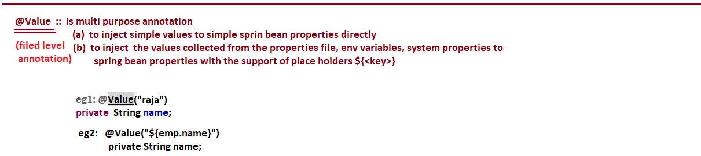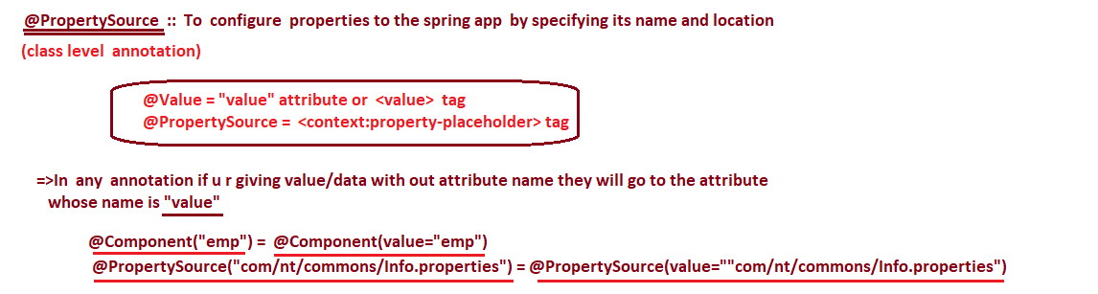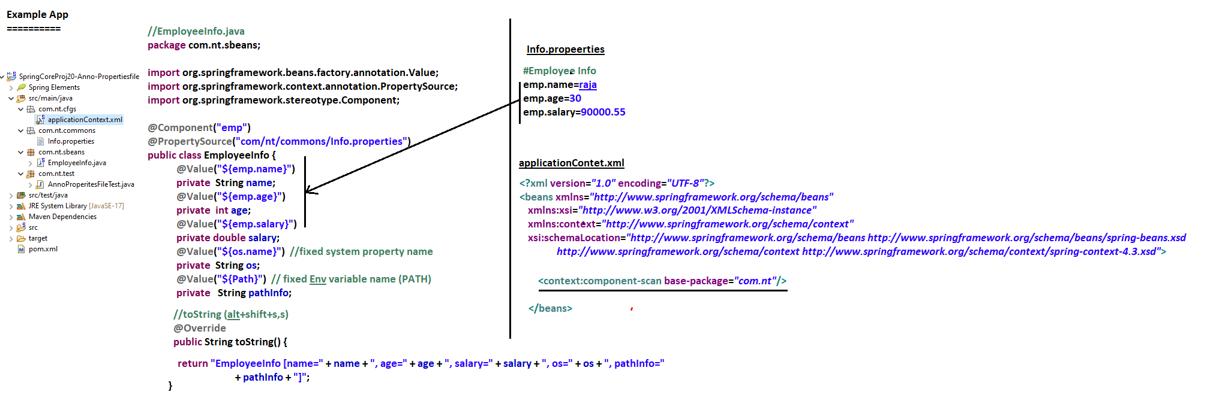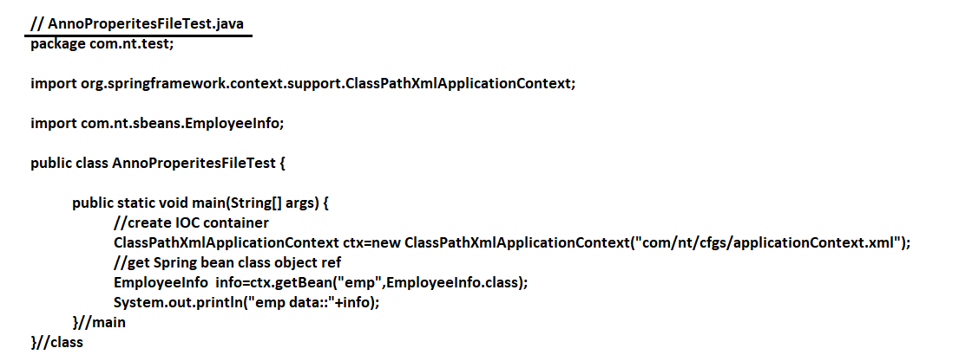

**--------------**

**07/06/2022**

**--------------**

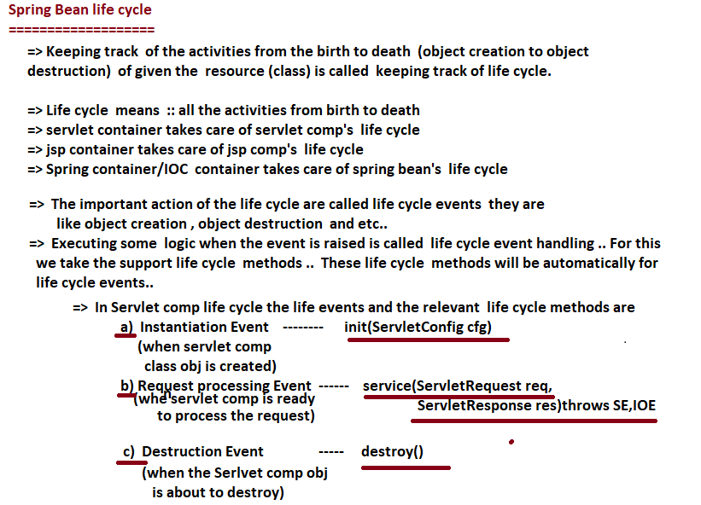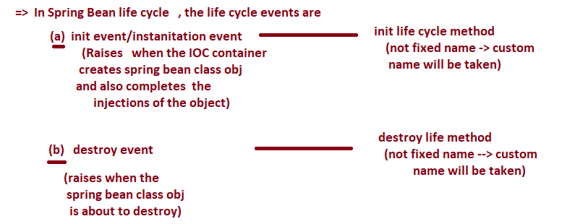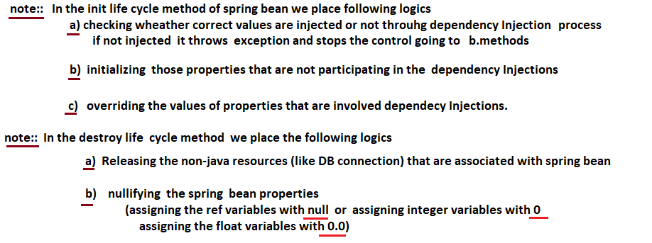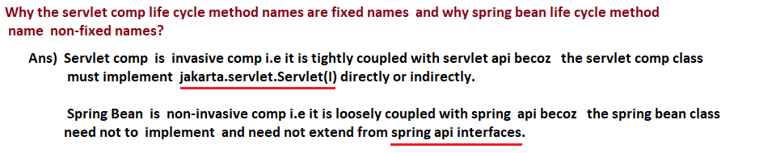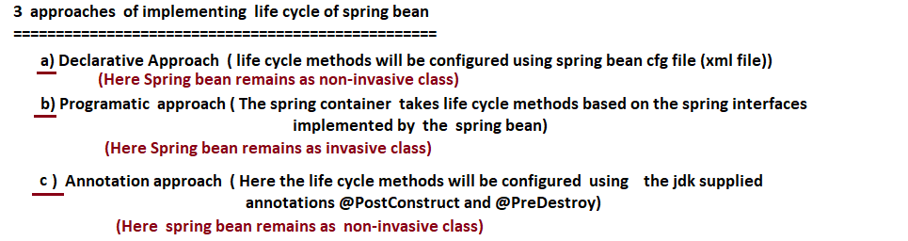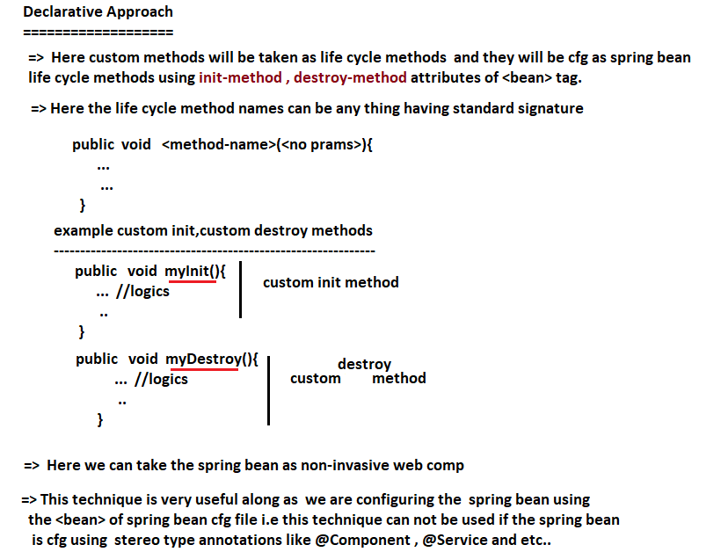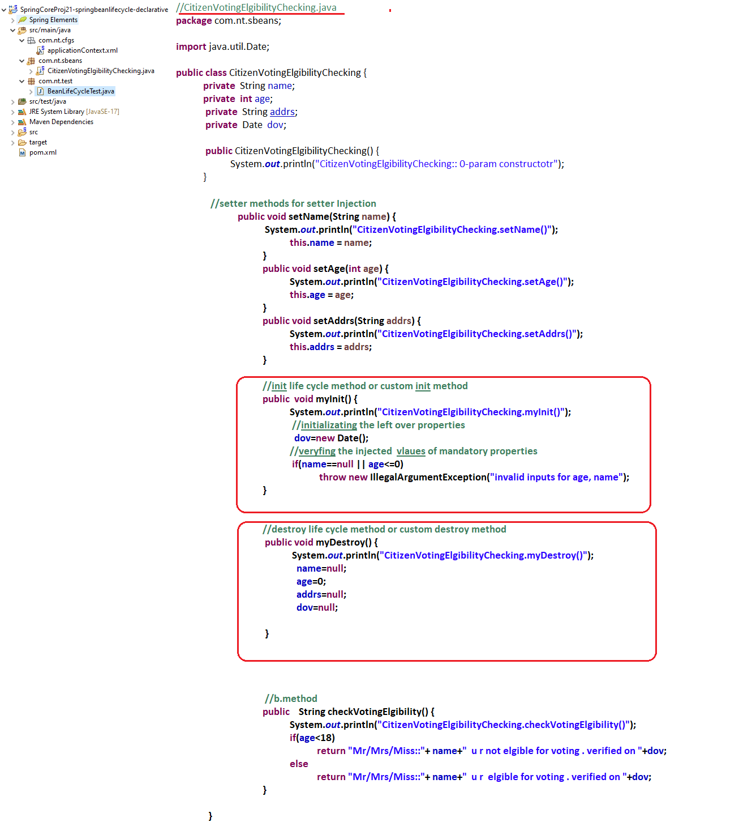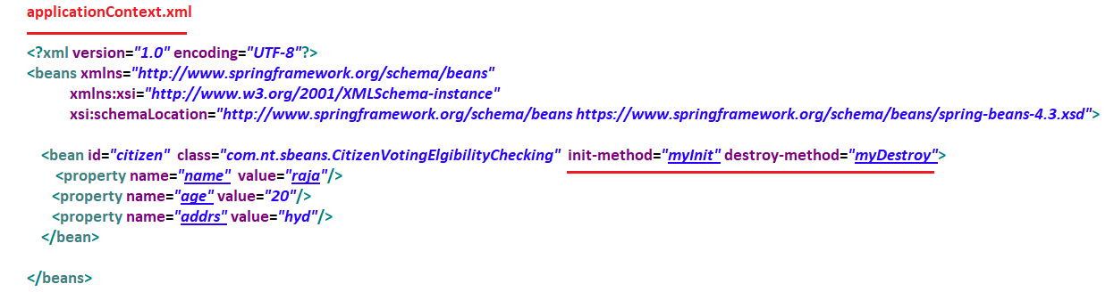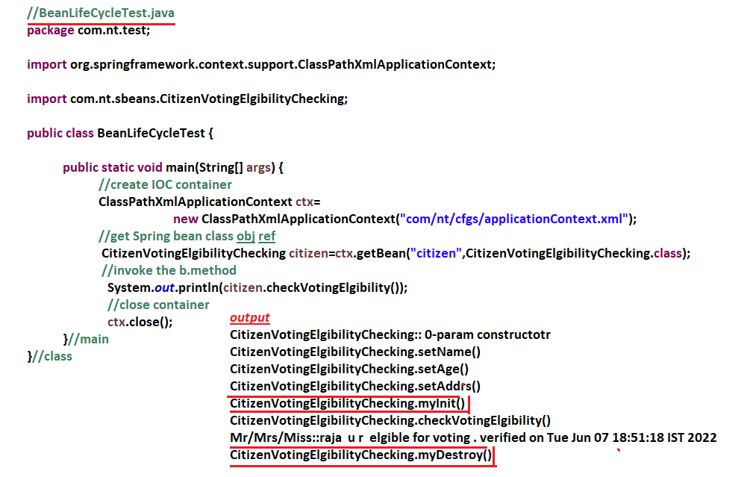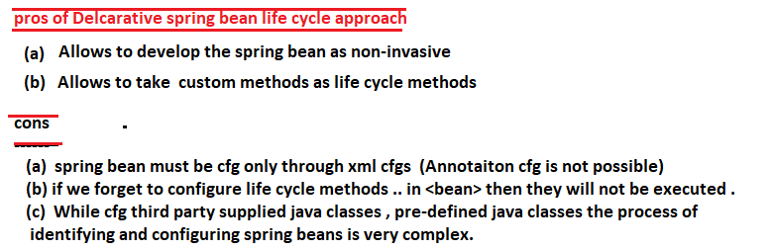

**--------------**

**09/06/2022**

**--------------**

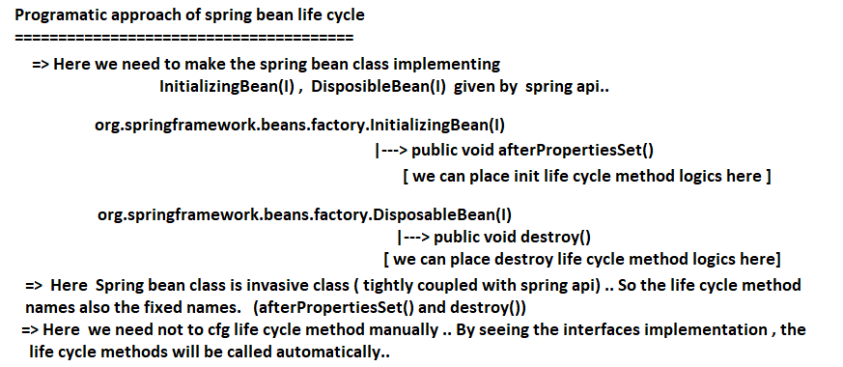

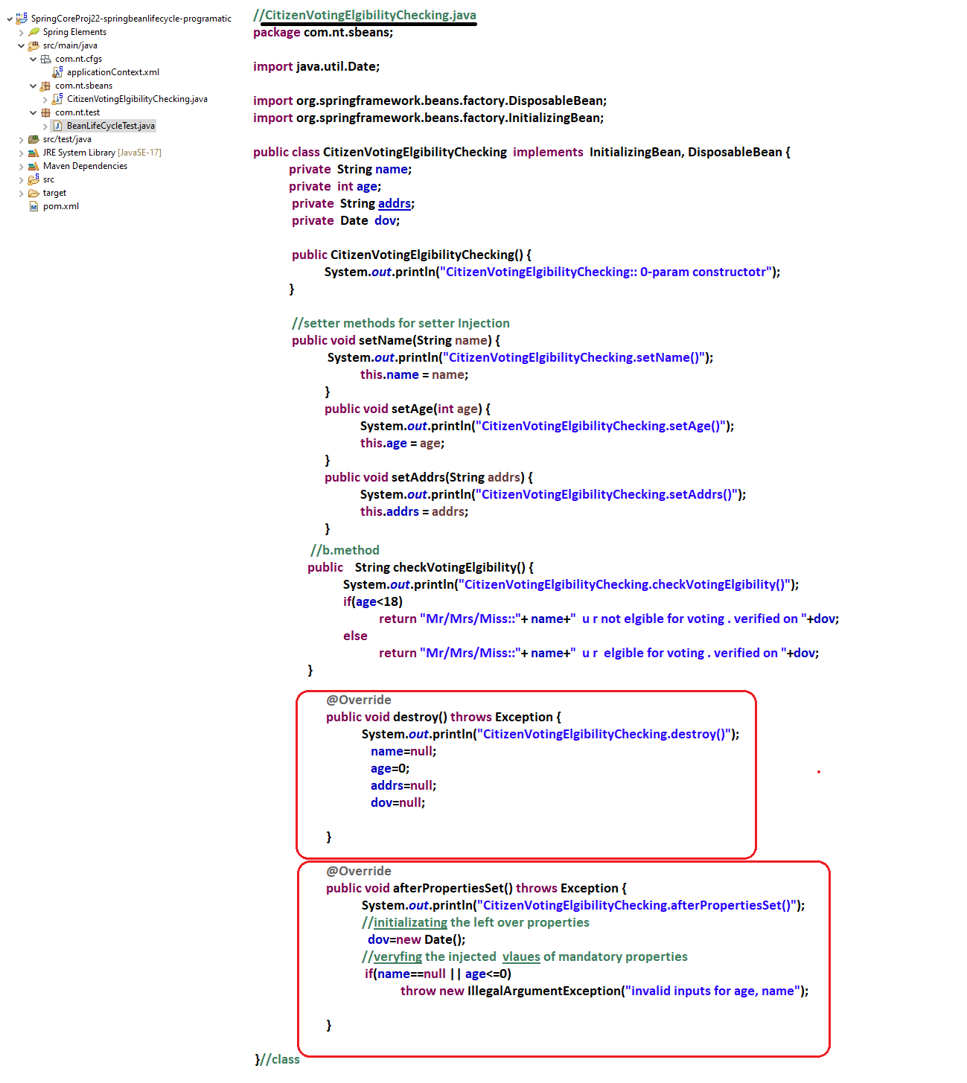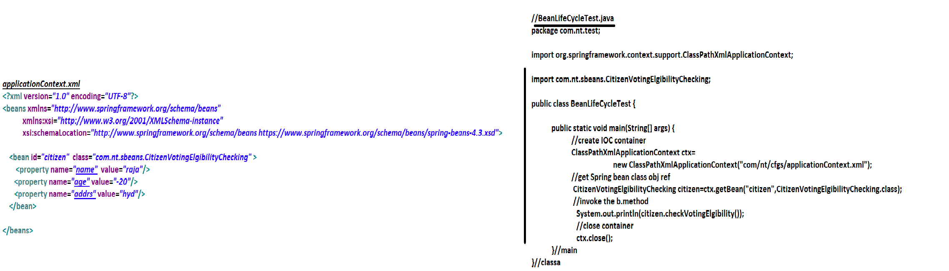

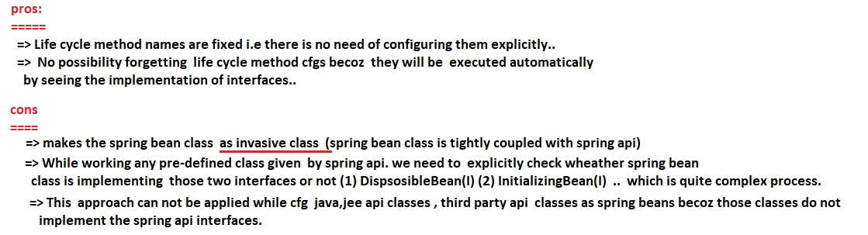

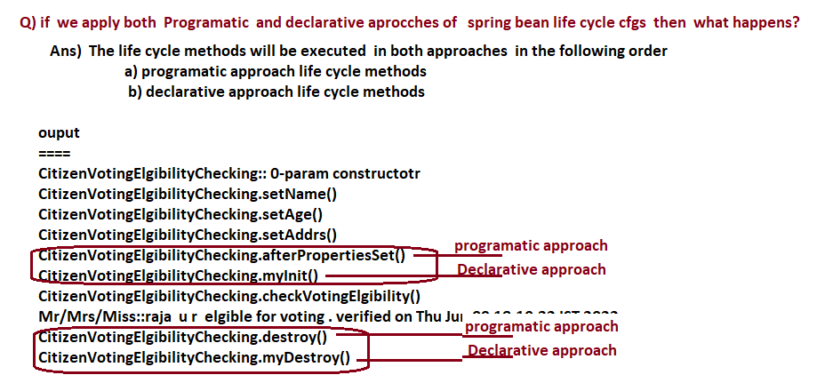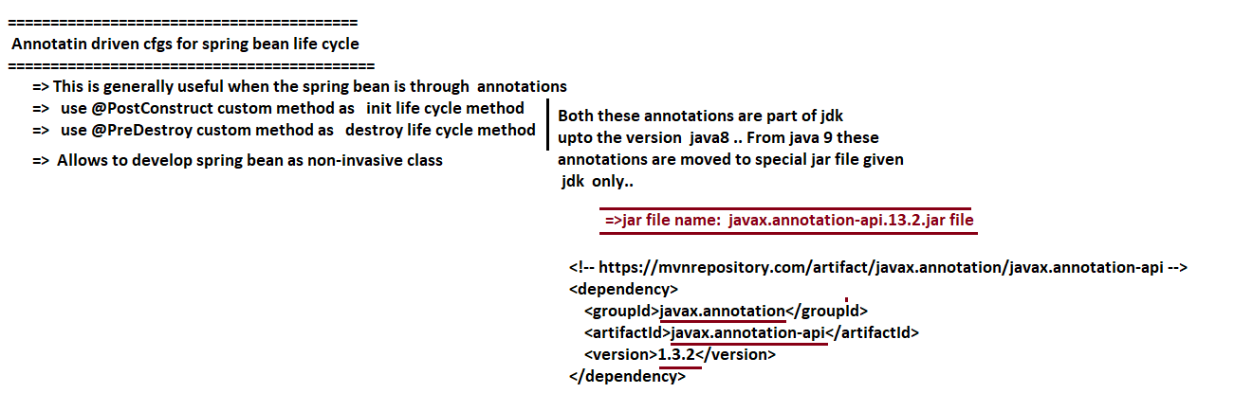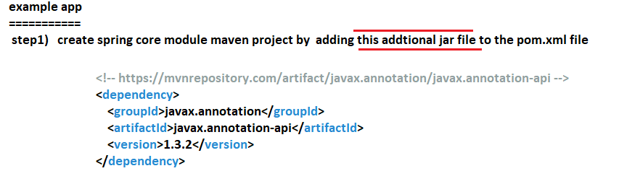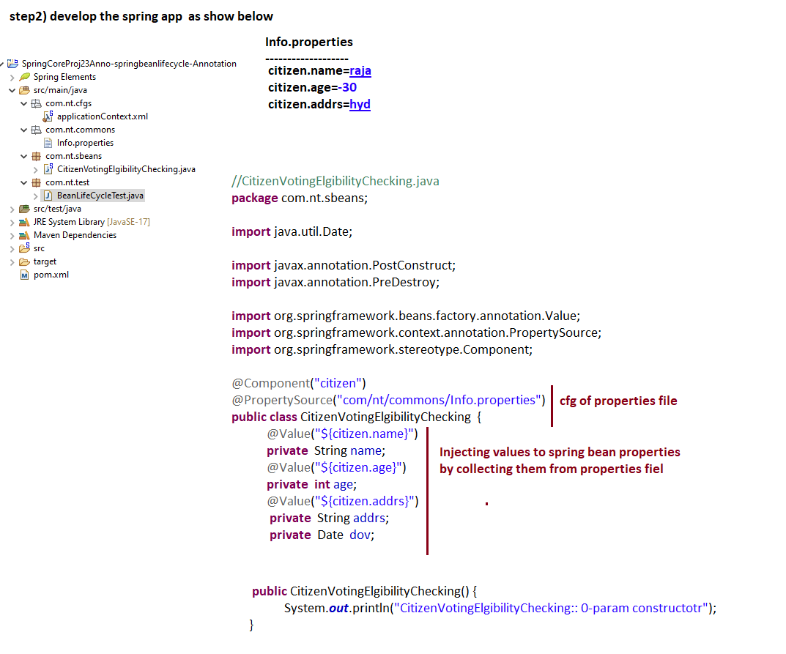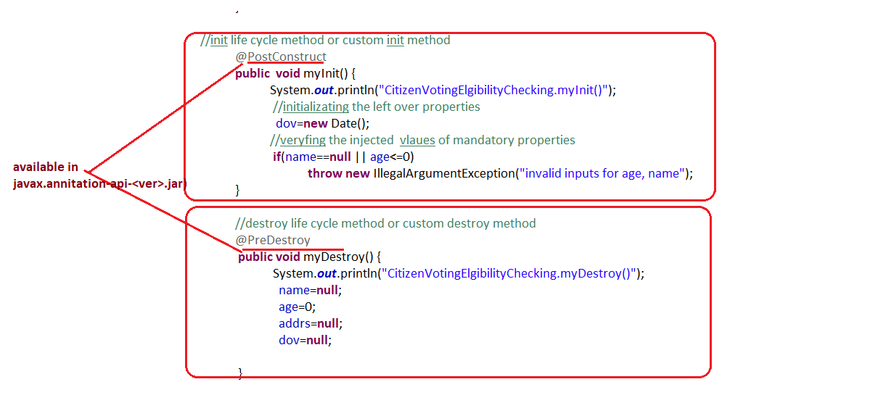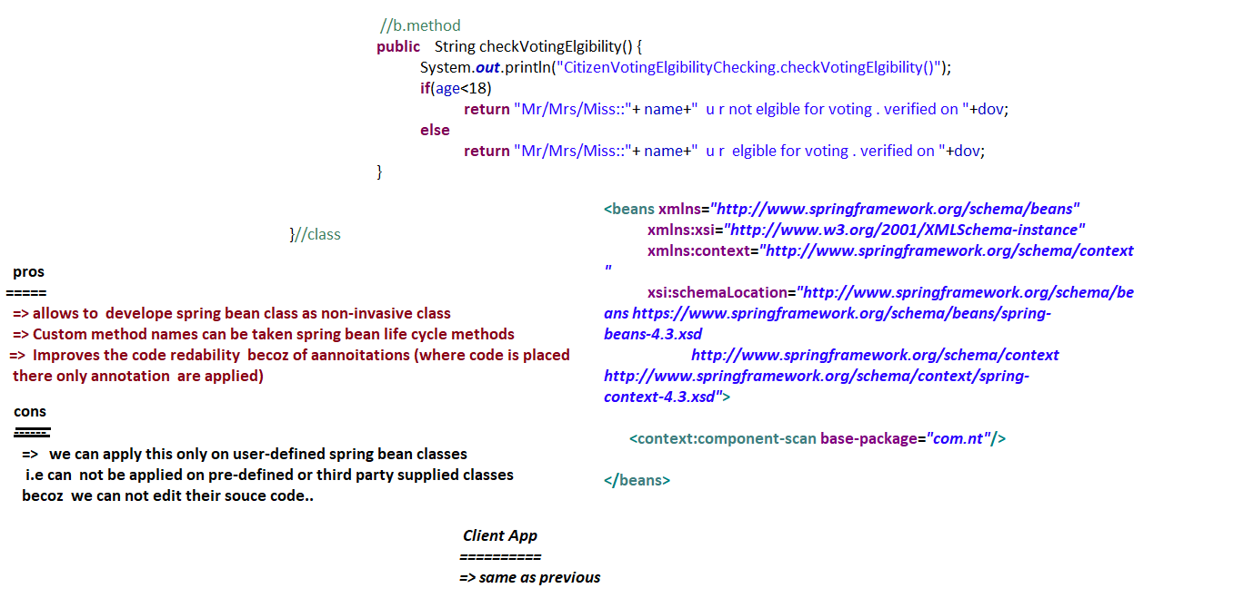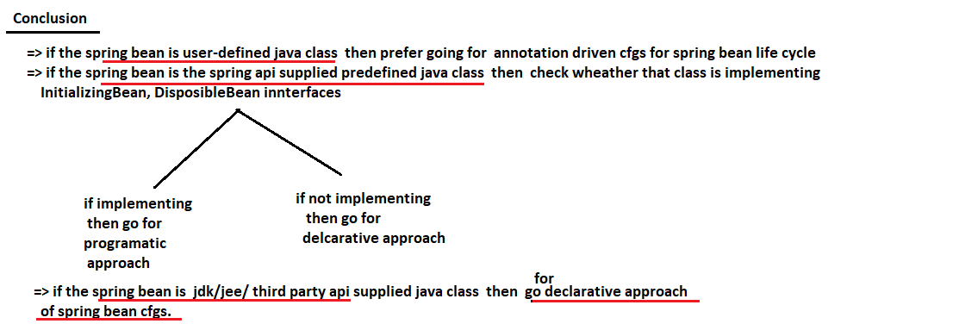

**------------------**

**10/06/2022**

**------------------**

**Different approaches developing the spring app**

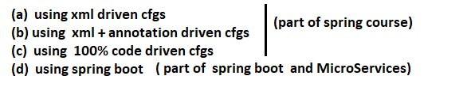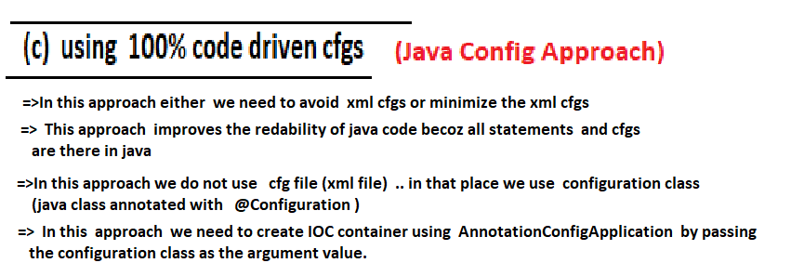

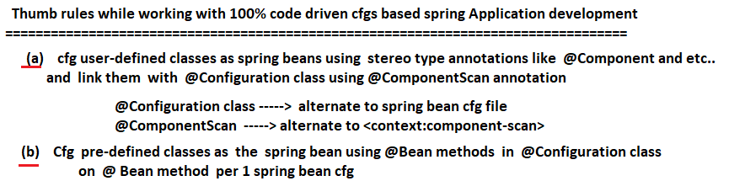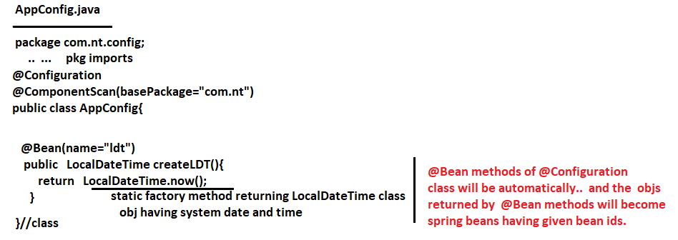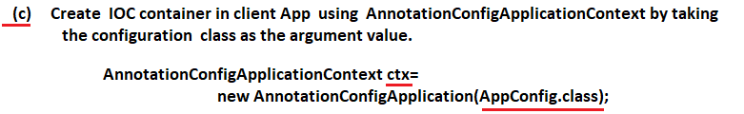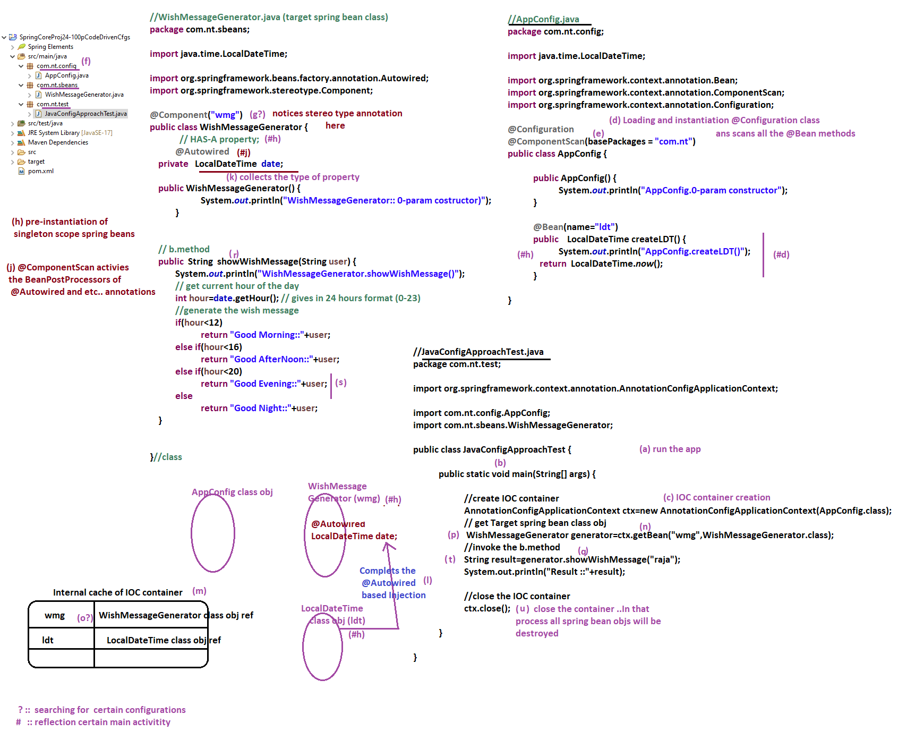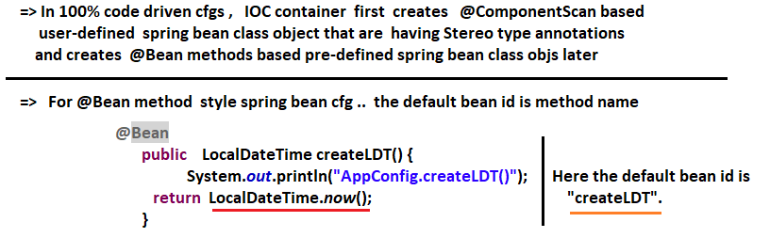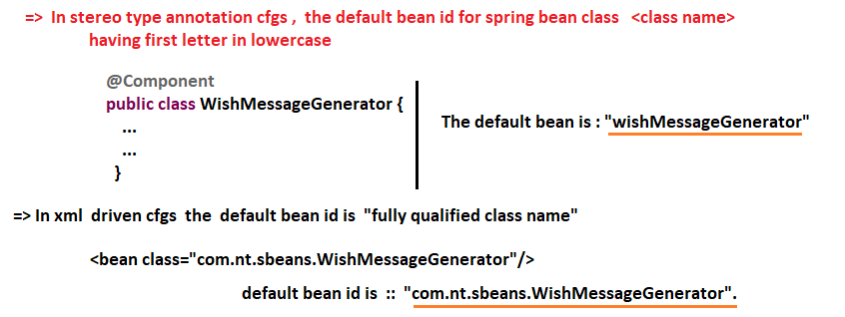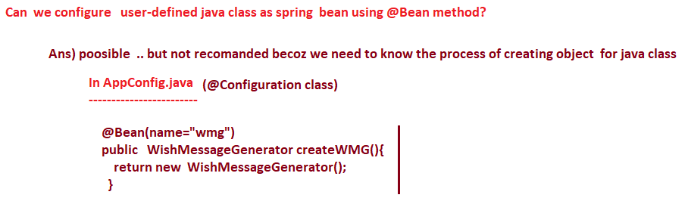

**--------------**

**14/06/2022**

**--------------**

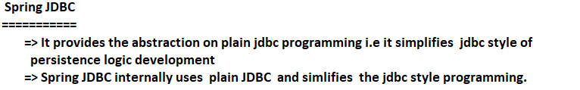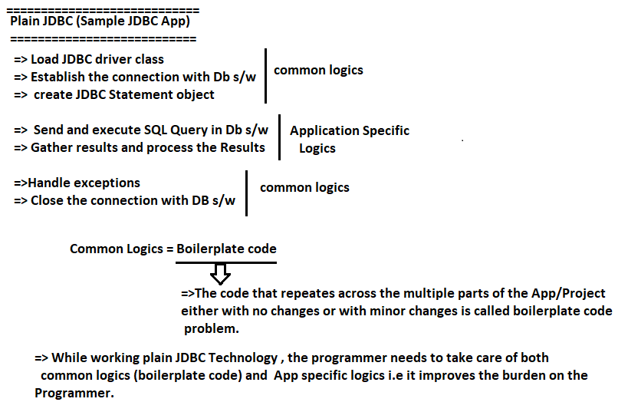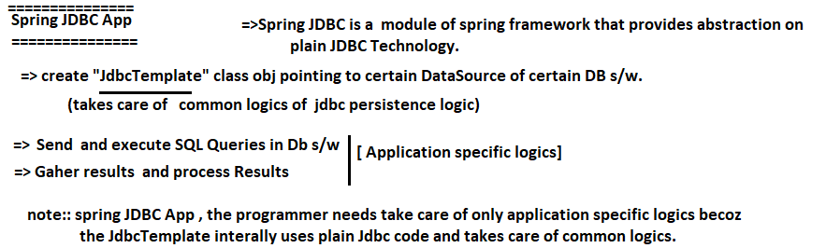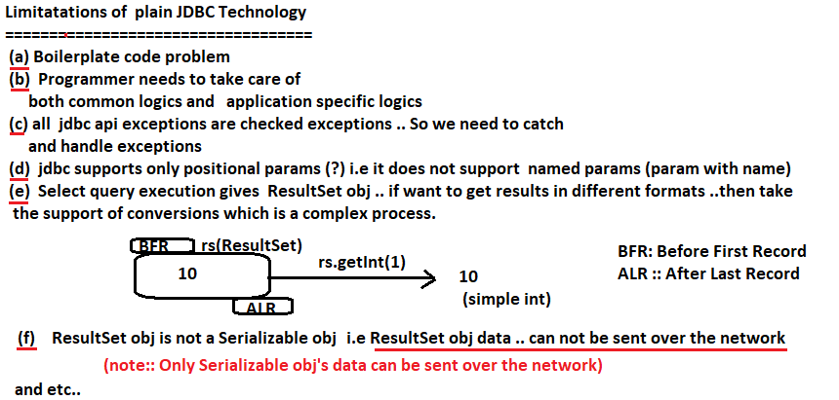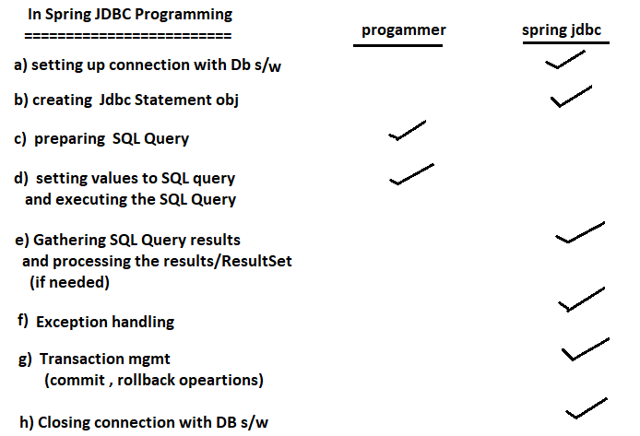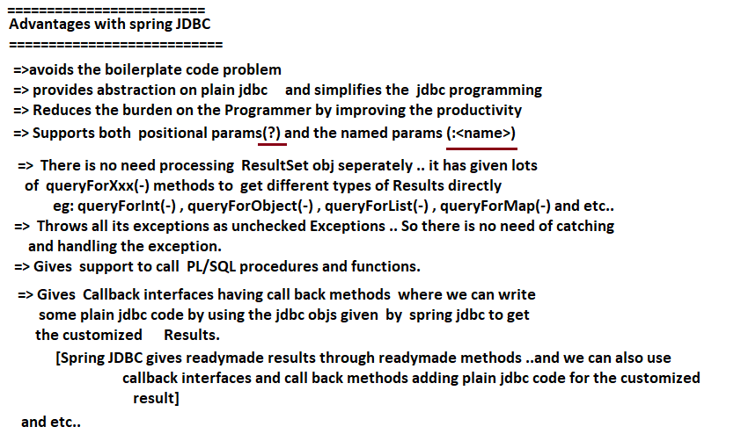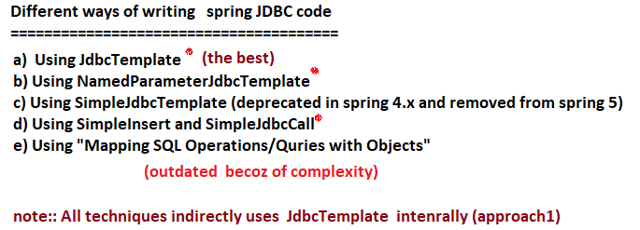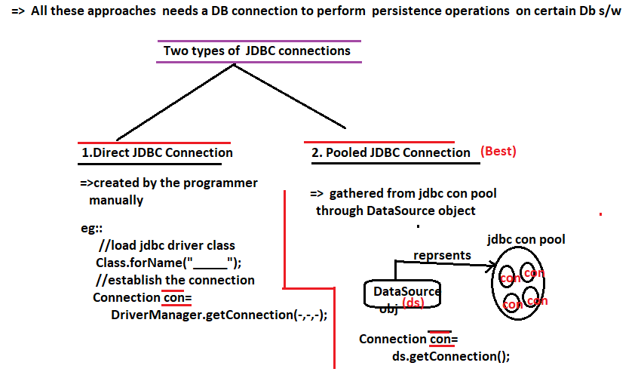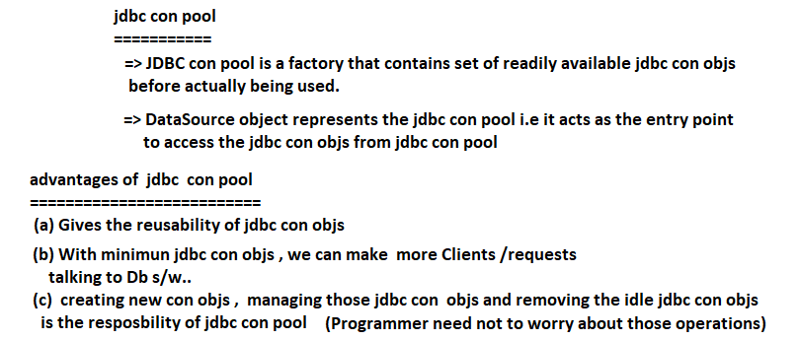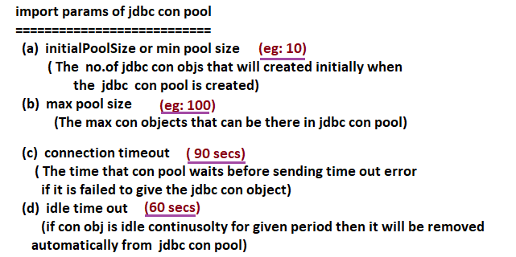

**---------------**

**15/06/2022**

**---------------**

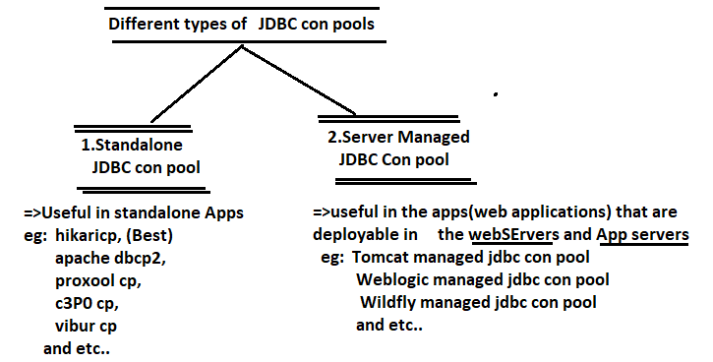

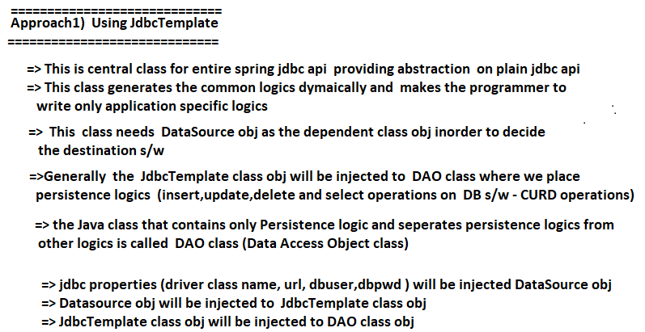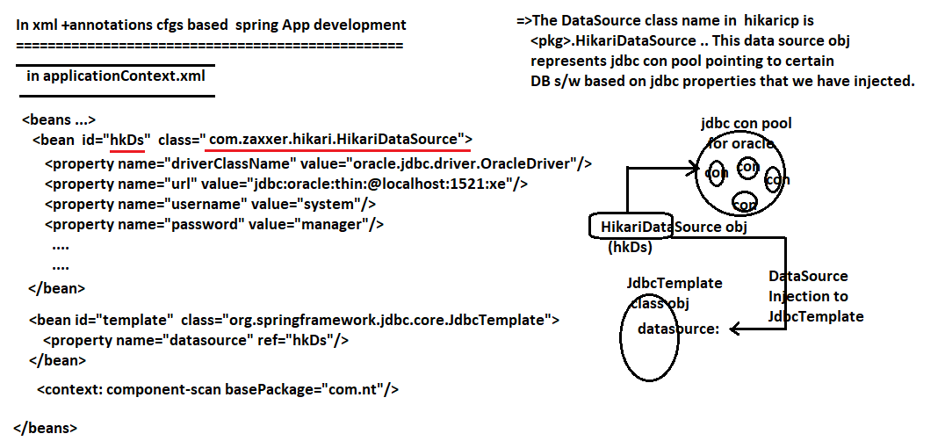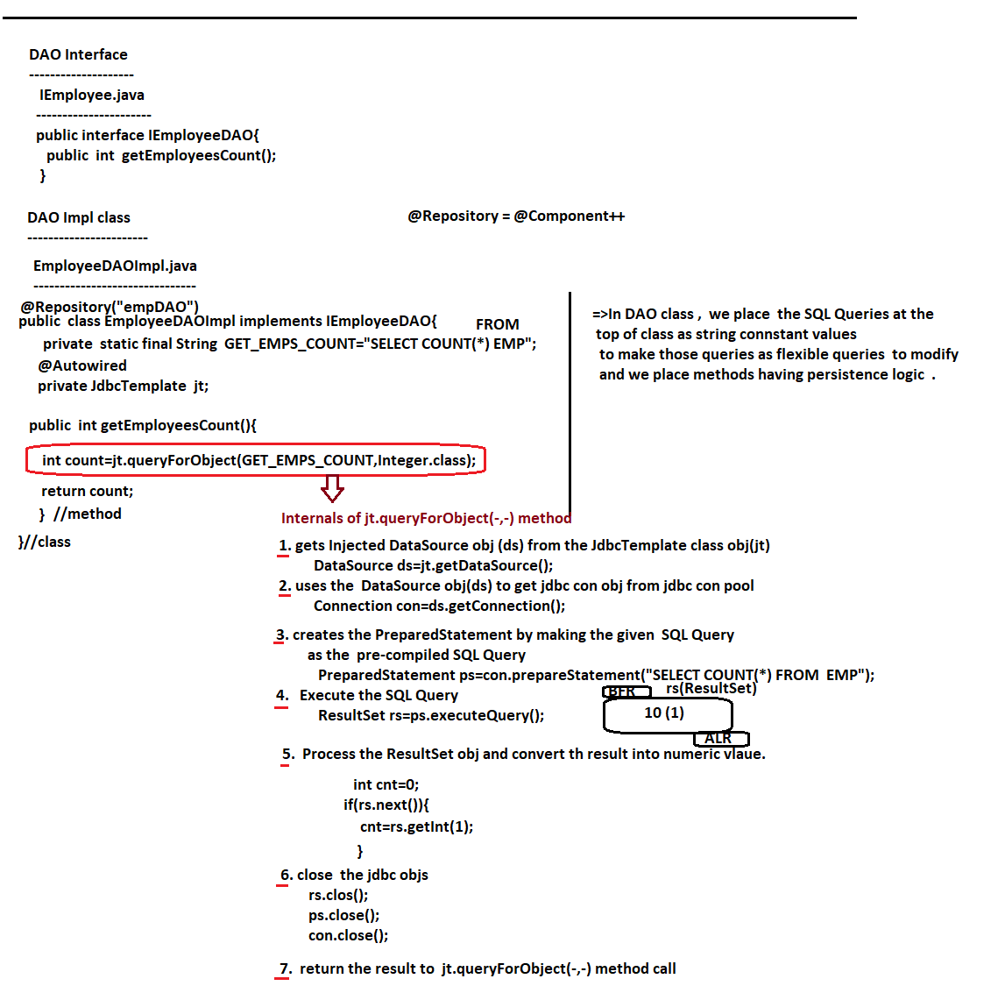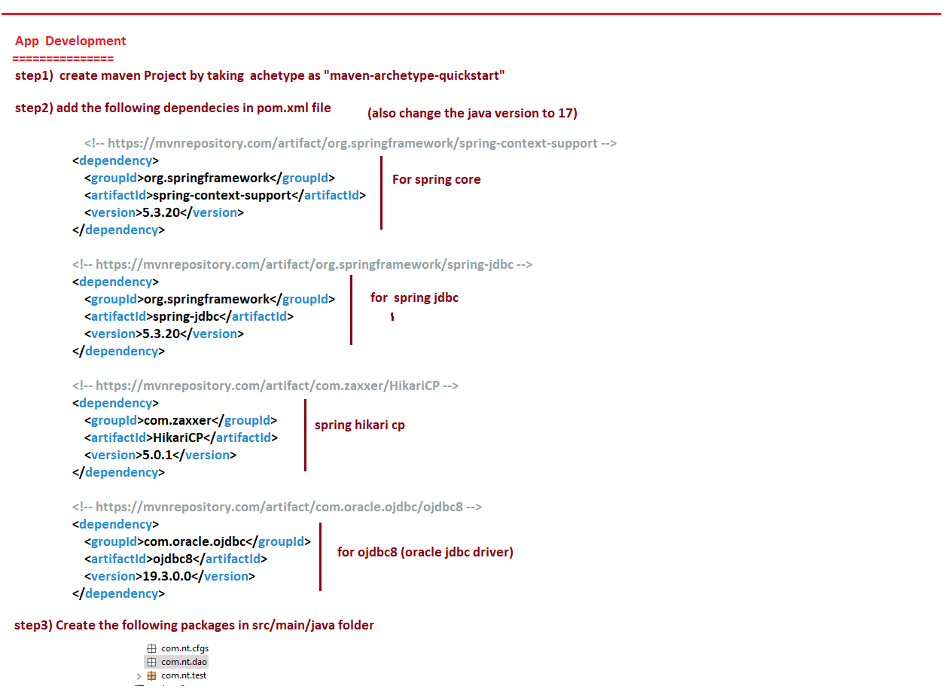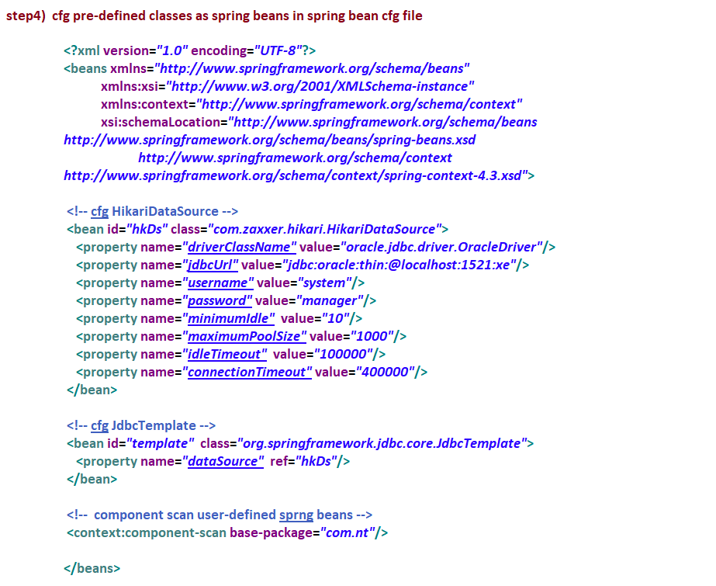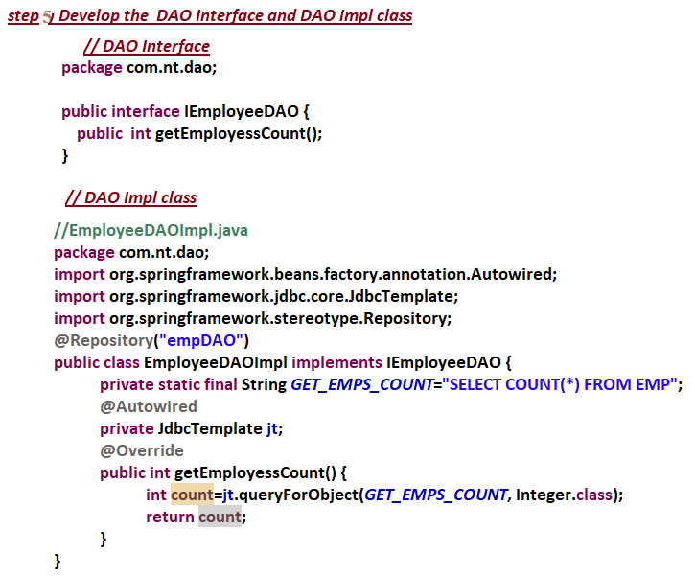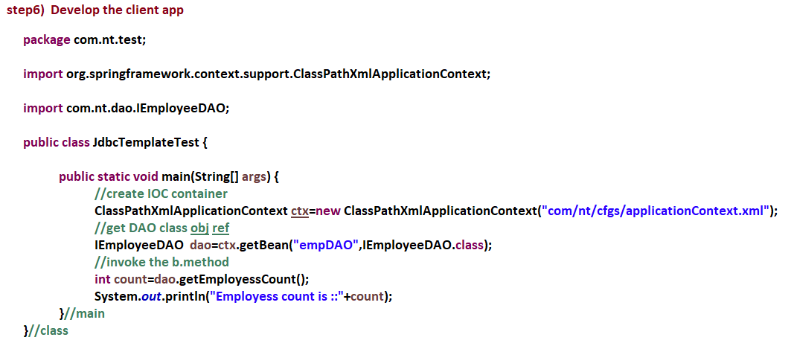

**--------------**

**16/06/2022**

**---------------**

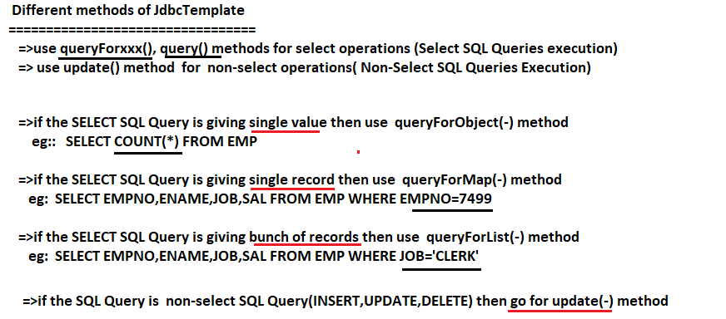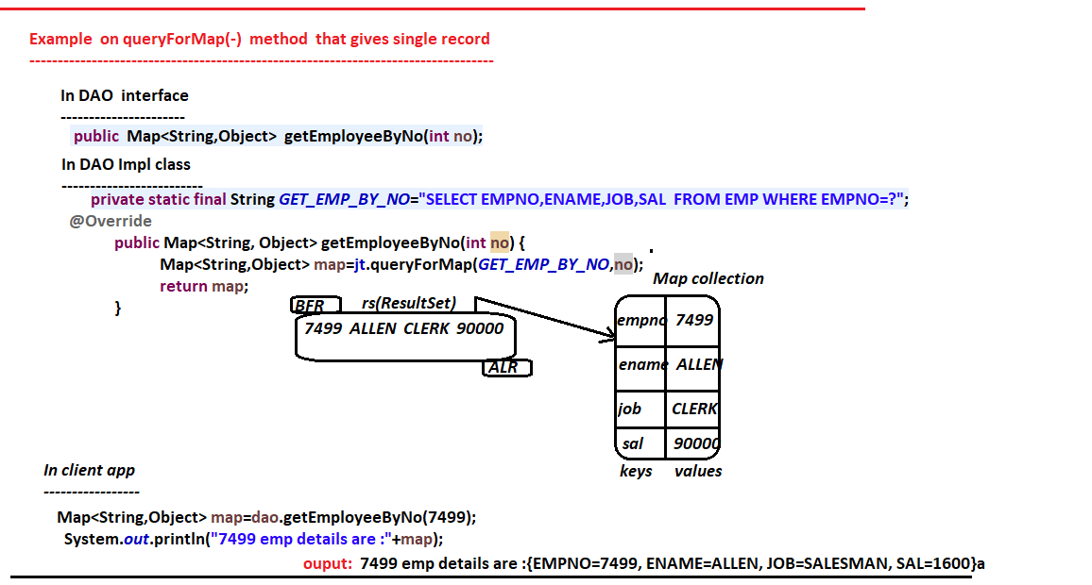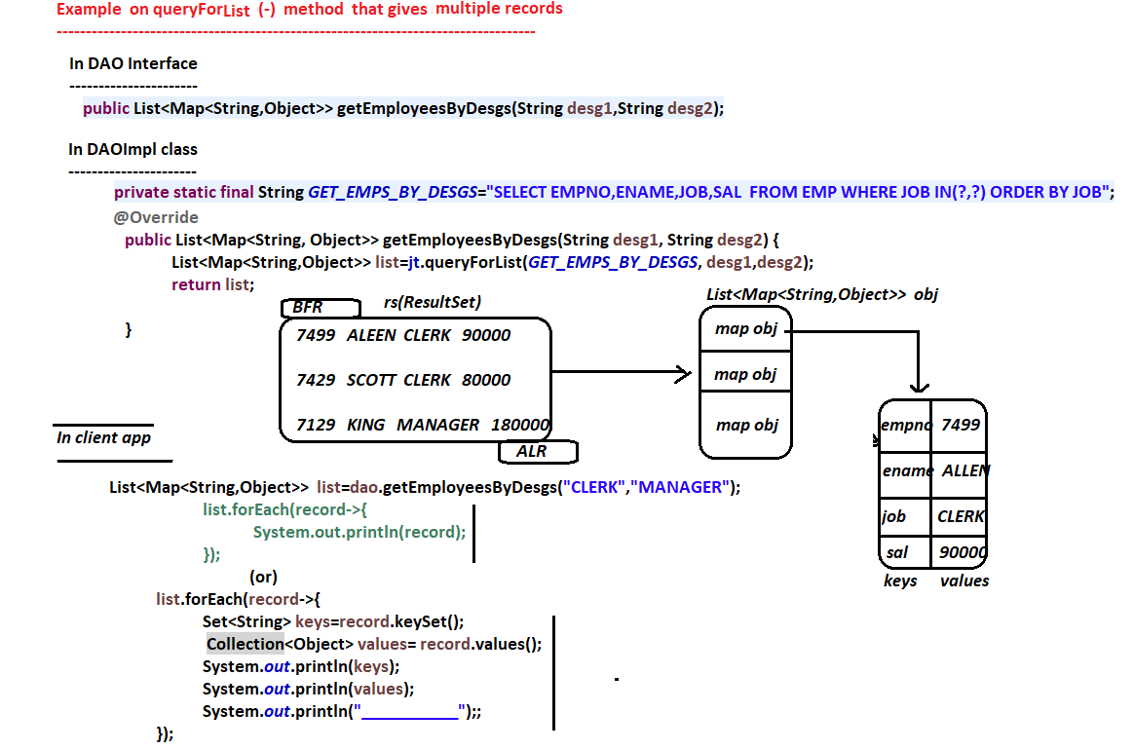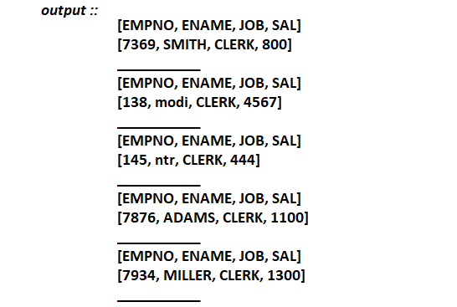

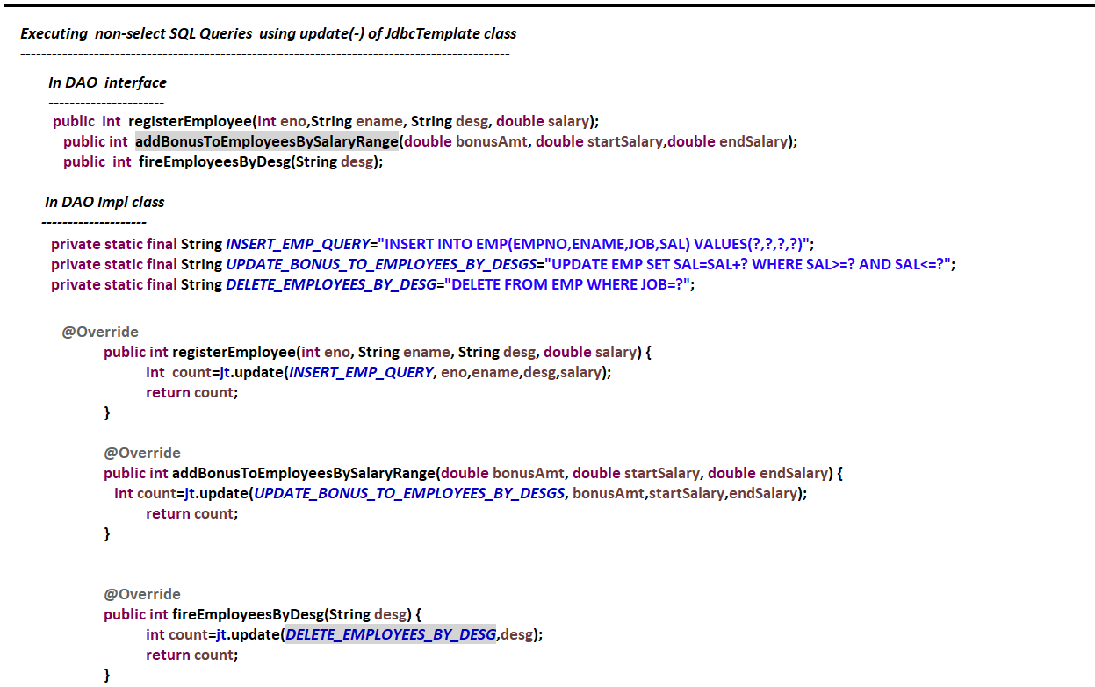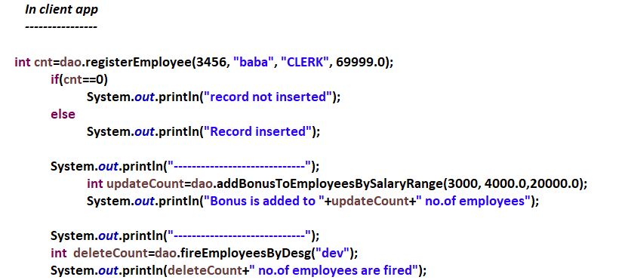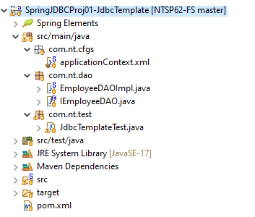

**-------------**

**17/06/2022**

**--------------**

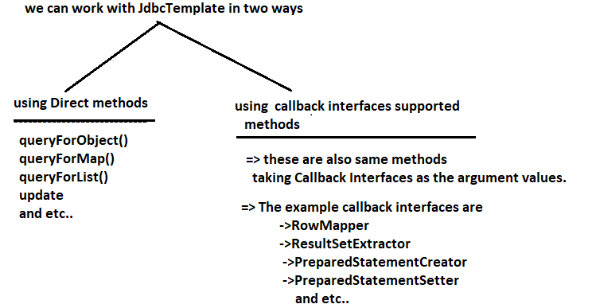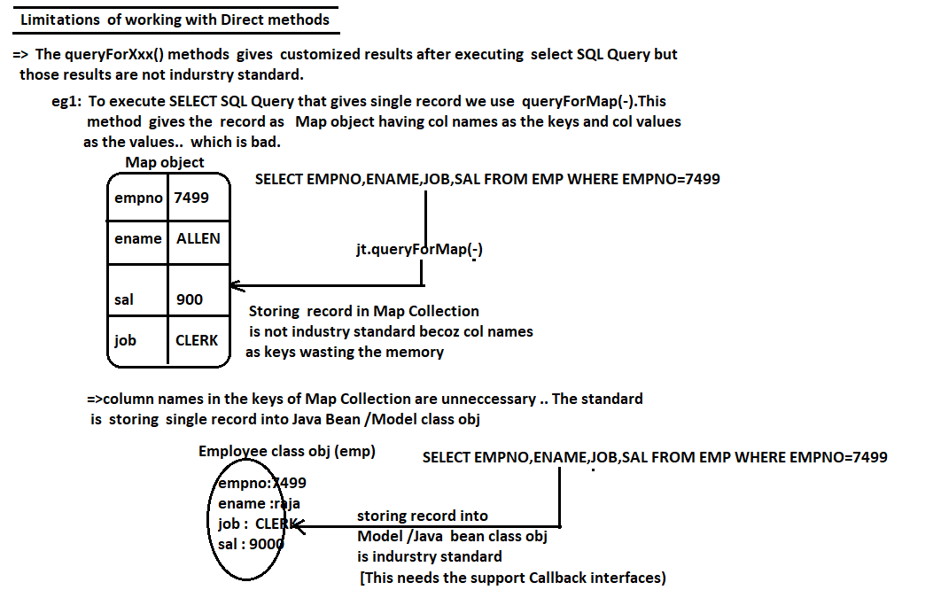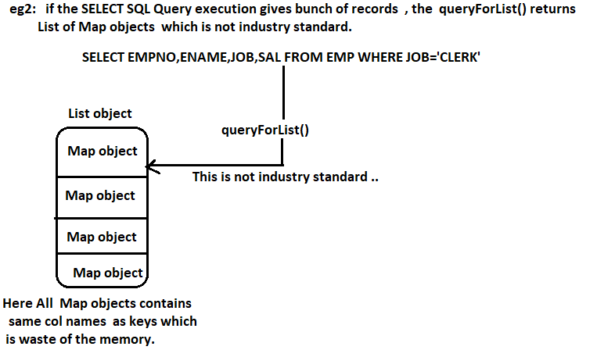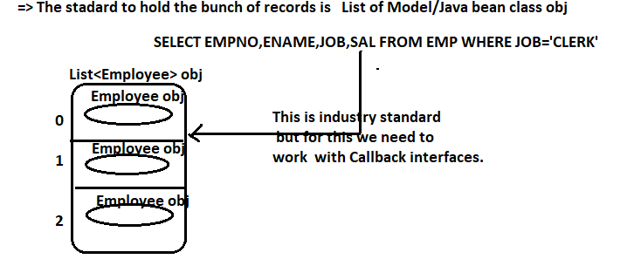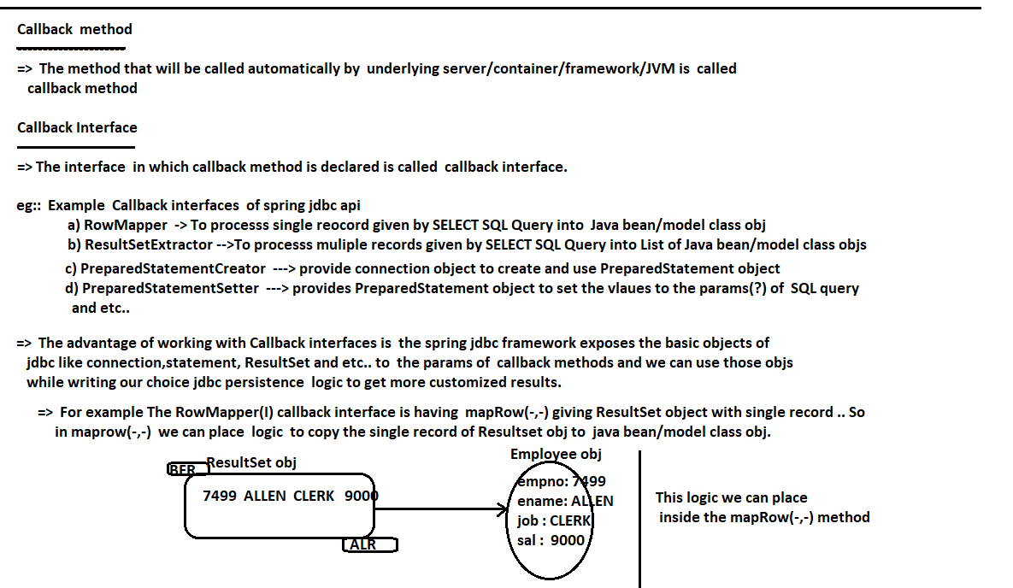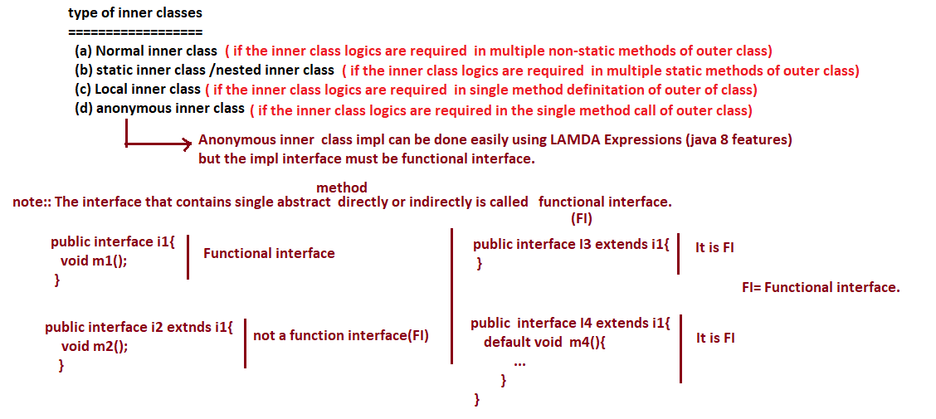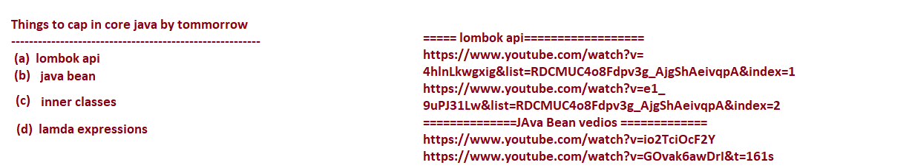

**---------------**

**18/06/2022**

**---------------**

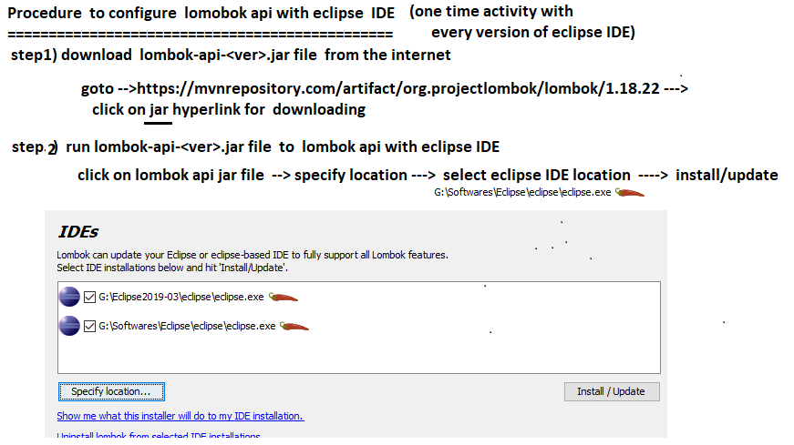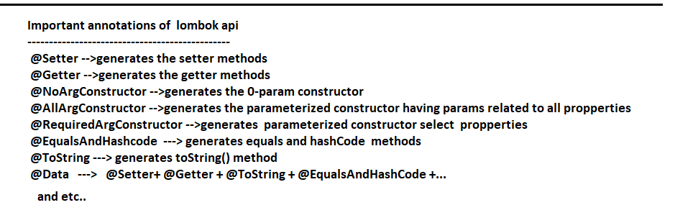

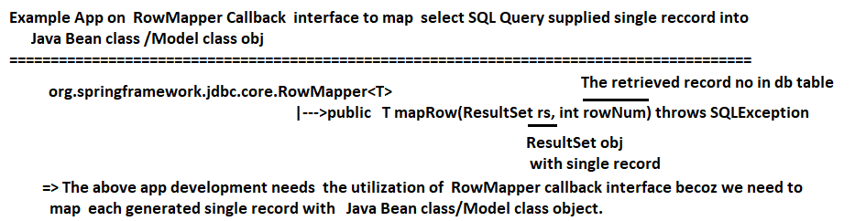

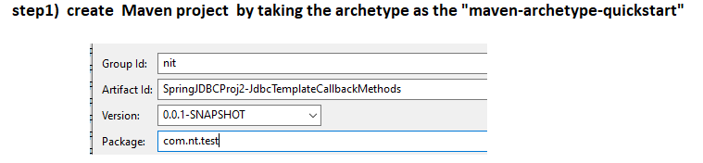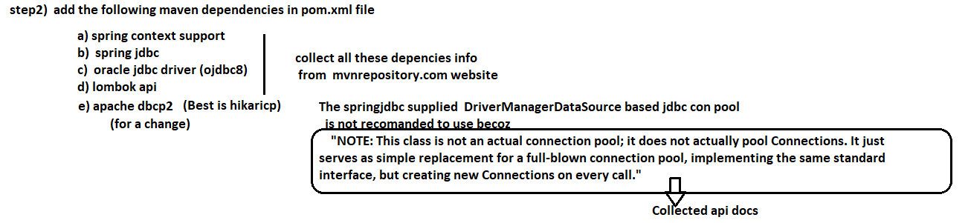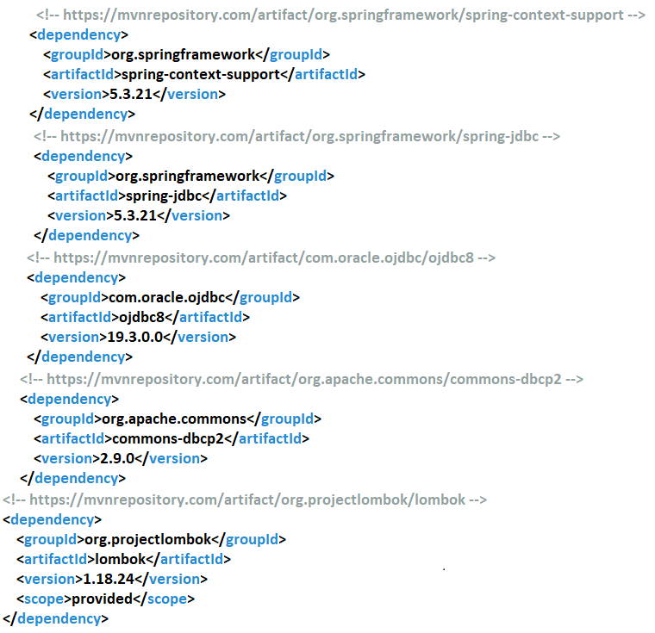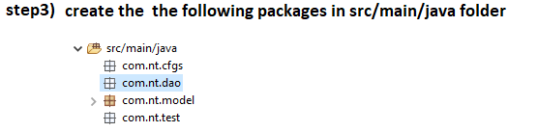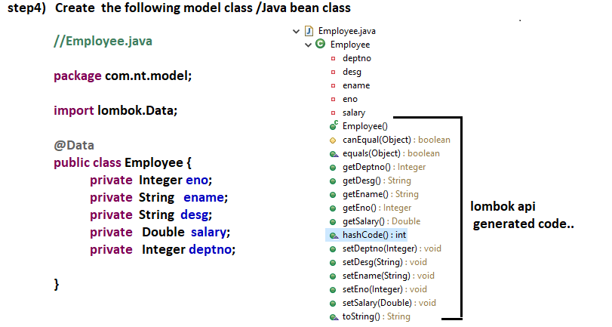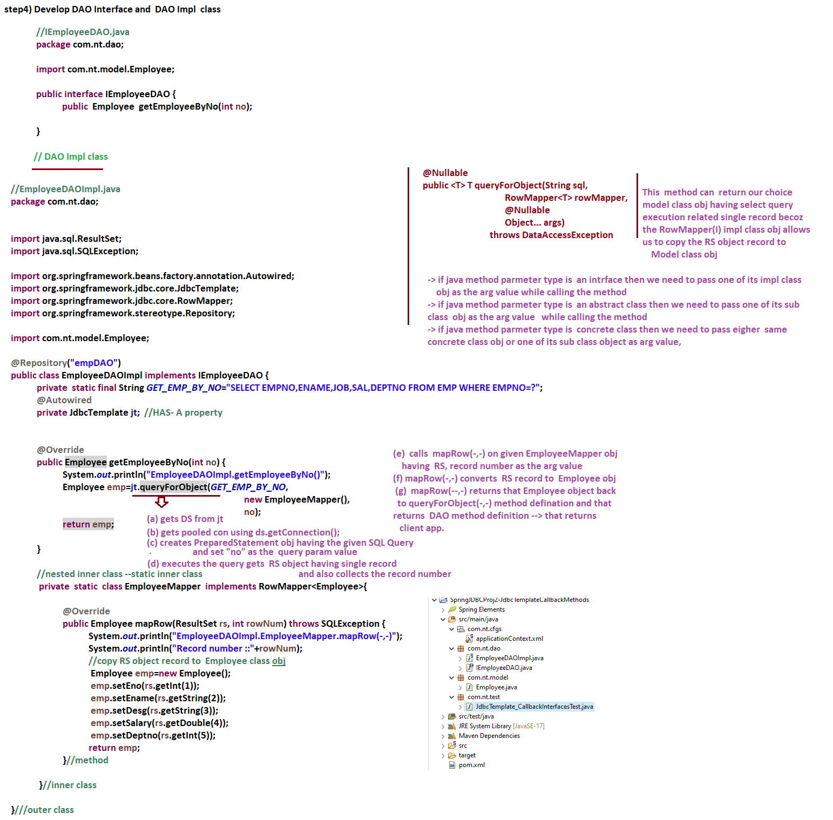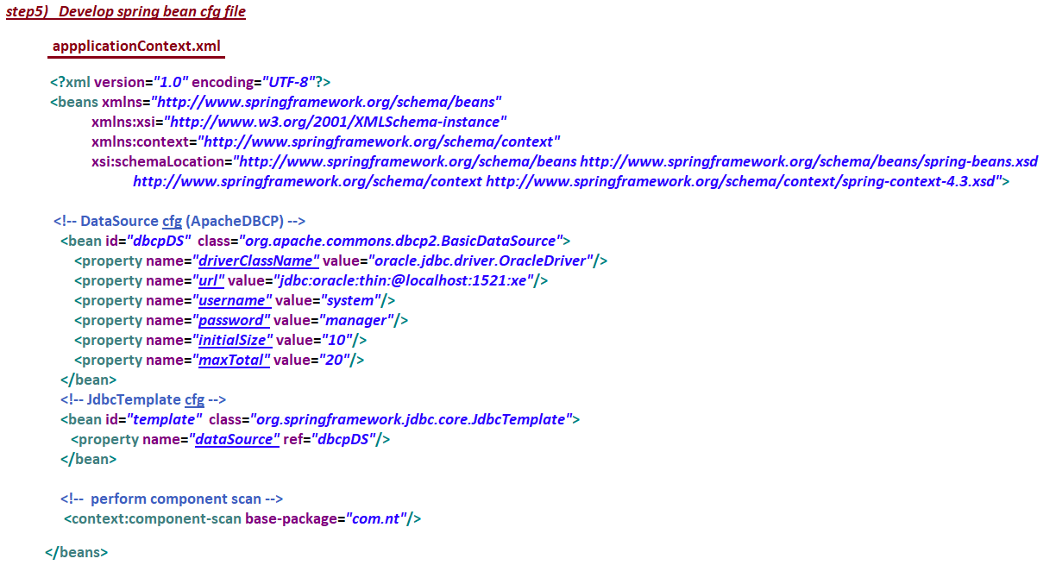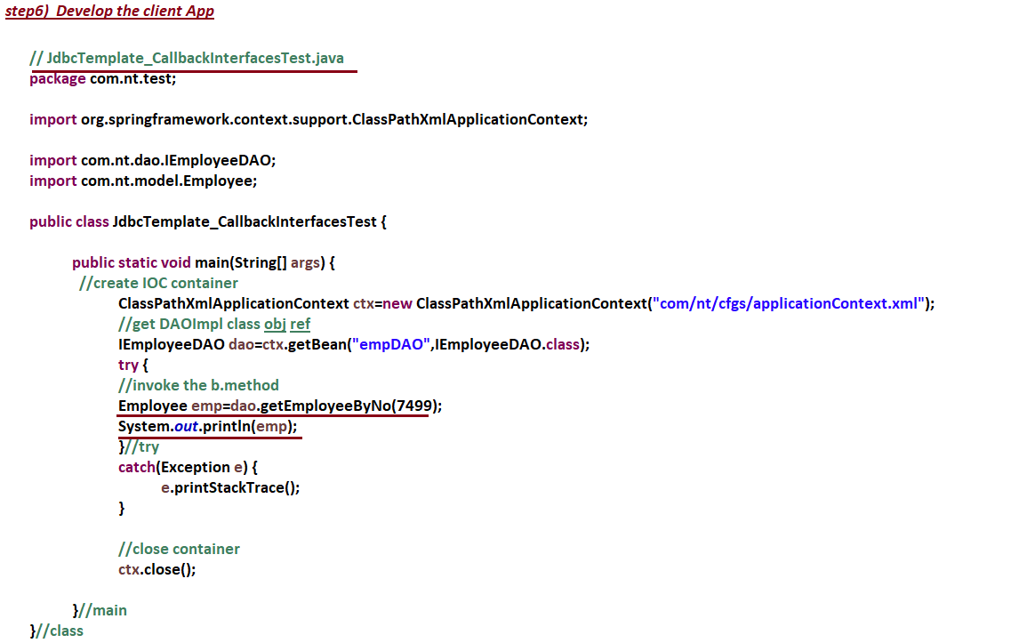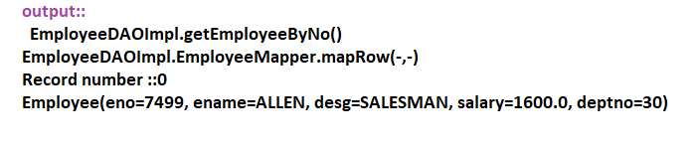

**--------------**

**20/06/2022**

**---------------**

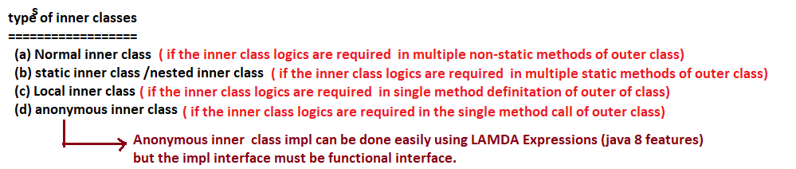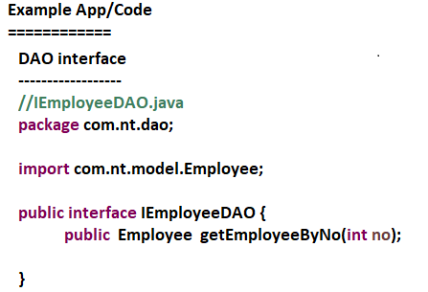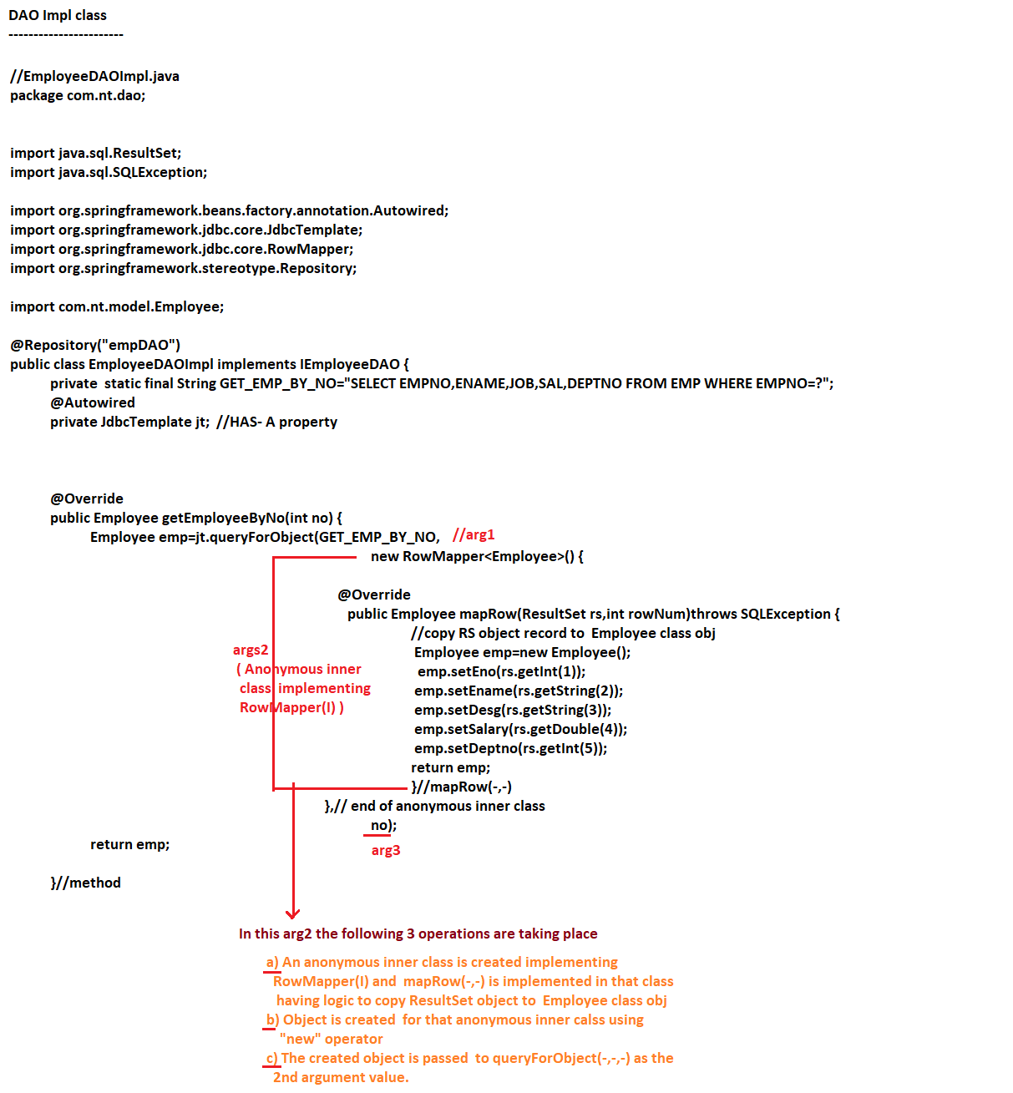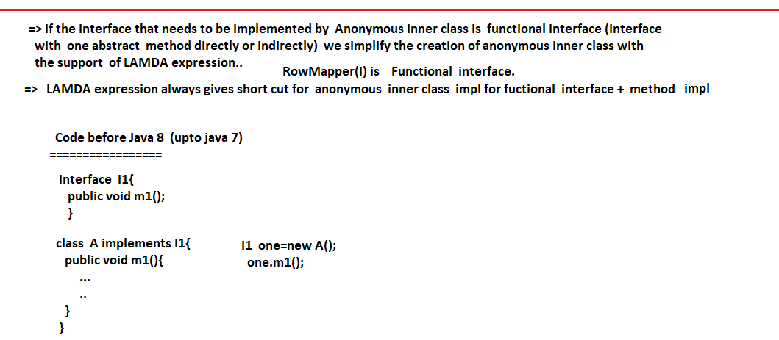

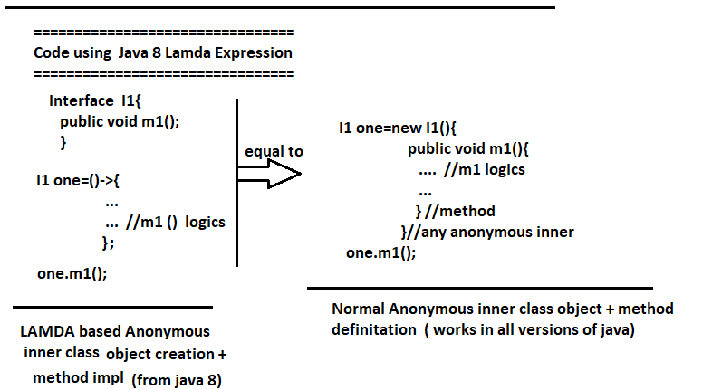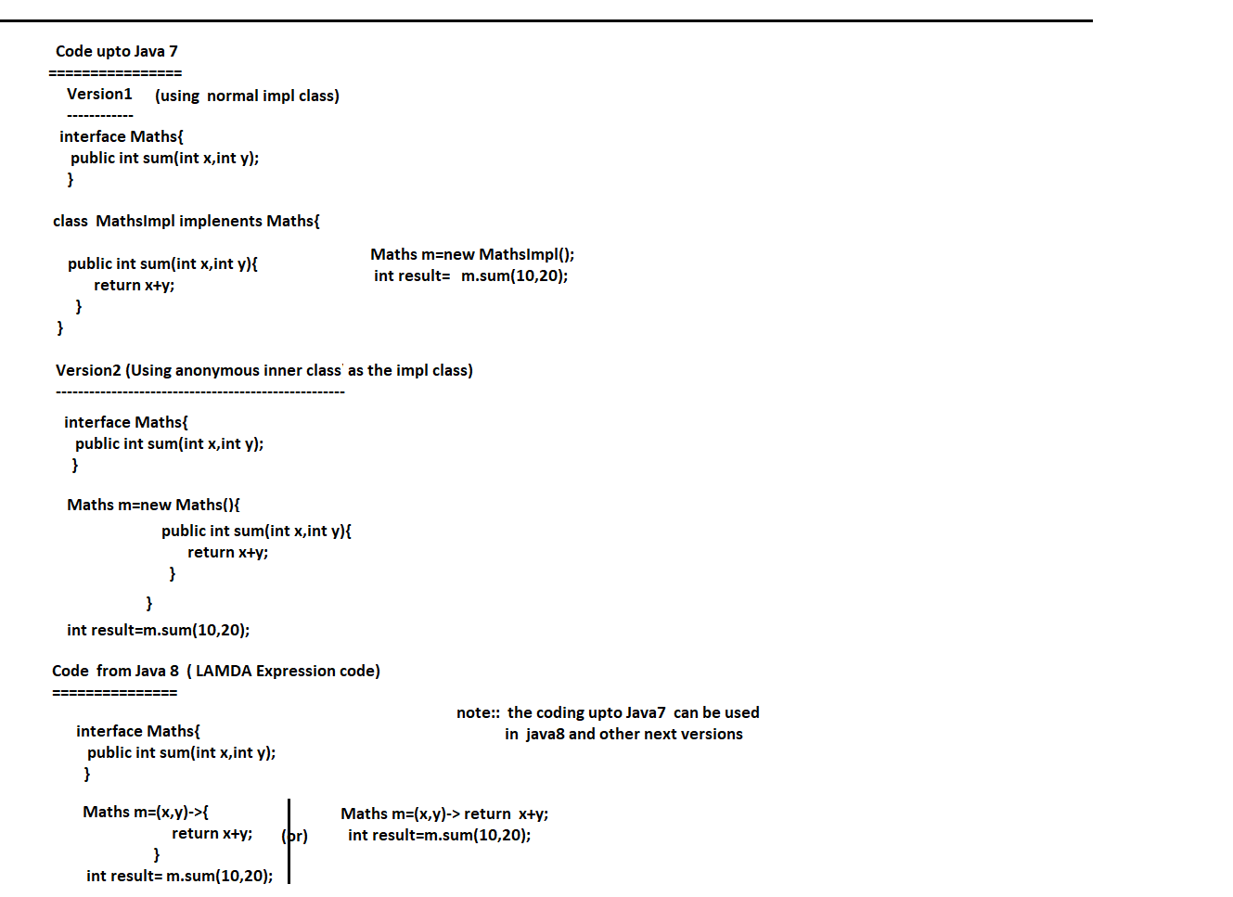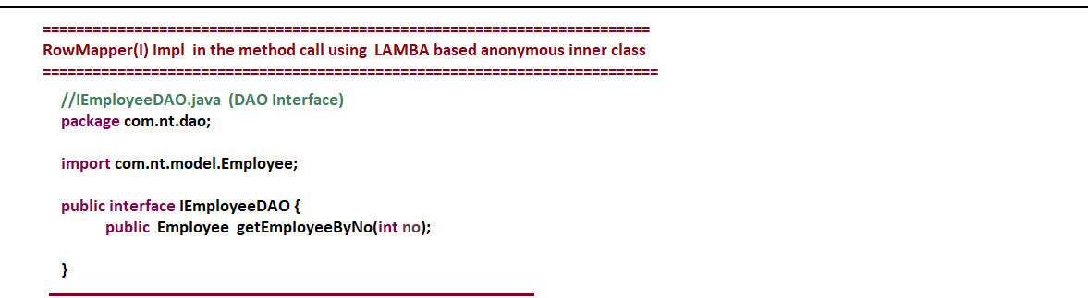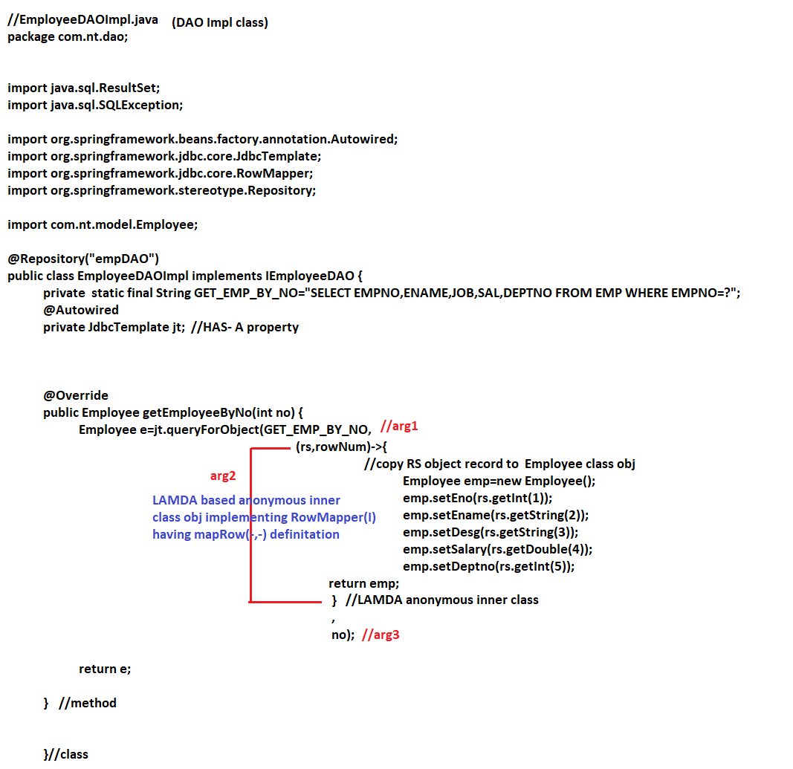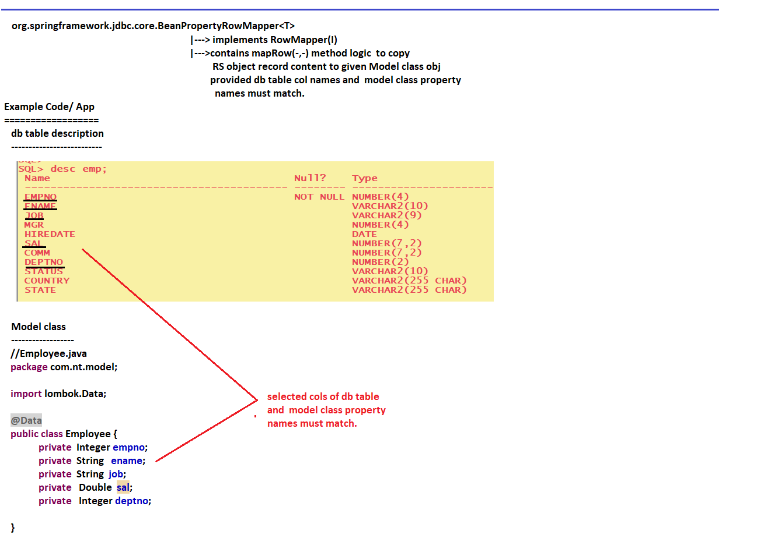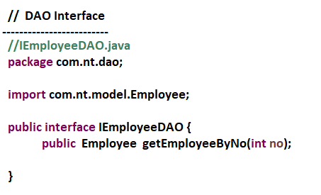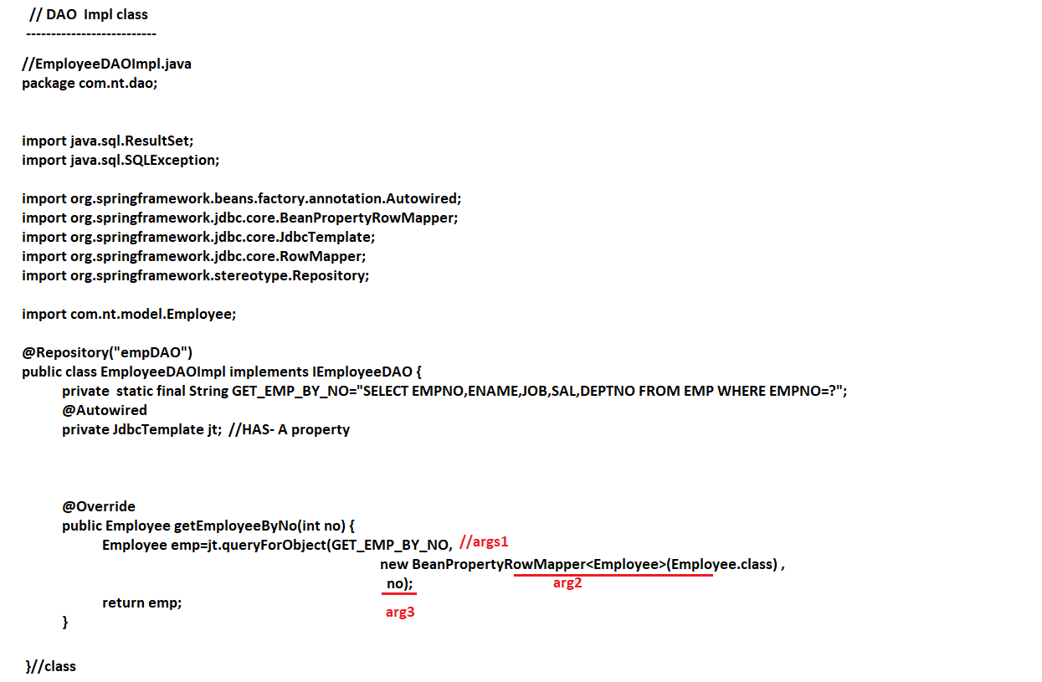

**-----------------**

**21/06/2022**

**-----------------**

